Multiverse analysis

First Author1 & Ernst-August Doelle1,2

1 Wilhelm-Wundt-University

2 Konstanz Business School

Author note

Add complete departmental affiliations for each author here. Each new line herein must be indented, like this line.

Enter author note here.

The authors made the following contributions. First Author: Conceptualization, Writing - Original Draft Preparation, Writing - Review & Editing; Ernst-August Doelle: Writing - Review & Editing, Supervision.

Correspondence concerning this article should be addressed to First Author, Postal address. E-mail: [my@email.com](mailto:my@email.com)

Abstract

One or two sentences providing a **basic introduction** to the field, comprehensible to a scientist in any discipline.

*Keywords:* keywords

*Word count:* X

Multiverse analysis

# Results

## Multiverse

In this document we show the results using another analytic technique. Namely treating study ID as a fixed effect. This is what we wrote in the protocol originally.

## The effects of physical activity volume on sleep

We estimated the effects of physical activity on sleep (RQ1) using mixed-effects models We estimated the effect of physical activity volume on sleep by age, and the results are presented in Table 1 and Figure 1

Table 1:

*Physical activity on sleep controlling for SES, gender and BMI*

| Term | $β$ [95% CI] | SE | t | p | $β$ [95% CI] | SE | t | p |
| --- | --- | --- | --- | --- | --- | --- | --- | --- |
| Sleep duration |  |  |  |  |  |  |  |  |
| (Intercept) | 0.97 [0.64, 1.29] | 0.17 | 5.79 | < .001 | 0.87 [0.45, 1.29] | 0.21 | 4.05 | .008 |
| Physical activity | 0.22 [0.13, 0.30] | 0.04 | 5.08 | .014 | 0.05 [-0.35, 0.44] | 0.20 | 0.23 | .837 |
| Age | 0.00 [-0.01, 0.00] | 0.00 | -0.45 | .652 | 0.00 [-0.01, 0.00] | 0.00 | -0.44 | .667 |
| Physical activity $​^{2}$ | -0.03 [-0.04, -0.02] | 0.01 | -4.52 | .001 | 0.04 [0.00, 0.08] | 0.02 | 2.03 | .090 |
| Physical activity $×$ age | 0.00 [0.00, 0.00] | 0.00 | -2.04 | .117 | 0.00 [0.00, 0.00] | 0.00 | 0.31 | .782 |
| Age $×$ Physical activity $​^{2}$ | 0.00 [0.00, 0.00] | 0.00 | 2.39 | .037 | 0.00 [0.00, 0.00] | 0.00 | -0.64 | .562 |
| Sleep efficency |  |  |  |  |  |  |  |  |
| (Intercept) | -0.31 [-0.82, 0.19] | 0.26 | -1.21 | .323 | -0.35 [-0.77, 0.08] | 0.22 | -1.59 | .210 |
| Physical activity | 0.19 [-0.25, 0.62] | 0.22 | 0.84 | .488 | -0.04 [-0.38, 0.31] | 0.18 | -0.22 | .849 |
| Age | 0.00 [0.00, 0.01] | 0.00 | 0.65 | .534 | 0.00 [0.00, 0.01] | 0.00 | 0.74 | .464 |
| Physical activity $​^{2}$ | -0.03 [-0.09, 0.02] | 0.03 | -1.15 | .363 | 0.01 [-0.08, 0.11] | 0.05 | 0.26 | .814 |
| Physical activity $×$ age | 0.00 [-0.01, 0.00] | 0.00 | -1.16 | .361 | 0.00 [-0.01, 0.01] | 0.00 | 0.00 | .997 |
| Age $×$ Physical activity $​^{2}$ | 0.00 [0.00, 0.00] | 0.00 | 1.94 | .113 | 0.00 [0.00, 0.00] | 0.00 | -1.05 | .360 |
| Sleep onset |  |  |  |  |  |  |  |  |
| (Intercept) | -0.80 [-1.45, -0.14] | 0.33 | -2.39 | .112 | -0.97 [-1.36, -0.58] | 0.20 | -4.89 | .005 |
| Physical activity | 0.35 [-0.33, 1.02] | 0.34 | 1.01 | .425 | 0.14 [-0.16, 0.45] | 0.16 | 0.92 | .455 |
| Age | 0.00 [0.00, 0.01] | 0.00 | 0.39 | .713 | 0.00 [0.00, 0.01] | 0.00 | 0.43 | .683 |
| Physical activity $​^{2}$ | -0.05 [-0.14, 0.04] | 0.04 | -1.17 | .361 | 0.03 [-0.11, 0.17] | 0.07 | 0.46 | .686 |
| Physical activity $×$ age | -0.01 [-0.01, 0.00] | 0.00 | -1.56 | .258 | 0.00 [-0.01, 0.00] | 0.00 | -0.91 | .456 |
| Age $×$ Physical activity $​^{2}$ | 0.00 [0.00, 0.00] | 0.00 | 1.75 | .211 | 0.00 [0.00, 0.00] | 0.00 | -0.35 | .759 |
| Sleep regularity |  |  |  |  |  |  |  |  |
| (Intercept) | -0.20 [-0.74, 0.34] | 0.28 | -0.72 | .523 | -0.19 [-0.68, 0.31] | 0.25 | -0.73 | .515 |
| Physical activity | 0.01 [-0.22, 0.24] | 0.12 | 0.08 | .945 | 0.14 [0.07, 0.20] | 0.03 | 3.95 | .016 |
| Age | 0.00 [0.00, 0.00] | 0.00 | 0.12 | .905 | 0.00 [-0.01, 0.00] | 0.00 | -0.69 | .493 |
| Physical activity $​^{2}$ | 0.00 [-0.04, 0.04] | 0.02 | 0.00 | .998 | -0.06 [-0.24, 0.11] | 0.09 | -0.71 | .551 |
| Physical activity $×$ age | 0.00 [0.00, 0.01] | 0.00 | 1.65 | .223 | 0.00 [0.00, 0.00] | 0.00 | -3.76 | .003 |
| Age $×$ Physical activity $​^{2}$ | 0.00 [0.00, 0.00] | 0.00 | -2.53 | .093 | 0.00 [0.00, 0.00] | 0.00 | 0.40 | .726 |

*Note.* Adjusted for SES, BMI, and sex.

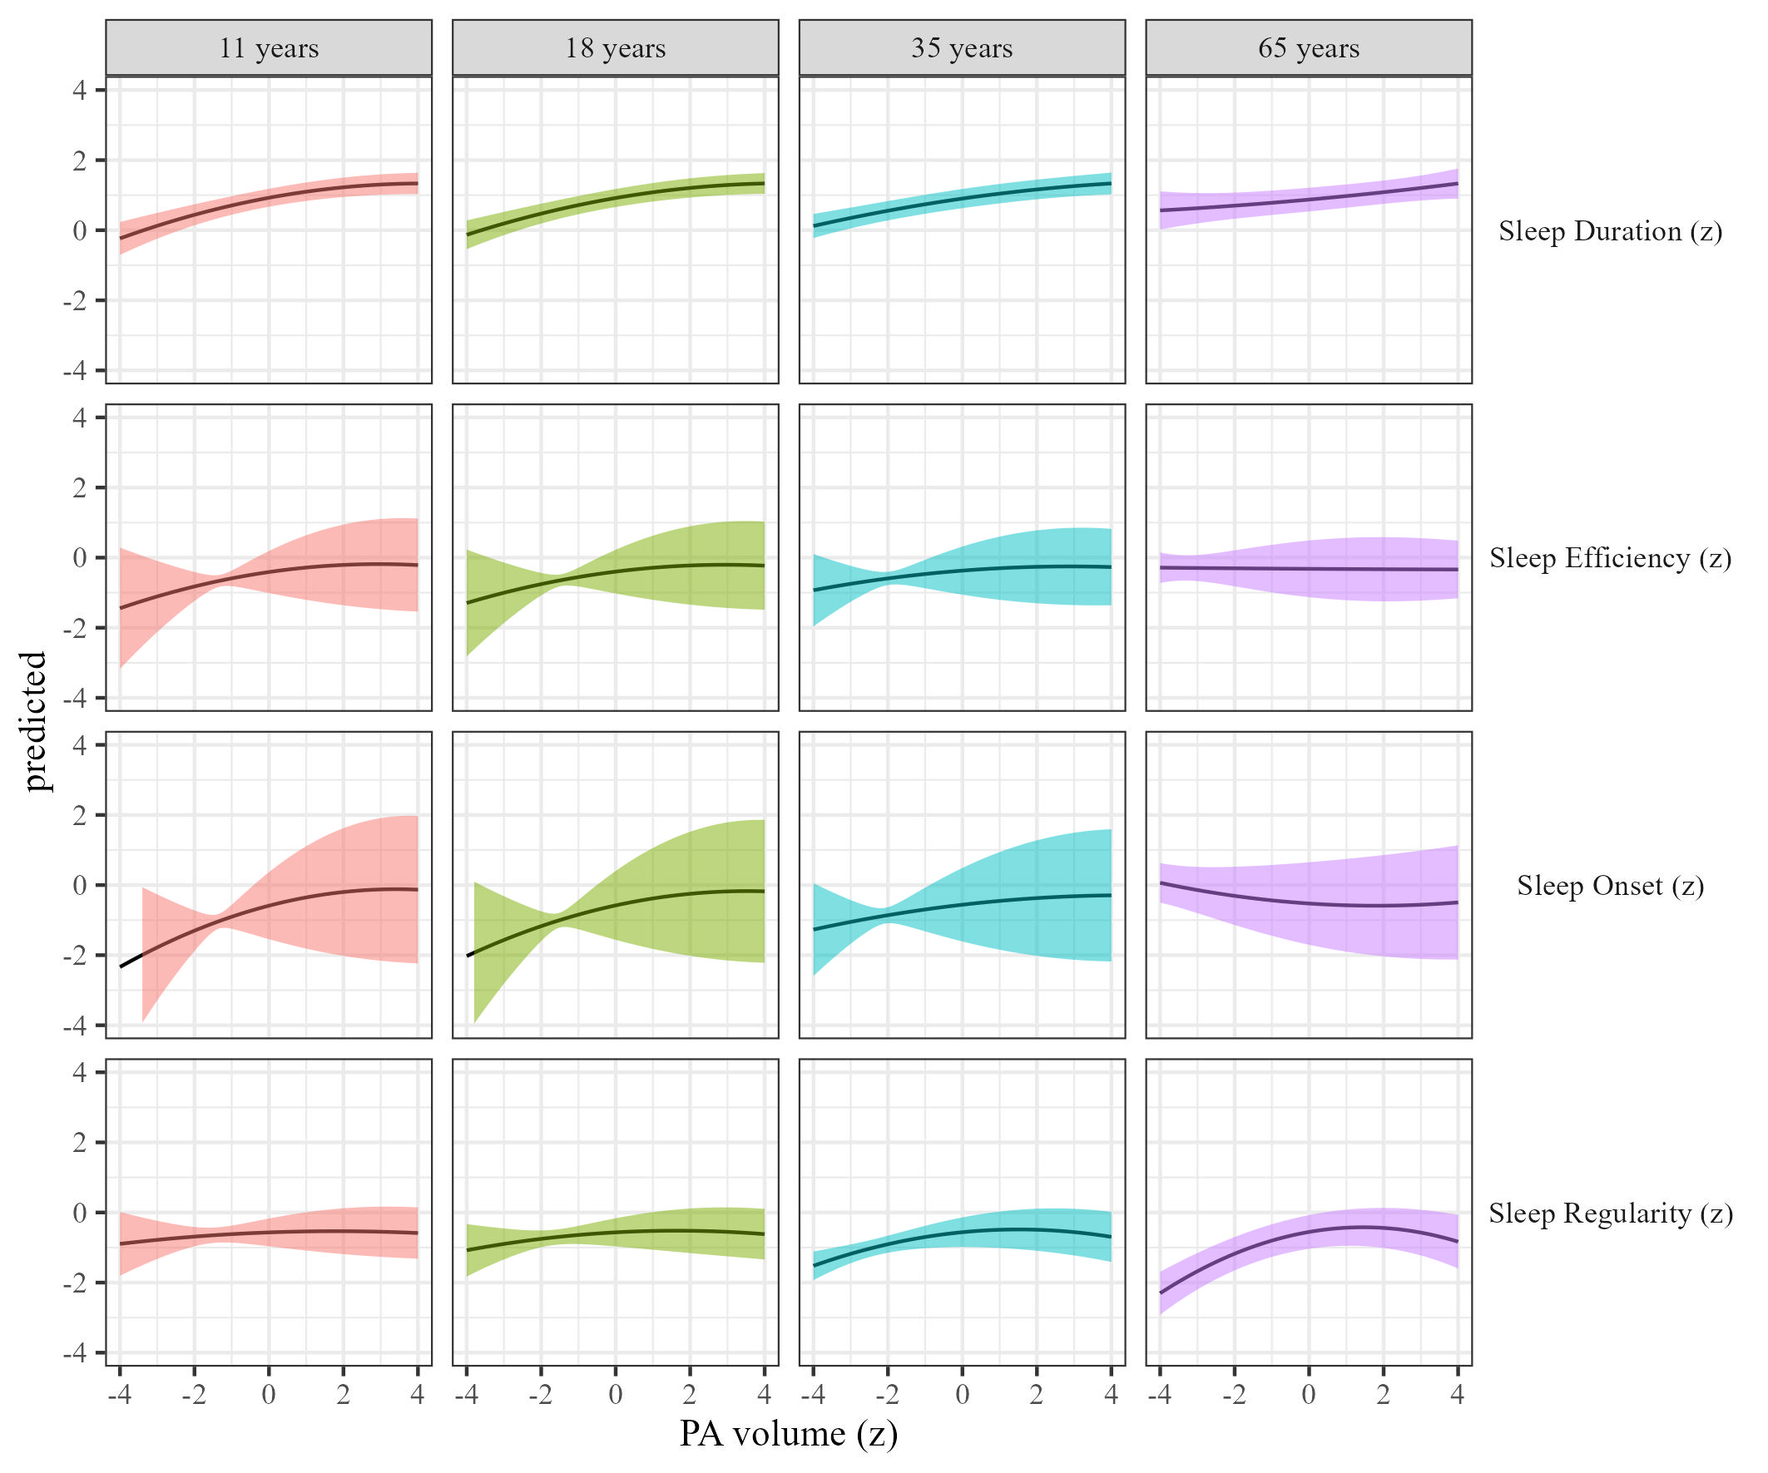

Figure 1: Sleep metrics on Physical activity volume

## The effects of physical activity intensity on sleep

We estimated how physical activity intensity affects sleep across different age groups We present the results controlling for sex, SES, and BMI, in Table 1 and Figure 2.

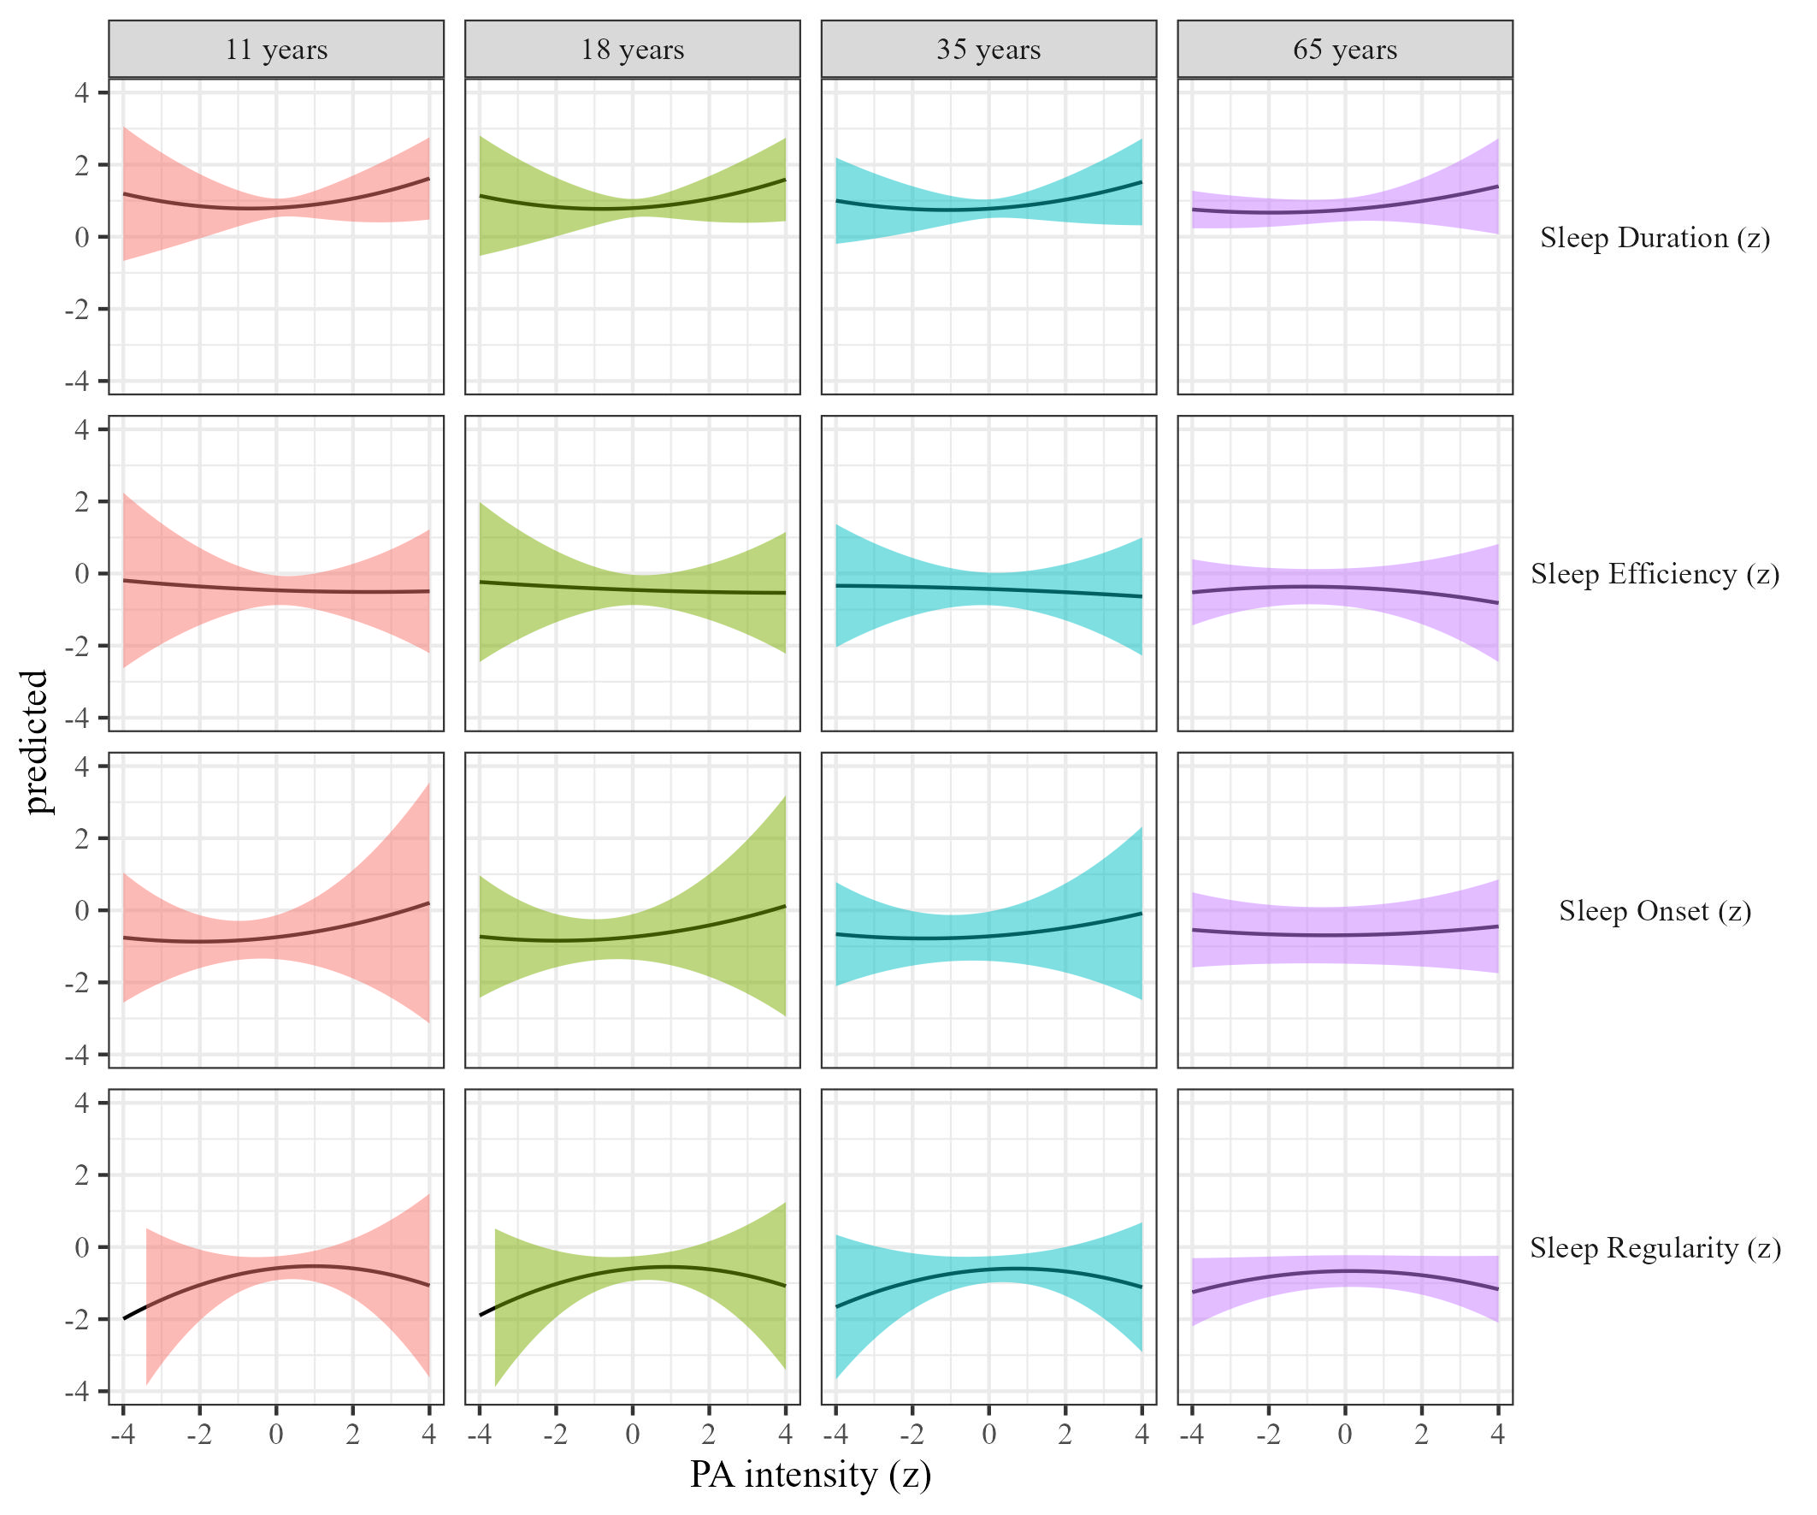

Figure 2: Sleep metrics on Physical activity intensity

## The effects of sleep duration on physical activity

We estimated the effect of sleep duration on physical activity by age Results, controlling for sex, SES, and BMI are presented in Table 2 and Figure 3.

Table 2:

*Sleep on physical activity controlling for SES, gender and BMI*

| Term | $β$ [95% CI] | SE | t | p | $β$ [95% CI] | SE | t | p |
| --- | --- | --- | --- | --- | --- | --- | --- | --- |
| Sleep duration |  |  |  |  |  |  |  |  |
| (Intercept) | 0.33 [-0.08, 0.74] | 0.21 | 1.56 | .183 | 0.82 [0.39, 1.25] | 0.22 | 3.73 | .017 |
| Sleep duration | -0.02 [-0.05, 0.01] | 0.01 | -1.43 | .156 | -0.01 [-0.03, 0.01] | 0.01 | -0.78 | .440 |
| Age | -0.02 [-0.02, -0.01] | 0.00 | -7.92 | < .001 | -0.02 [-0.02, -0.01] | 0.00 | -8.04 | < .001 |
| Sleep duration $​^{2}$ | 0.04 [0.02, 0.06] | 0.01 | 4.69 | .001 | -0.01 [-0.15, 0.12] | 0.07 | -0.19 | .864 |
| Sleep duration $×$ age | 0.00 [0.00, 0.00] | 0.00 | 0.20 | .855 | 0.00 [0.00, 0.00] | 0.00 | 0.92 | .409 |
| Age $×$ Sleep duration $​^{2}$ | 0.00 [0.00, 0.00] | 0.00 | -4.87 | < .001 | 0.00 [0.00, 0.00] | 0.00 | -0.09 | .934 |
| Sleep efficency |  |  |  |  |  |  |  |  |
| (Intercept) | 0.36 [-0.05, 0.78] | 0.21 | 1.71 | .153 | 0.81 [0.31, 1.30] | 0.25 | 3.17 | .040 |
| Sleep efficiency | 0.00 [-0.06, 0.07] | 0.03 | 0.10 | .926 | -0.01 [-0.15, 0.13] | 0.07 | -0.19 | .866 |
| Age | -0.02 [-0.02, -0.01] | 0.00 | -8.04 | < .001 | -0.02 [-0.02, -0.01] | 0.00 | -10.11 | < .001 |
| Sleep efficiency $​^{2}$ | 0.01 [-0.01, 0.02] | 0.01 | 1.16 | .284 | 0.00 [-0.04, 0.05] | 0.02 | 0.02 | .985 |
| Sleep efficiency $×$ age | 0.00 [0.00, 0.00] | 0.00 | 0.44 | .682 | 0.00 [0.00, 0.00] | 0.00 | 0.37 | .742 |
| Age $×$ Sleep efficiency $​^{2}$ | 0.00 [0.00, 0.00] | 0.00 | -1.15 | .258 | 0.00 [0.00, 0.00] | 0.00 | -0.14 | .902 |
| Sleep onset |  |  |  |  |  |  |  |  |
| (Intercept) | 0.34 [-0.07, 0.75] | 0.21 | 1.61 | .171 | 0.81 [0.37, 1.26] | 0.23 | 3.57 | .022 |
| Sleep onset | -0.05 [-0.13, 0.04] | 0.04 | -1.11 | .338 | 0.00 [-0.05, 0.05] | 0.03 | -0.09 | .935 |
| Age | -0.02 [-0.02, -0.01] | 0.00 | -8.11 | < .001 | -0.02 [-0.02, -0.01] | 0.00 | -10.85 | < .001 |
| Sleep onset $​^{2}$ | -0.02 [-0.08, 0.05] | 0.03 | -0.50 | .656 | -0.01 [-0.05, 0.03] | 0.02 | -0.30 | .778 |
| Sleep onset $×$ age | 0.00 [0.00, 0.00] | 0.00 | 0.33 | .747 | 0.00 [0.00, 0.00] | 0.00 | -0.19 | .849 |
| Age $×$ Sleep onset $​^{2}$ | 0.00 [0.00, 0.00] | 0.00 | 0.42 | .700 | 0.00 [0.00, 0.00] | 0.00 | 0.53 | .601 |
| Sleep regularity |  |  |  |  |  |  |  |  |
| (Intercept) | 0.31 [-0.09, 0.72] | 0.21 | 1.51 | .190 | 0.80 [0.38, 1.23] | 0.22 | 3.67 | .017 |
| Sleep regularity | 0.13 [0.05, 0.21] | 0.04 | 3.11 | .070 | 0.07 [-0.03, 0.16] | 0.05 | 1.42 | .281 |
| Age | -0.02 [-0.02, -0.01] | 0.00 | -8.45 | < .001 | -0.02 [-0.02, -0.01] | 0.00 | -9.72 | < .001 |
| Sleep regularity $​^{2}$ | 0.03 [-0.01, 0.07] | 0.02 | 1.41 | .260 | 0.00 [-0.05, 0.05] | 0.03 | 0.05 | .962 |
| Sleep regularity $×$ age | 0.00 [0.00, 0.00] | 0.00 | -1.70 | .191 | 0.00 [0.00, 0.00] | 0.00 | -1.10 | .369 |
| Age $×$ Sleep regularity $​^{2}$ | 0.00 [0.00, 0.00] | 0.00 | -0.39 | .725 | 0.00 [0.00, 0.00] | 0.00 | 0.08 | .942 |

*Note.* Adjusted for SES, BMI, and sex.

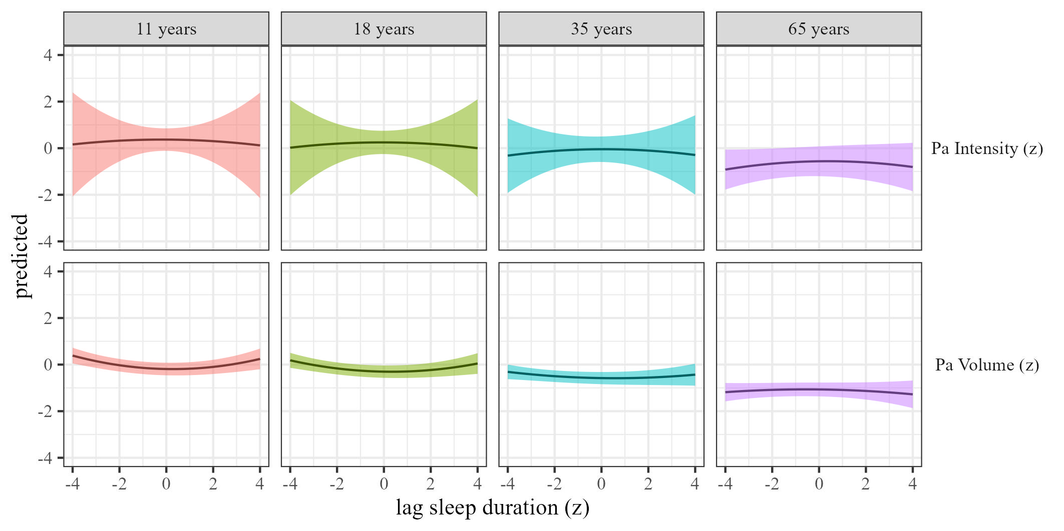

Figure 3: Physical activty by sleep duration

## The effects of sleep efficiency on physical activity

We estimated the effect of sleep efficiency on physical activity by age. Results, controlling for sex, SES, and BMI are presented in Table 2 and Figure 4.

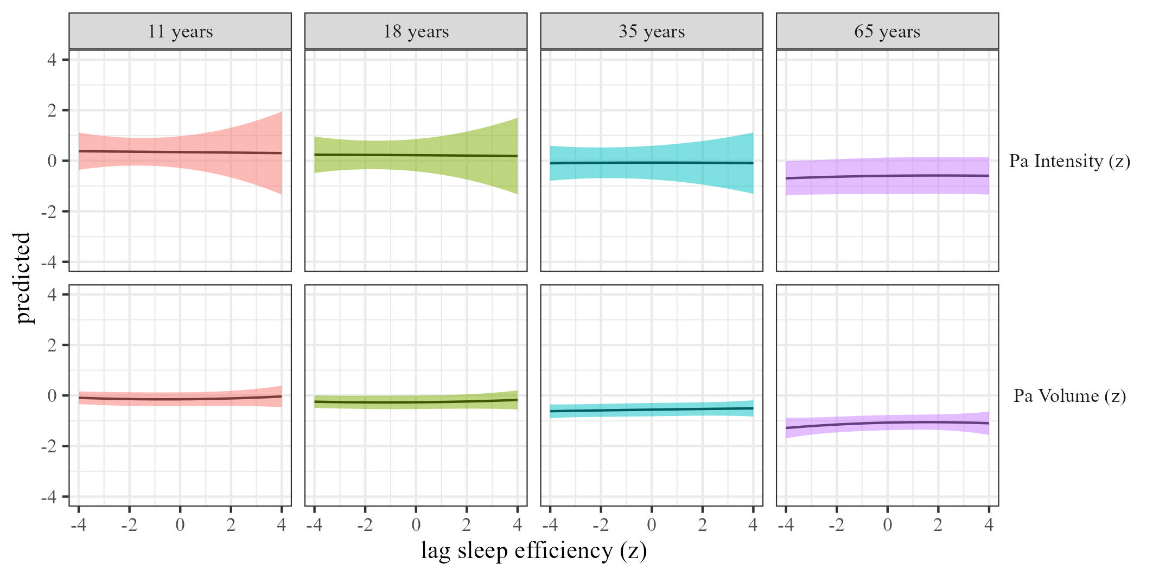

Figure 4: Physical activty by sleep efficiency

## The effects of sleep onset on physical activity

We estimated the effect of sleep onset on physical activity by age Results, controlling for sex, SES, and BMI are presented in Table 2 and Figure 5.

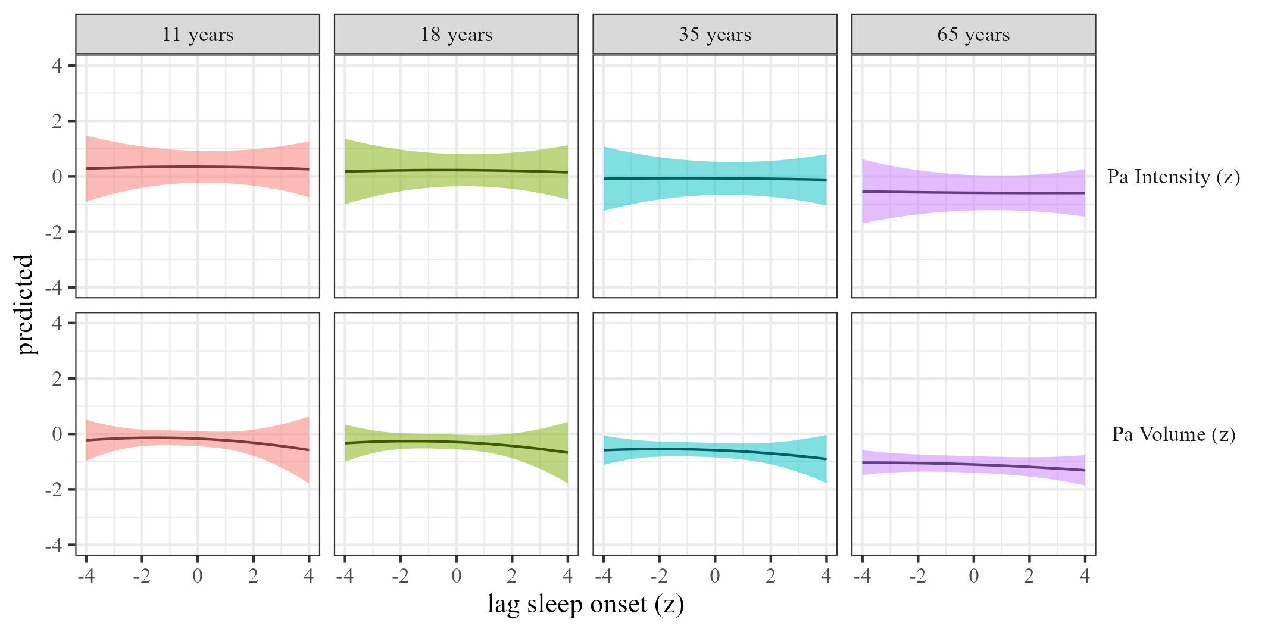

Figure 5: Physical activty by sleep onset

## The effects of sleep regularity on physical activity

We estimated the effect of sleep regularity on physical activity by age. Results, controlling for sex, SES, and BMI are presented in Table 2 and Figure 6.

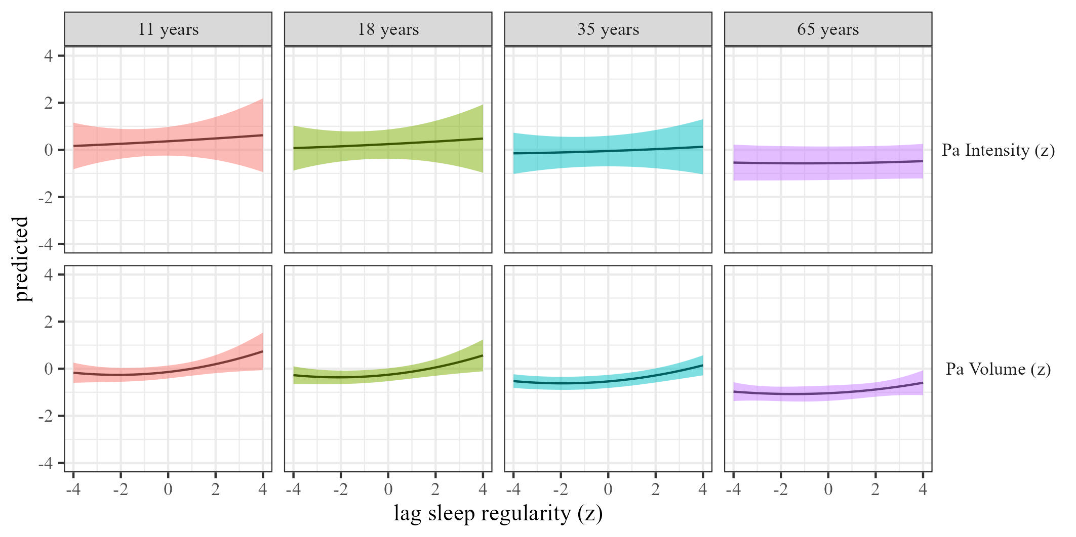

Figure 6: Physical activty by sleep regularity

# Moderation

In the following section we present models for a range of moderators which were pre-defined in our protocol.

## BMI

### The effects of physical activity volume on sleep.

We estimated the effects of physical activity on sleep (RQ1) using mixed-effects models We estimated the effect of physical activity volume on sleep by BMI, and the results are presented in Table 3 and Figure 7

Table 3:

*Physical activity on sleep controlling for SES, gender and BMI*

| Term | $β$ [95% CI] | SE | t | p | $β$ [95% CI] | SE | t | p |
| --- | --- | --- | --- | --- | --- | --- | --- | --- |
| Sleep duration |  |  |  |  |  |  |  |  |
| (Intercept) | 0.48 [0.14, 0.81] | 0.17 | 2.76 | .037 | 0.53 [0.10, 0.97] | 0.22 | 2.39 | .092 |
| Physical activity | 0.22 [0.11, 0.33] | 0.06 | 4.04 | .006 | 0.01 [-0.33, 0.34] | 0.17 | 0.04 | .969 |
| Physical activity $​^{2}$ | -0.05 [-0.09, -0.01] | 0.02 | -2.19 | .093 | 0.01 [-0.04, 0.07] | 0.03 | 0.47 | .652 |
| Age | 0.00 [-0.01, 0.00] | 0.00 | -1.39 | .167 | 0.00 [-0.01, 0.00] | 0.00 | -1.27 | .279 |
| Physical activity $×$ bmi | 0.00 [-0.01, 0.00] | 0.00 | -1.57 | .125 | 0.00 [0.00, 0.01] | 0.00 | 1.40 | .193 |
| Sleep efficency |  |  |  |  |  |  |  |  |
| (Intercept) | 0.11 [-0.16, 0.37] | 0.14 | 0.79 | .447 | 0.19 [-0.25, 0.64] | 0.23 | 0.86 | .450 |
| Physical activity | 0.12 [-0.27, 0.52] | 0.20 | 0.62 | .594 | -0.08 [-0.37, 0.21] | 0.15 | -0.54 | .638 |
| Physical activity $​^{2}$ | -0.02 [-0.09, 0.04] | 0.03 | -0.73 | .527 | 0.02 [-0.02, 0.06] | 0.02 | 1.09 | .277 |
| Age | 0.00 [0.00, 0.01] | 0.00 | 1.45 | .191 | 0.00 [0.00, 0.01] | 0.00 | 0.58 | .577 |
| Physical activity $×$ bmi | 0.00 [-0.01, 0.01] | 0.00 | -0.42 | .705 | 0.00 [-0.01, 0.01] | 0.00 | 0.45 | .686 |
| Sleep onset |  |  |  |  |  |  |  |  |
| (Intercept) | -0.18 [-0.49, 0.13] | 0.16 | -1.11 | .277 | -0.18 [-0.58, 0.23] | 0.21 | -0.86 | .419 |
| Physical activity | 0.34 [-0.42, 1.10] | 0.39 | 0.87 | .477 | 0.07 [-0.25, 0.39] | 0.16 | 0.41 | .719 |
| Physical activity $​^{2}$ | -0.05 [-0.17, 0.07] | 0.06 | -0.84 | .488 | 0.06 [-0.12, 0.24] | 0.09 | 0.63 | .592 |
| Age | 0.00 [0.00, 0.01] | 0.00 | 0.70 | .533 | 0.00 [0.00, 0.00] | 0.00 | 0.71 | .482 |
| Physical activity $×$ bmi | -0.01 [-0.02, 0.01] | 0.01 | -1.04 | .405 | 0.00 [-0.01, 0.01] | 0.00 | 0.05 | .961 |
| Sleep regularity |  |  |  |  |  |  |  |  |
| (Intercept) | 0.20 [-0.26, 0.65] | 0.23 | 0.85 | .446 | 0.31 [-0.24, 0.87] | 0.28 | 1.10 | .352 |
| Physical activity | -0.12 [-0.22, -0.02] | 0.05 | -2.35 | .054 | 0.01 [-0.05, 0.08] | 0.03 | 0.43 | .669 |
| Physical activity $​^{2}$ | 0.04 [-0.01, 0.09] | 0.02 | 1.74 | .163 | -0.06 [-0.15, 0.04] | 0.05 | -1.19 | .326 |
| Age | 0.00 [-0.01, 0.00] | 0.00 | -0.23 | .823 | 0.00 [0.00, 0.00] | 0.00 | -0.26 | .799 |
| Physical activity $×$ bmi | 0.01 [0.00, 0.02] | 0.00 | 2.13 | .137 | 0.00 [0.00, 0.01] | 0.00 | 0.62 | .567 |

*Note.* Adjusted for SES, BMI, and sex.

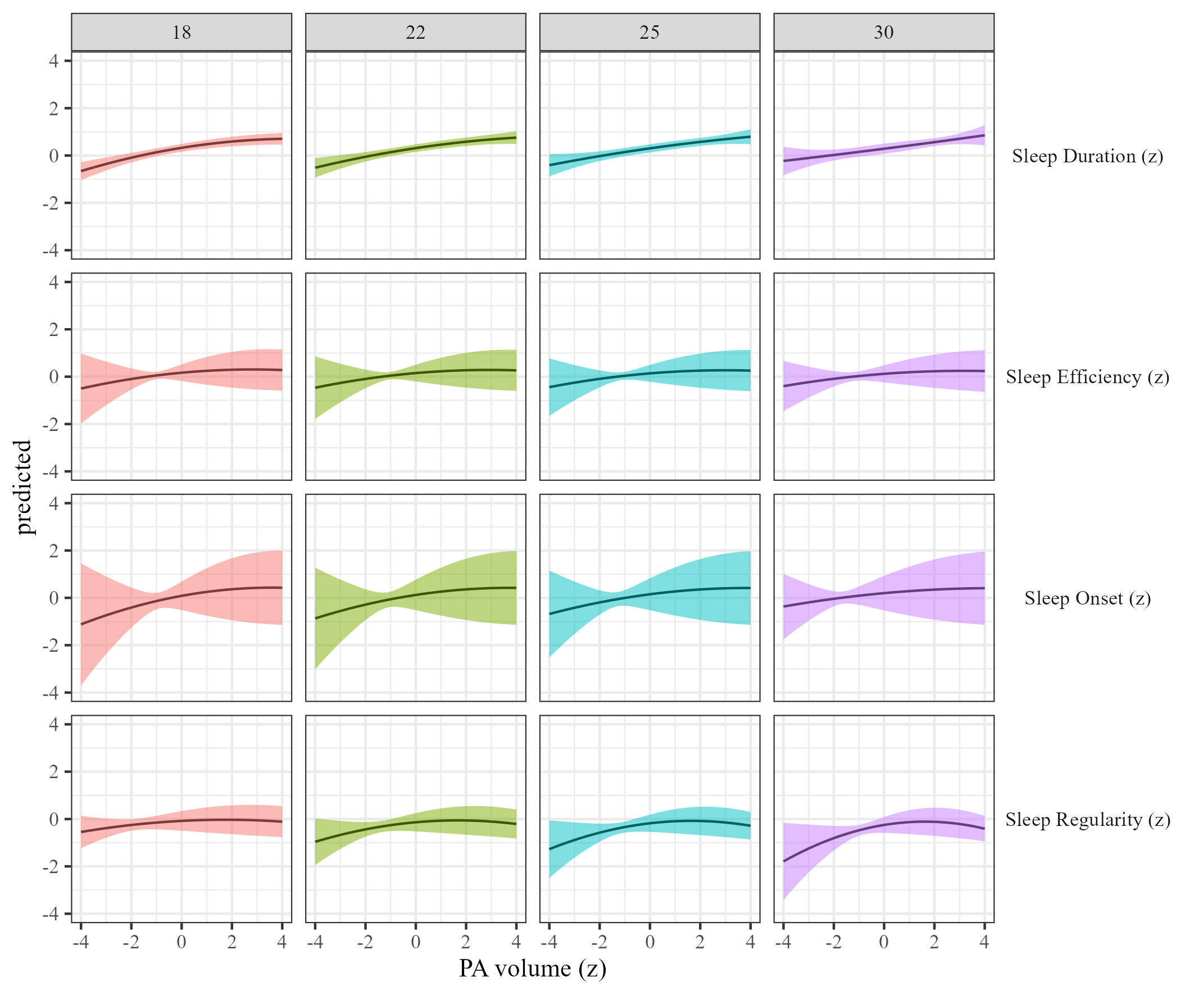

Figure 7: Sleep metrics on Physical activity volume by BMI

### The effects of physical activity intensity on sleep by BMI.

We estimated how physical activity intensity affects sleep across BMI We present the results in Table 3 and Figure 8.

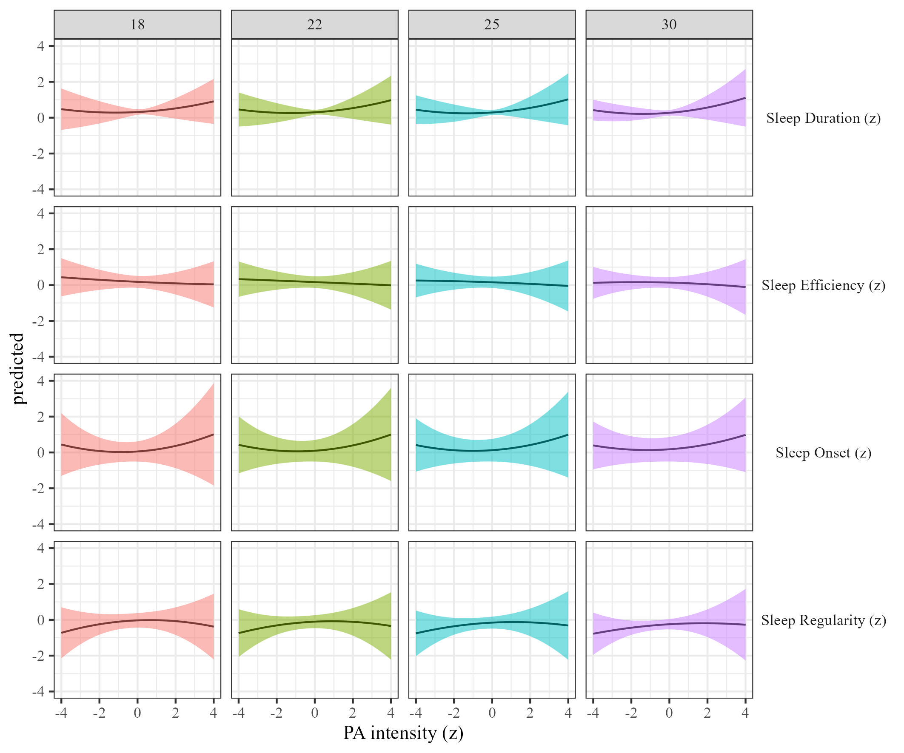

Figure 8: Sleep metrics on Physical activity intensity moderated by BMI

### The effects of sleep duration on physical activity.

We estimated the effect of sleep duration on physical activity by BMI Results, controlling for sex, SES, and BMI are presented in Table 2 and Figure 9.

Table 4:

*Sleep on physical activity controlling for SES, gender and BMI*

| Term | $β$ [95% CI] | SE | t | p | $β$ [95% CI] | SE | t | p |
| --- | --- | --- | --- | --- | --- | --- | --- | --- |
| Sleep duration |  |  |  |  |  |  |  |  |
| (Intercept) | 1.41 [0.86, 1.96] | 0.28 | 5.03 | .005 | 1.05 [0.53, 1.56] | 0.26 | 3.99 | .033 |
| Sleep duration | -0.02 [-0.06, 0.02] | 0.02 | -0.99 | .323 | 0.00 [-0.03, 0.04] | 0.02 | 0.07 | .945 |
| Sleep duration $​^{2}$ | 0.04 [0.01, 0.07] | 0.02 | 2.56 | .029 | -0.01 [-0.15, 0.13] | 0.07 | -0.15 | .895 |
| Age | -0.02 [-0.02, -0.01] | 0.00 | -8.32 | < .001 | -0.02 [-0.02, -0.01] | 0.00 | -12.17 | < .001 |
| Sleep duration $×$ bmi | 0.00 [0.00, 0.00] | 0.00 | 0.24 | .815 | 0.00 [0.00, 0.00] | 0.00 | 0.09 | .932 |
| Sleep efficency |  |  |  |  |  |  |  |  |
| (Intercept) | 1.46 [0.94, 1.98] | 0.26 | 5.53 | .002 | 1.04 [0.44, 1.64] | 0.31 | 3.38 | .055 |
| Sleep efficiency | 0.04 [-0.17, 0.25] | 0.11 | 0.39 | .731 | -0.01 [-0.23, 0.20] | 0.11 | -0.12 | .913 |
| Sleep efficiency $​^{2}$ | 0.00 [-0.03, 0.03] | 0.01 | -0.06 | .953 | 0.00 [-0.03, 0.03] | 0.02 | 0.11 | .918 |
| Age | -0.02 [-0.02, -0.01] | 0.00 | -8.10 | < .001 | -0.02 [-0.02, -0.01] | 0.00 | -11.92 | < .001 |
| Sleep efficiency $×$ bmi | 0.00 [-0.01, 0.01] | 0.00 | -0.31 | .785 | 0.00 [-0.01, 0.01] | 0.00 | 0.23 | .834 |
| Sleep onset |  |  |  |  |  |  |  |  |
| (Intercept) | 1.49 [0.98, 1.99] | 0.26 | 5.75 | .001 | 1.04 [0.44, 1.65] | 0.31 | 3.36 | .056 |
| Sleep onset | -0.01 [-0.10, 0.07] | 0.04 | -0.32 | .760 | 0.00 [-0.07, 0.08] | 0.04 | 0.07 | .946 |
| Sleep onset $​^{2}$ | -0.03 [-0.07, 0.01] | 0.02 | -1.46 | .161 | -0.01 [-0.04, 0.02] | 0.02 | -0.57 | .573 |
| Age | -0.02 [-0.02, -0.01] | 0.00 | -8.12 | < .001 | -0.02 [-0.02, -0.01] | 0.00 | -11.81 | < .001 |
| Sleep onset $×$ bmi | 0.00 [0.00, 0.00] | 0.00 | -0.62 | .550 | 0.00 [0.00, 0.00] | 0.00 | -0.22 | .826 |
| Sleep regularity |  |  |  |  |  |  |  |  |
| (Intercept) | 1.39 [0.87, 1.91] | 0.27 | 5.24 | .003 | 1.00 [0.47, 1.54] | 0.27 | 3.67 | .041 |
| Sleep regularity | 0.14 [-0.01, 0.30] | 0.08 | 1.88 | .171 | 0.09 [-0.05, 0.24] | 0.07 | 1.29 | .304 |
| Sleep regularity $​^{2}$ | 0.01 [-0.06, 0.08] | 0.04 | 0.39 | .720 | 0.01 [-0.04, 0.06] | 0.03 | 0.49 | .654 |
| Age | -0.02 [-0.02, -0.01] | 0.00 | -7.94 | < .001 | -0.02 [-0.02, -0.01] | 0.00 | -11.77 | < .001 |
| Sleep regularity $×$ bmi | 0.00 [-0.01, 0.00] | 0.00 | -0.95 | .410 | 0.00 [-0.01, 0.00] | 0.00 | -1.04 | .373 |

*Note.* Adjusted for SES, BMI, and sex.

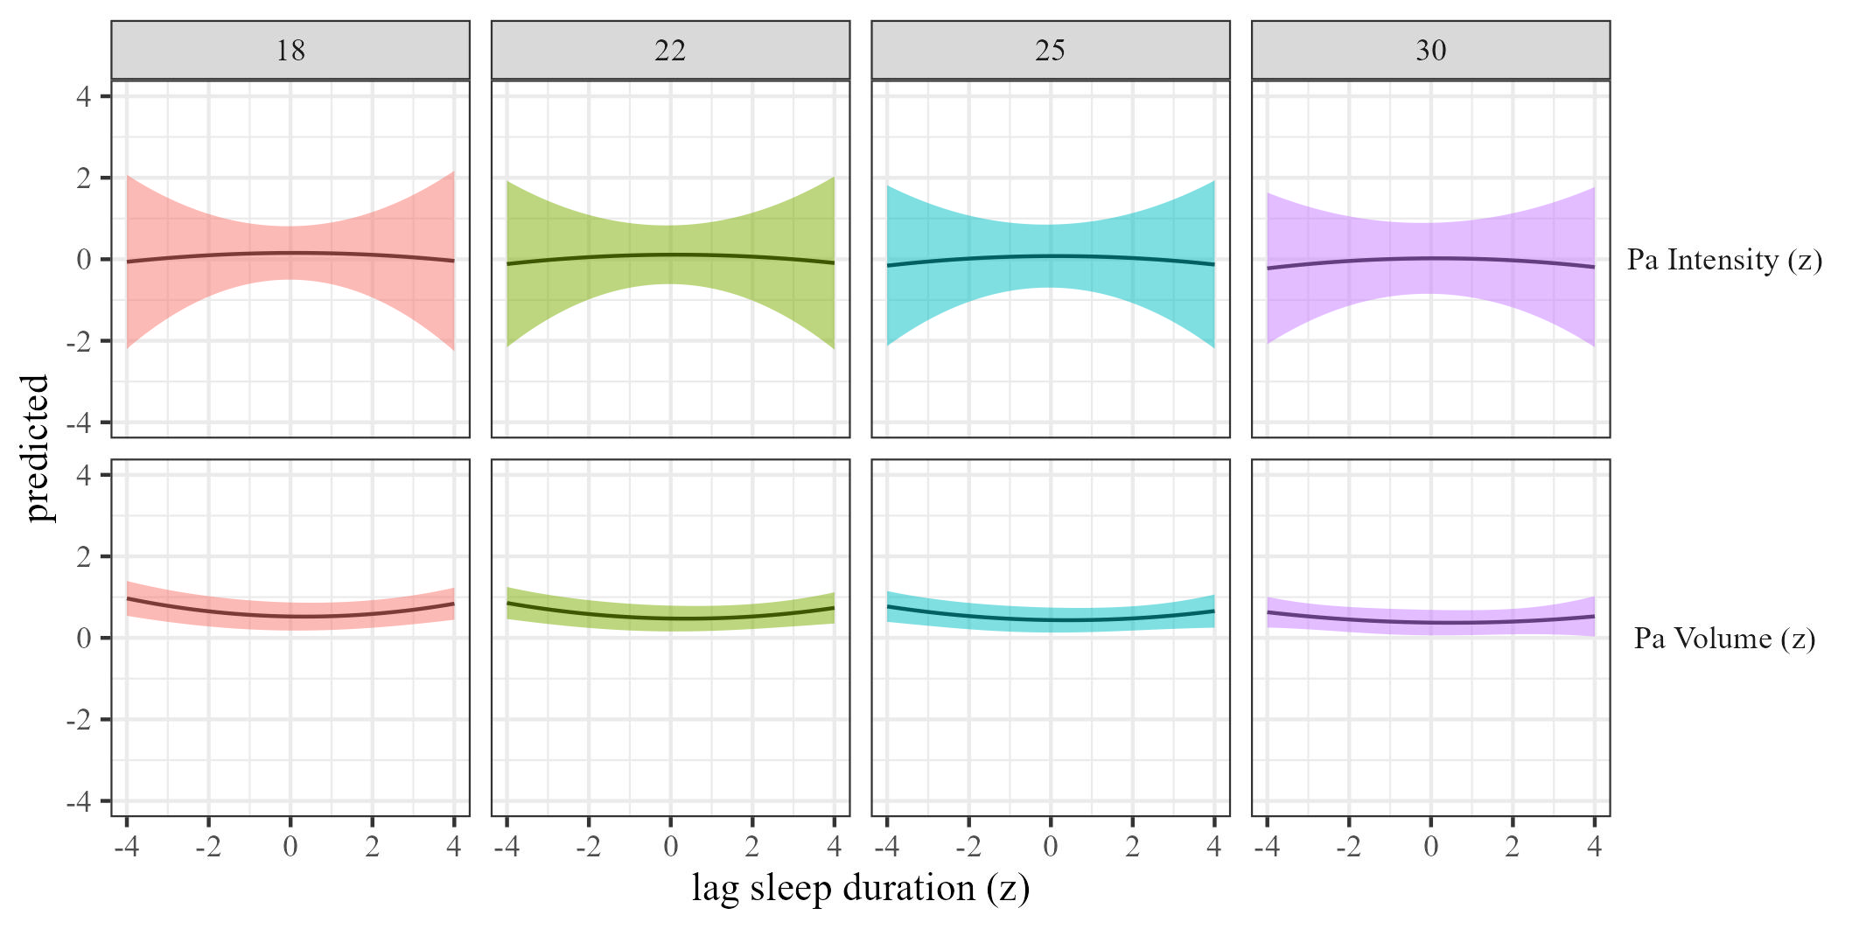

Figure 9: Physical activty by sleep duration moderated by BMI

### The effects of sleep efficiency on physical activity.

We estimated the effect of sleep efficiency on physical activity by BMI. Results, controlling for sex, SES, and BMI are presented in Table 4 and Figure 10.

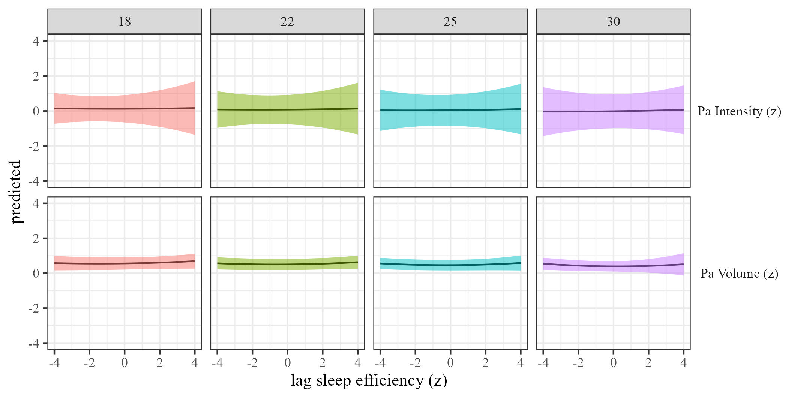

Figure 10: Physical activty by sleep efficiency moderated by BMI

### The effects of sleep onset on physical activity.

We estimated the effect of sleep onset on physical activity by BMI Results, controlling for sex, SES, and BMI are presented in Table 2 and Figure 11.

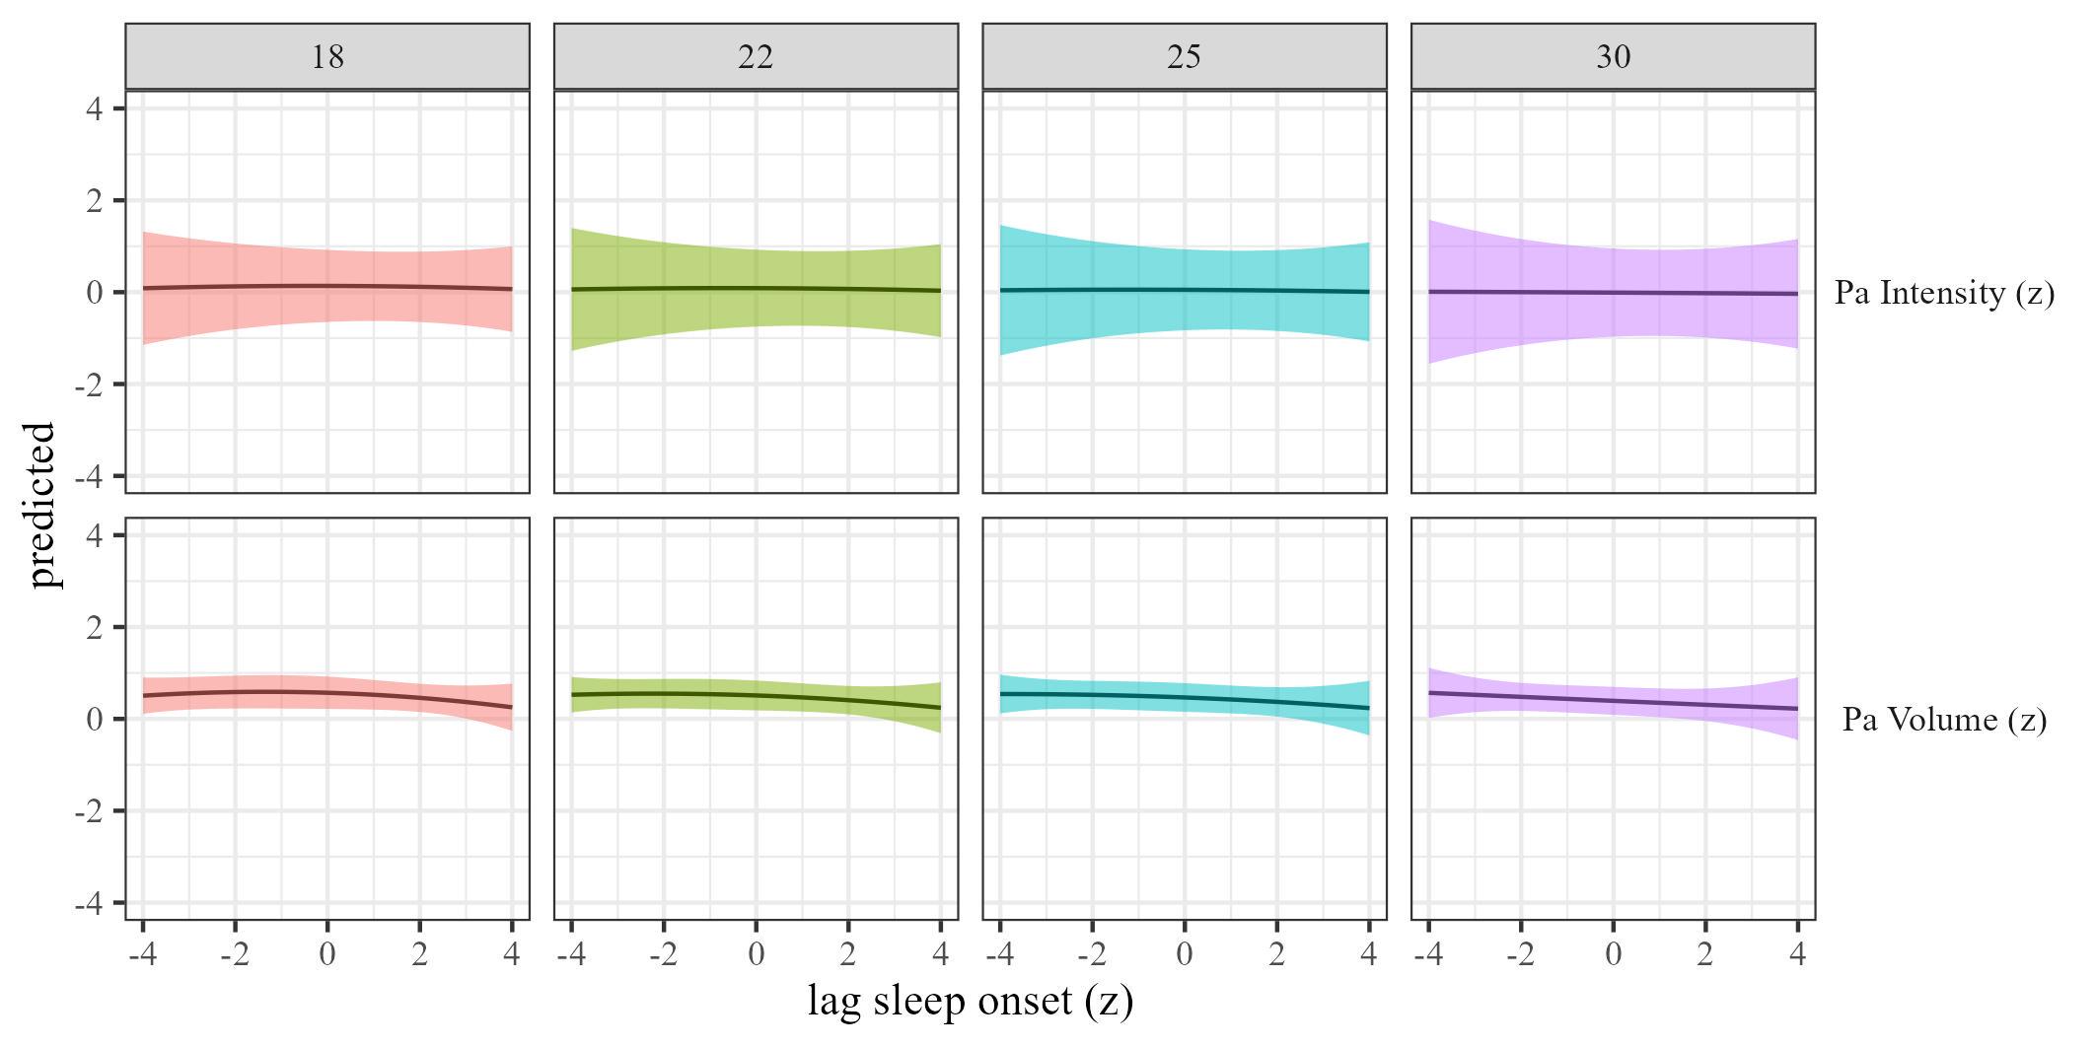

Figure 11: Physical activty by sleep onset moderated by BMI

### The effects of sleep regularity on physical activity.

We estimated the effect of sleep regularity on physical activity by BMI. Results are presented in Table 2 and Figure 12.

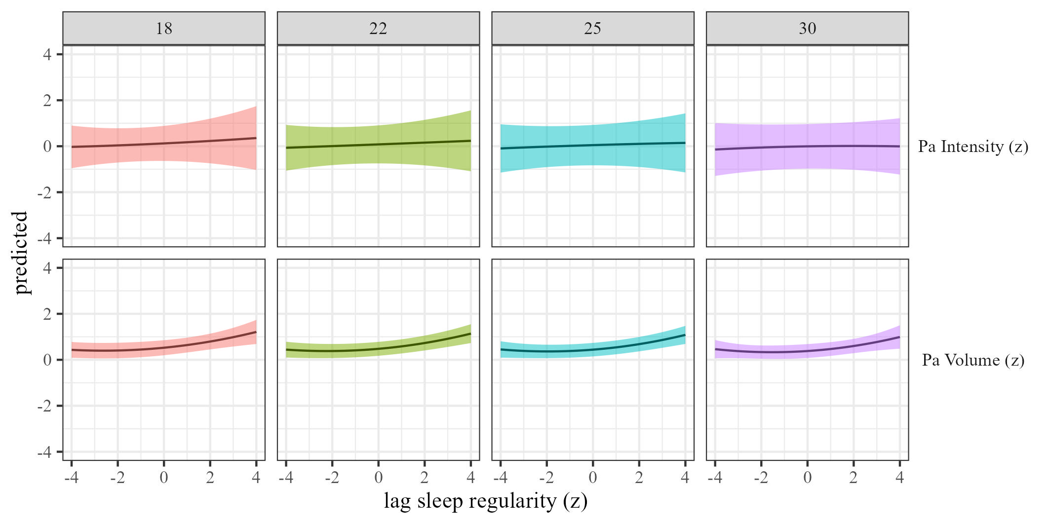 ## SES

### The effects of physical activity volume on sleep.

We estimated the effects of physical activity on sleep (RQ1) using mixed-effects models We estimated the effect of physical activity volume on sleep by SES, and the results are presented in Table 5 and Figure 13

Table 5:

*Physical activity on sleep controlling for SES, gender and BMI*

| Term | $β$ [95% CI] | SE | t | p | $β$ [95% CI] | SE | t | p |
| --- | --- | --- | --- | --- | --- | --- | --- | --- |
| Sleep duration |  |  |  |  |  |  |  |  |
| (Intercept) | 0.44 [0.15, 0.72] | 0.14 | 3.02 | .013 | 0.52 [-0.04, 1.07] | 0.28 | 1.84 | .178 |
| Physical activity | 0.15 [0.08, 0.21] | 0.03 | 4.42 | .003 | 0.05 [-0.23, 0.32] | 0.14 | 0.33 | .772 |
| Physical activity $​^{2}$ | -0.01 [-0.03, 0.00] | 0.01 | -1.70 | .090 | 0.03 [-0.02, 0.08] | 0.02 | 1.10 | .353 |
| Age | 0.00 [-0.01, 0.00] | 0.00 | -1.26 | .210 | 0.00 [-0.01, 0.00] | 0.00 | -1.28 | .277 |
| Physical activity $×$ sesmedium | 0.00 [-0.09, 0.10] | 0.05 | 0.06 | .958 | 0.03 [-0.01, 0.08] | 0.03 | 1.36 | .190 |
| Physical activity $×$ seshigh | 0.04 [-0.03, 0.11] | 0.03 | 1.22 | .239 | 0.01 [-0.04, 0.06] | 0.02 | 0.51 | .612 |
| Sleep efficency |  |  |  |  |  |  |  |  |
| (Intercept) | 0.11 [-0.15, 0.38] | 0.14 | 0.84 | .421 | 0.24 [-0.23, 0.71] | 0.24 | 1.01 | .385 |
| Physical activity | 0.10 [-0.15, 0.35] | 0.13 | 0.79 | .510 | -0.05 [-0.23, 0.13] | 0.09 | -0.52 | .653 |
| Physical activity $​^{2}$ | -0.02 [-0.06, 0.01] | 0.02 | -1.18 | .326 | -0.01 [-0.05, 0.04] | 0.02 | -0.21 | .846 |
| Age | 0.00 [0.00, 0.01] | 0.00 | 1.41 | .204 | 0.00 [0.00, 0.01] | 0.00 | 0.55 | .592 |
| Physical activity $×$ sesmedium | -0.01 [-0.08, 0.05] | 0.03 | -0.41 | .688 | 0.01 [-0.04, 0.06] | 0.03 | 0.46 | .660 |
| Physical activity $×$ seshigh | 0.00 [-0.11, 0.11] | 0.06 | 0.04 | .969 | 0.00 [-0.05, 0.05] | 0.03 | -0.15 | .885 |
| Sleep onset |  |  |  |  |  |  |  |  |
| (Intercept) | -0.18 [-0.49, 0.13] | 0.16 | -1.15 | .265 | -0.14 [-0.61, 0.34] | 0.24 | -0.57 | .599 |
| Physical activity | 0.12 [-0.26, 0.50] | 0.19 | 0.63 | .594 | 0.08 [-0.09, 0.25] | 0.09 | 0.93 | .445 |
| Physical activity $​^{2}$ | -0.01 [-0.06, 0.04] | 0.02 | -0.43 | .702 | 0.03 [-0.06, 0.12] | 0.04 | 0.74 | .533 |
| Age | 0.00 [0.00, 0.01] | 0.00 | 0.82 | .465 | 0.00 [0.00, 0.00] | 0.00 | 0.78 | .441 |
| Physical activity $×$ sesmedium | 0.01 [-0.06, 0.08] | 0.04 | 0.22 | .834 | -0.03 [-0.10, 0.04] | 0.03 | -0.92 | .419 |
| Physical activity $×$ seshigh | 0.06 [-0.05, 0.18] | 0.06 | 1.08 | .364 | 0.00 [-0.04, 0.03] | 0.02 | -0.26 | .798 |
| Sleep regularity |  |  |  |  |  |  |  |  |
| (Intercept) | 0.25 [-0.26, 0.76] | 0.26 | 0.95 | .408 | 0.27 [-0.28, 0.83] | 0.28 | 0.96 | .409 |
| Physical activity | 0.11 [-0.03, 0.25] | 0.07 | 1.60 | .231 | 0.04 [-0.04, 0.13] | 0.04 | 1.00 | .398 |
| Physical activity $​^{2}$ | -0.03 [-0.05, -0.01] | 0.01 | -3.17 | .008 | -0.02 [-0.10, 0.07] | 0.04 | -0.45 | .693 |
| Age | 0.00 [-0.01, 0.00] | 0.00 | -0.29 | .778 | 0.00 [0.00, 0.00] | 0.00 | -0.25 | .803 |
| Physical activity $×$ sesmedium | -0.01 [-0.07, 0.04] | 0.03 | -0.48 | .634 | 0.01 [-0.03, 0.05] | 0.02 | 0.60 | .547 |
| Physical activity $×$ seshigh | -0.07 [-0.13, 0.00] | 0.03 | -2.06 | .062 | -0.01 [-0.07, 0.05] | 0.03 | -0.29 | .783 |

*Note.* Adjusted for SES, BMI, and sex.

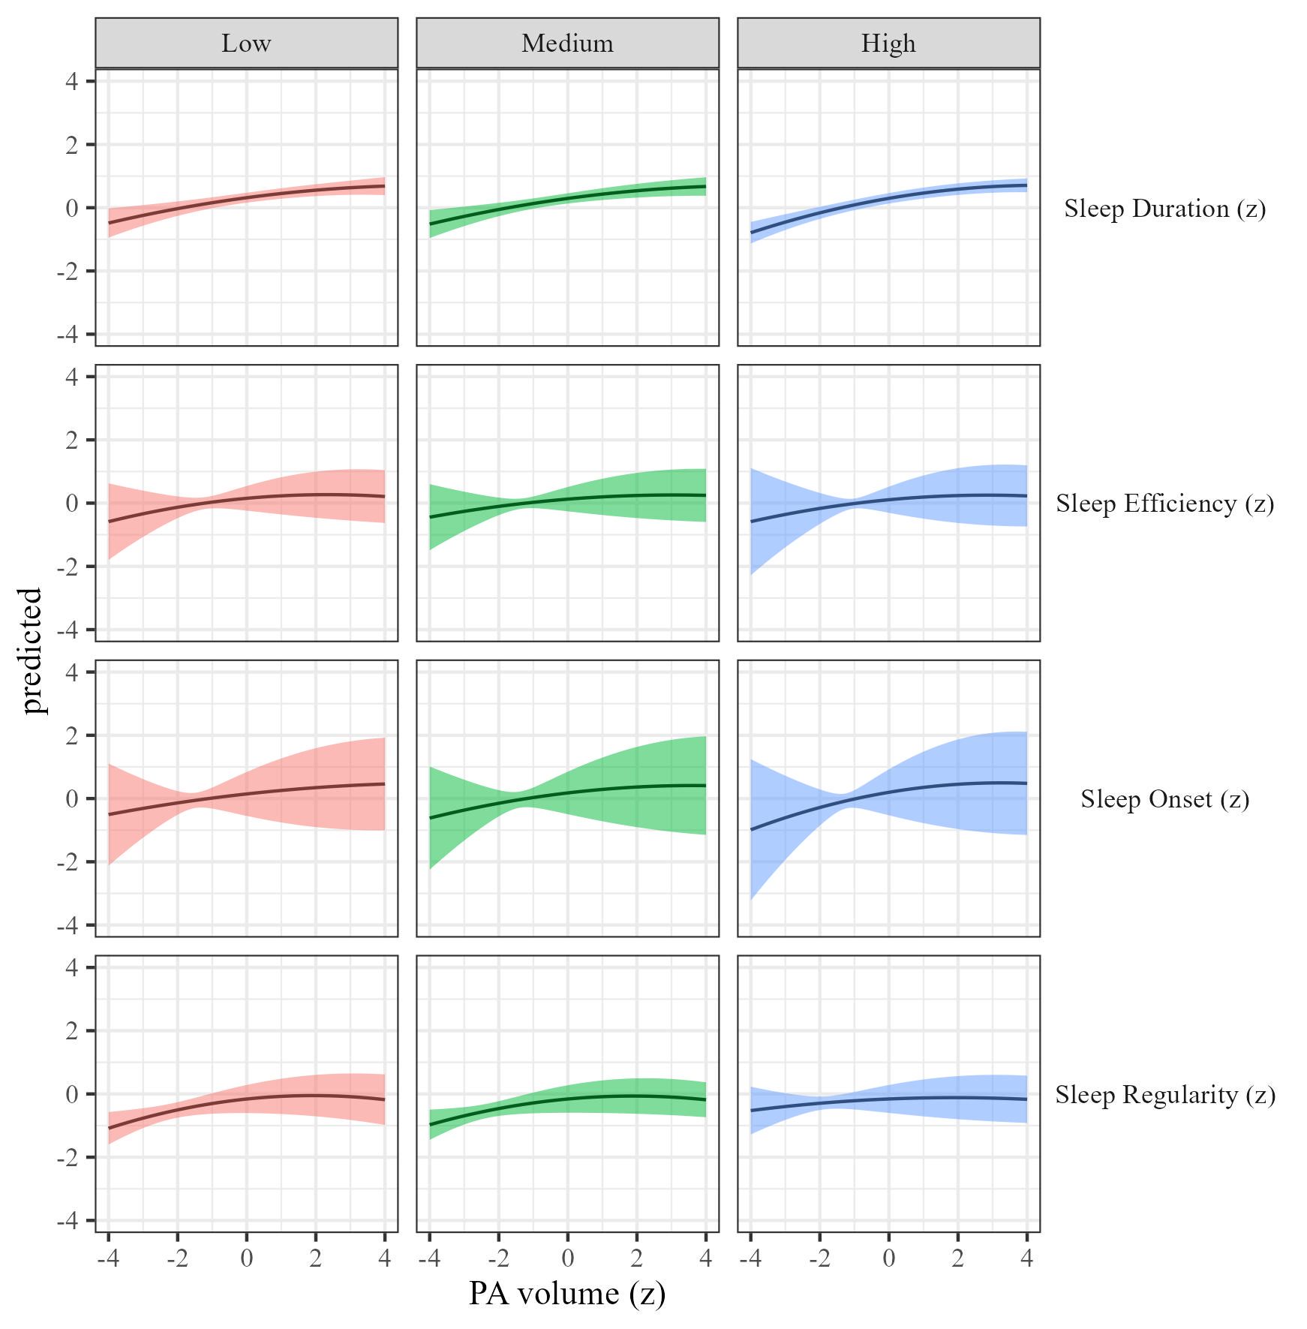

Figure 13: Sleep metrics on Physical activity volume by SES

### The effects of physical activity intensity on sleep by SES.

We estimated how physical activity intensity affects sleep across SES We present the results in Table 5 and Figure 14.

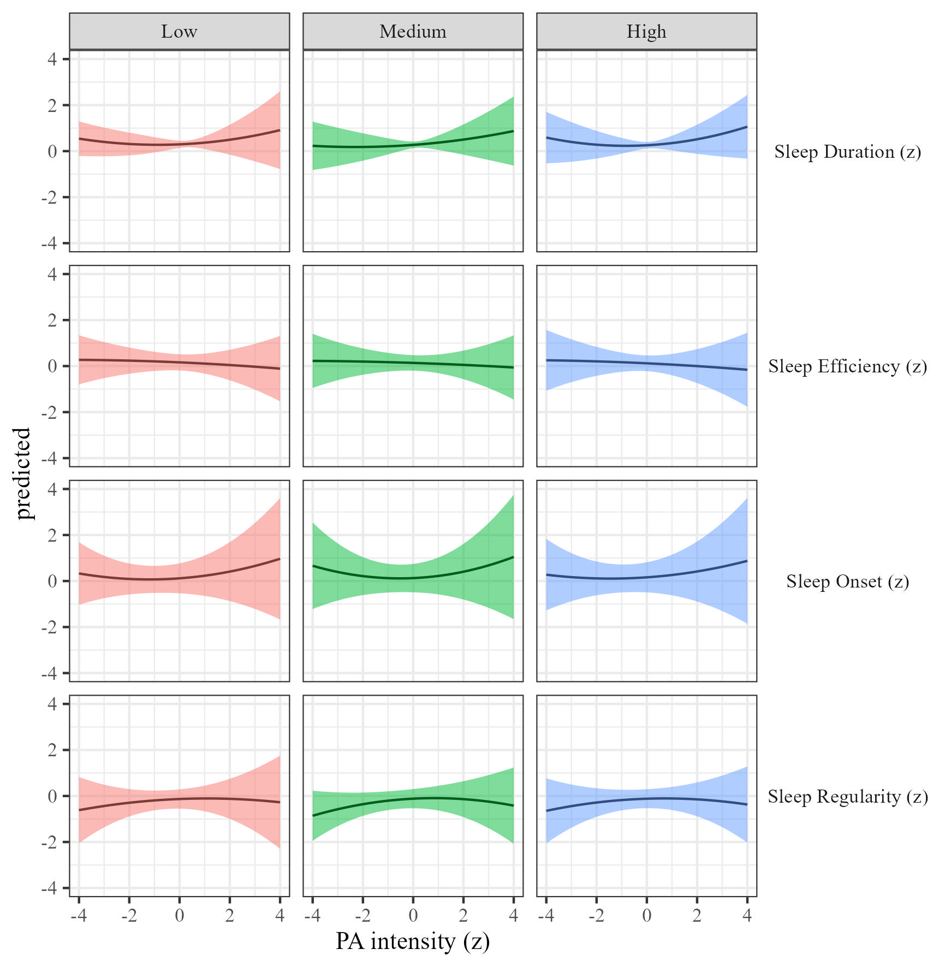

Figure 14: Sleep metrics on Physical activity intensity moderated by SES

### The effects of sleep duration on physical activity.

We estimated the effect of sleep duration on physical activity by SES Results, controlling for sex, SES, and BMI are presented in Table 2 and Figure 15.

Table 6:

*Sleep on physical activity controlling for SES, gender and BMI*

| Term | $β$ [95% CI] | SE | t | p | $β$ [95% CI] | SE | t | p |
| --- | --- | --- | --- | --- | --- | --- | --- | --- |
| Sleep duration |  |  |  |  |  |  |  |  |
| (Intercept) | 1.45 [0.94, 1.97] | 0.26 | 5.51 | .002 | 1.06 [0.50, 1.61] | 0.28 | 3.72 | .043 |
| Sleep duration | -0.03 [-0.08, 0.03] | 0.03 | -0.85 | .457 | 0.00 [-0.06, 0.06] | 0.03 | 0.08 | .942 |
| Sleep duration $​^{2}$ | 0.01 [-0.01, 0.04] | 0.01 | 0.96 | .400 | -0.02 [-0.09, 0.06] | 0.04 | -0.48 | .677 |
| Age | -0.02 [-0.02, -0.01] | 0.00 | -8.26 | < .001 | -0.02 [-0.02, -0.01] | 0.00 | -12.11 | < .001 |
| Sleep duration $×$ sesmedium | 0.00 [-0.06, 0.06] | 0.03 | 0.09 | .930 | 0.00 [-0.08, 0.08] | 0.04 | -0.01 | .992 |
| Sleep duration $×$ seshigh | 0.02 [-0.02, 0.06] | 0.02 | 1.08 | .286 | 0.00 [-0.05, 0.05] | 0.03 | -0.06 | .954 |
| Sleep efficency |  |  |  |  |  |  |  |  |
| (Intercept) | 1.45 [0.92, 1.98] | 0.27 | 5.35 | .003 | 1.04 [0.44, 1.63] | 0.30 | 3.41 | .054 |
| Sleep efficiency | 0.02 [-0.02, 0.07] | 0.02 | 0.99 | .335 | -0.01 [-0.08, 0.06] | 0.03 | -0.32 | .769 |
| Sleep efficiency $​^{2}$ | 0.01 [-0.01, 0.03] | 0.01 | 1.40 | .215 | 0.00 [-0.04, 0.04] | 0.02 | -0.01 | .996 |
| Age | -0.02 [-0.02, -0.01] | 0.00 | -8.06 | < .001 | -0.02 [-0.02, -0.01] | 0.00 | -11.97 | < .001 |
| Sleep efficiency $×$ sesmedium | 0.00 [-0.06, 0.06] | 0.03 | 0.05 | .964 | 0.04 [0.00, 0.08] | 0.02 | 1.81 | .072 |
| Sleep efficiency $×$ seshigh | -0.03 [-0.10, 0.04] | 0.03 | -0.91 | .379 | -0.01 [-0.05, 0.04] | 0.02 | -0.34 | .733 |
| Sleep onset |  |  |  |  |  |  |  |  |
| (Intercept) | 1.48 [0.94, 2.02] | 0.28 | 5.36 | .003 | 1.04 [0.41, 1.66] | 0.32 | 3.25 | .061 |
| Sleep onset | -0.03 [-0.08, 0.02] | 0.02 | -1.18 | .282 | 0.00 [-0.04, 0.04] | 0.02 | -0.10 | .921 |
| Sleep onset $​^{2}$ | -0.02 [-0.06, 0.02] | 0.02 | -1.05 | .367 | 0.00 [-0.02, 0.02] | 0.01 | 0.09 | .930 |
| Age | -0.02 [-0.02, -0.01] | 0.00 | -8.20 | < .001 | -0.02 [-0.02, -0.01] | 0.00 | -12.02 | < .001 |
| Sleep onset $×$ sesmedium | 0.00 [-0.04, 0.04] | 0.02 | -0.07 | .941 | 0.00 [-0.04, 0.03] | 0.02 | -0.21 | .837 |
| Sleep onset $×$ seshigh | -0.02 [-0.06, 0.02] | 0.02 | -0.87 | .386 | 0.00 [-0.06, 0.06] | 0.03 | -0.05 | .965 |
| Sleep regularity |  |  |  |  |  |  |  |  |
| (Intercept) | 1.37 [0.86, 1.87] | 0.26 | 5.30 | .003 | 1.00 [0.46, 1.55] | 0.28 | 3.59 | .045 |
| Sleep regularity | 0.08 [0.02, 0.13] | 0.03 | 2.85 | .050 | 0.03 [-0.04, 0.10] | 0.04 | 0.86 | .464 |
| Sleep regularity $​^{2}$ | 0.02 [-0.03, 0.07] | 0.03 | 0.69 | .547 | 0.00 [-0.03, 0.04] | 0.02 | 0.08 | .945 |
| Age | -0.02 [-0.02, -0.01] | 0.00 | -8.05 | < .001 | -0.02 [-0.02, -0.01] | 0.00 | -11.76 | < .001 |
| Sleep regularity $×$ sesmedium | 0.01 [-0.04, 0.05] | 0.02 | 0.23 | .825 | 0.01 [-0.06, 0.08] | 0.04 | 0.25 | .819 |
| Sleep regularity $×$ seshigh | 0.02 [-0.03, 0.07] | 0.02 | 0.77 | .460 | 0.01 [-0.05, 0.07] | 0.03 | 0.36 | .738 |

*Note.* Adjusted for SES, BMI, and sex.

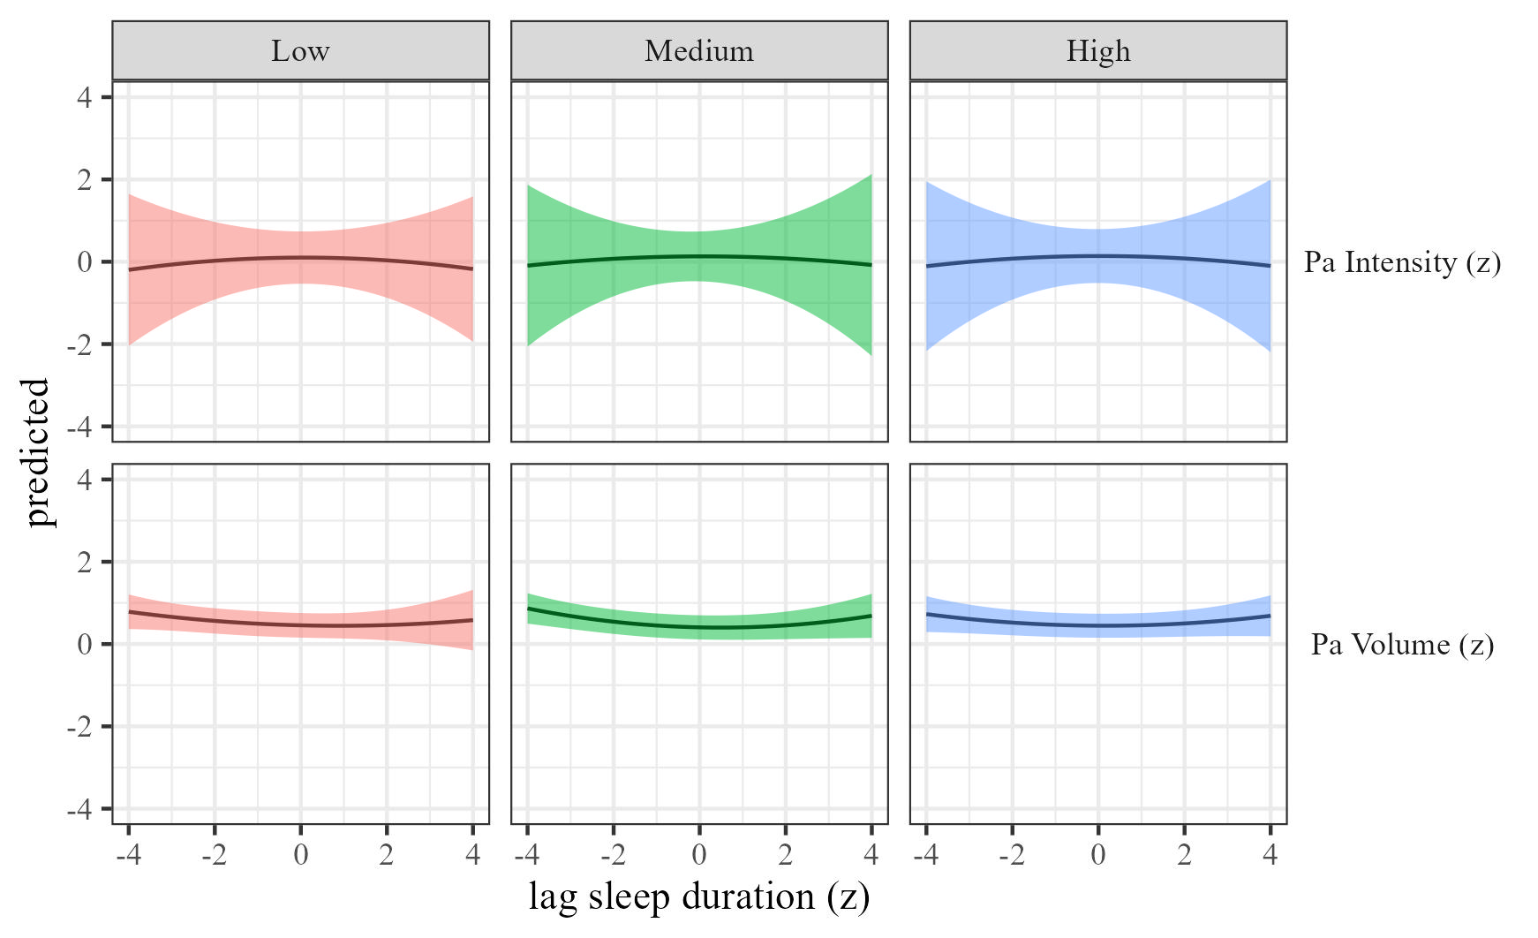

Figure 15: Physical activty by sleep duration moderated by SES

### The effects of sleep efficiency on physical activity.

We estimated the effect of sleep efficiency on physical activity by SES. Results, controlling for sex, SES, and BMI are presented in Table 6 and Figure 16.

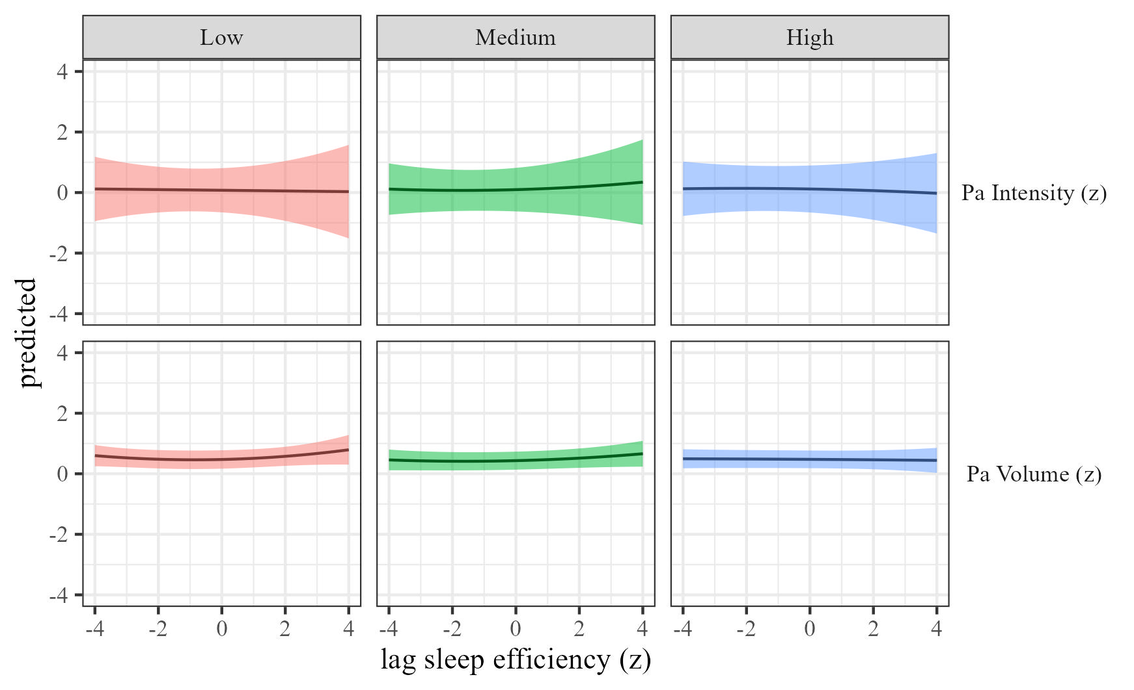

Figure 16: Physical activty by sleep efficiency moderated by SES

### The effects of sleep onset on physical activity.

We estimated the effect of sleep onset on physical activity by SES Results, controlling for sex, SES, and BMI are presented in Table 2 and Figure 17.

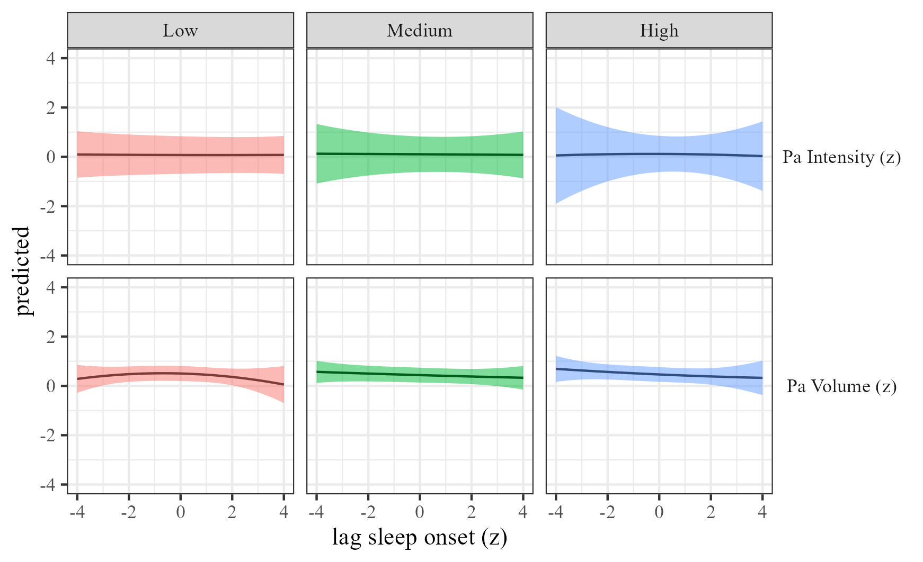

Figure 17: Physical activty by sleep onset moderated by SES

### The effects of sleep regularity on physical activity.

We estimated the effect of sleep regularity on physical activity by SES. Results are presented in Table 2 and Figure 18.

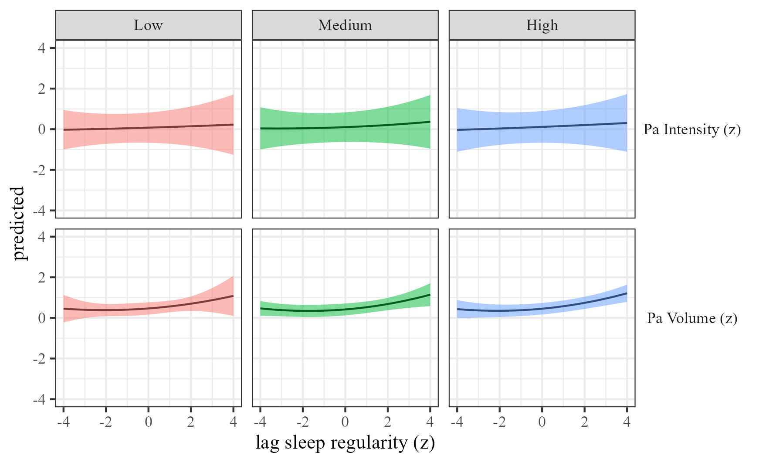 ## sex

### The effects of physical activity volume on sleep.

We estimated the effects of physical activity on sleep (RQ1) using mixed-effects models We estimated the effect of physical activity volume on sleep by sex, and the results are presented in Table 7 and Figure 19

Table 7:

*Physical activity on sleep controlling for SES, gender and BMI*

| Term | $β$ [95% CI] | SE | t | p | $β$ [95% CI] | SE | t | p |
| --- | --- | --- | --- | --- | --- | --- | --- | --- |
| Sleep duration |  |  |  |  |  |  |  |  |
| (Intercept) | 0.43 [0.15, 0.72] | 0.15 | 2.96 | .016 | 0.50 [-0.06, 1.07] | 0.29 | 1.76 | .191 |
| Physical activity | 0.16 [0.10, 0.23] | 0.03 | 4.99 | .009 | 0.06 [-0.21, 0.33] | 0.14 | 0.44 | .703 |
| Physical activity $​^{2}$ | -0.01 [-0.02, 0.00] | 0.01 | -2.43 | .015 | 0.04 [-0.01, 0.09] | 0.03 | 1.69 | .204 |
| Age | 0.00 [-0.01, 0.00] | 0.00 | -1.29 | .201 | 0.00 [-0.01, 0.00] | 0.00 | -1.26 | .285 |
| Physical activity $×$ sexmale | 0.00 [-0.07, 0.07] | 0.04 | -0.01 | .994 | 0.01 [-0.06, 0.07] | 0.03 | 0.19 | .858 |
| Sleep efficency |  |  |  |  |  |  |  |  |
| (Intercept) | 0.11 [-0.16, 0.38] | 0.14 | 0.81 | .440 | 0.25 [-0.22, 0.71] | 0.24 | 1.04 | .375 |
| Physical activity | 0.07 [-0.23, 0.37] | 0.15 | 0.45 | .696 | -0.08 [-0.24, 0.08] | 0.08 | -0.96 | .435 |
| Physical activity $​^{2}$ | -0.02 [-0.06, 0.02] | 0.02 | -0.82 | .492 | -0.01 [-0.08, 0.06] | 0.03 | -0.24 | .832 |
| Age | 0.00 [0.00, 0.01] | 0.00 | 1.50 | .177 | 0.00 [0.00, 0.01] | 0.00 | 0.60 | .562 |
| Physical activity $×$ sexmale | 0.05 [-0.03, 0.13] | 0.04 | 1.31 | .266 | 0.06 [-0.04, 0.17] | 0.05 | 1.19 | .339 |
| Sleep onset |  |  |  |  |  |  |  |  |
| (Intercept) | -0.17 [-0.48, 0.14] | 0.16 | -1.10 | .285 | -0.14 [-0.60, 0.31] | 0.23 | -0.62 | .562 |
| Physical activity | 0.18 [-0.30, 0.66] | 0.24 | 0.75 | .533 | 0.08 [-0.10, 0.27] | 0.09 | 0.89 | .464 |
| Physical activity $​^{2}$ | -0.02 [-0.08, 0.03] | 0.03 | -0.90 | .461 | 0.05 [-0.08, 0.17] | 0.06 | 0.70 | .554 |
| Age | 0.00 [0.00, 0.01] | 0.00 | 0.82 | .466 | 0.00 [0.00, 0.00] | 0.00 | 0.64 | .529 |
| Physical activity $×$ sexmale | -0.07 [-0.20, 0.06] | 0.07 | -1.08 | .381 | -0.04 [-0.13, 0.05] | 0.05 | -0.82 | .487 |
| Sleep regularity |  |  |  |  |  |  |  |  |
| (Intercept) | 0.25 [-0.27, 0.76] | 0.26 | 0.93 | .419 | 0.28 [-0.28, 0.84] | 0.29 | 0.99 | .398 |
| Physical activity | 0.06 [-0.11, 0.22] | 0.09 | 0.66 | .572 | 0.02 [-0.07, 0.10] | 0.04 | 0.36 | .749 |
| Physical activity $​^{2}$ | -0.02 [-0.04, 0.00] | 0.01 | -1.97 | .140 | -0.03 [-0.11, 0.05] | 0.04 | -0.69 | .557 |
| Age | 0.00 [-0.01, 0.00] | 0.00 | -0.24 | .818 | 0.00 [0.00, 0.00] | 0.00 | -0.16 | .876 |
| Physical activity $×$ sexmale | 0.05 [-0.01, 0.11] | 0.03 | 1.67 | .149 | 0.06 [0.00, 0.11] | 0.03 | 1.93 | .131 |

*Note.* Adjusted for SES, BMI, and sex.

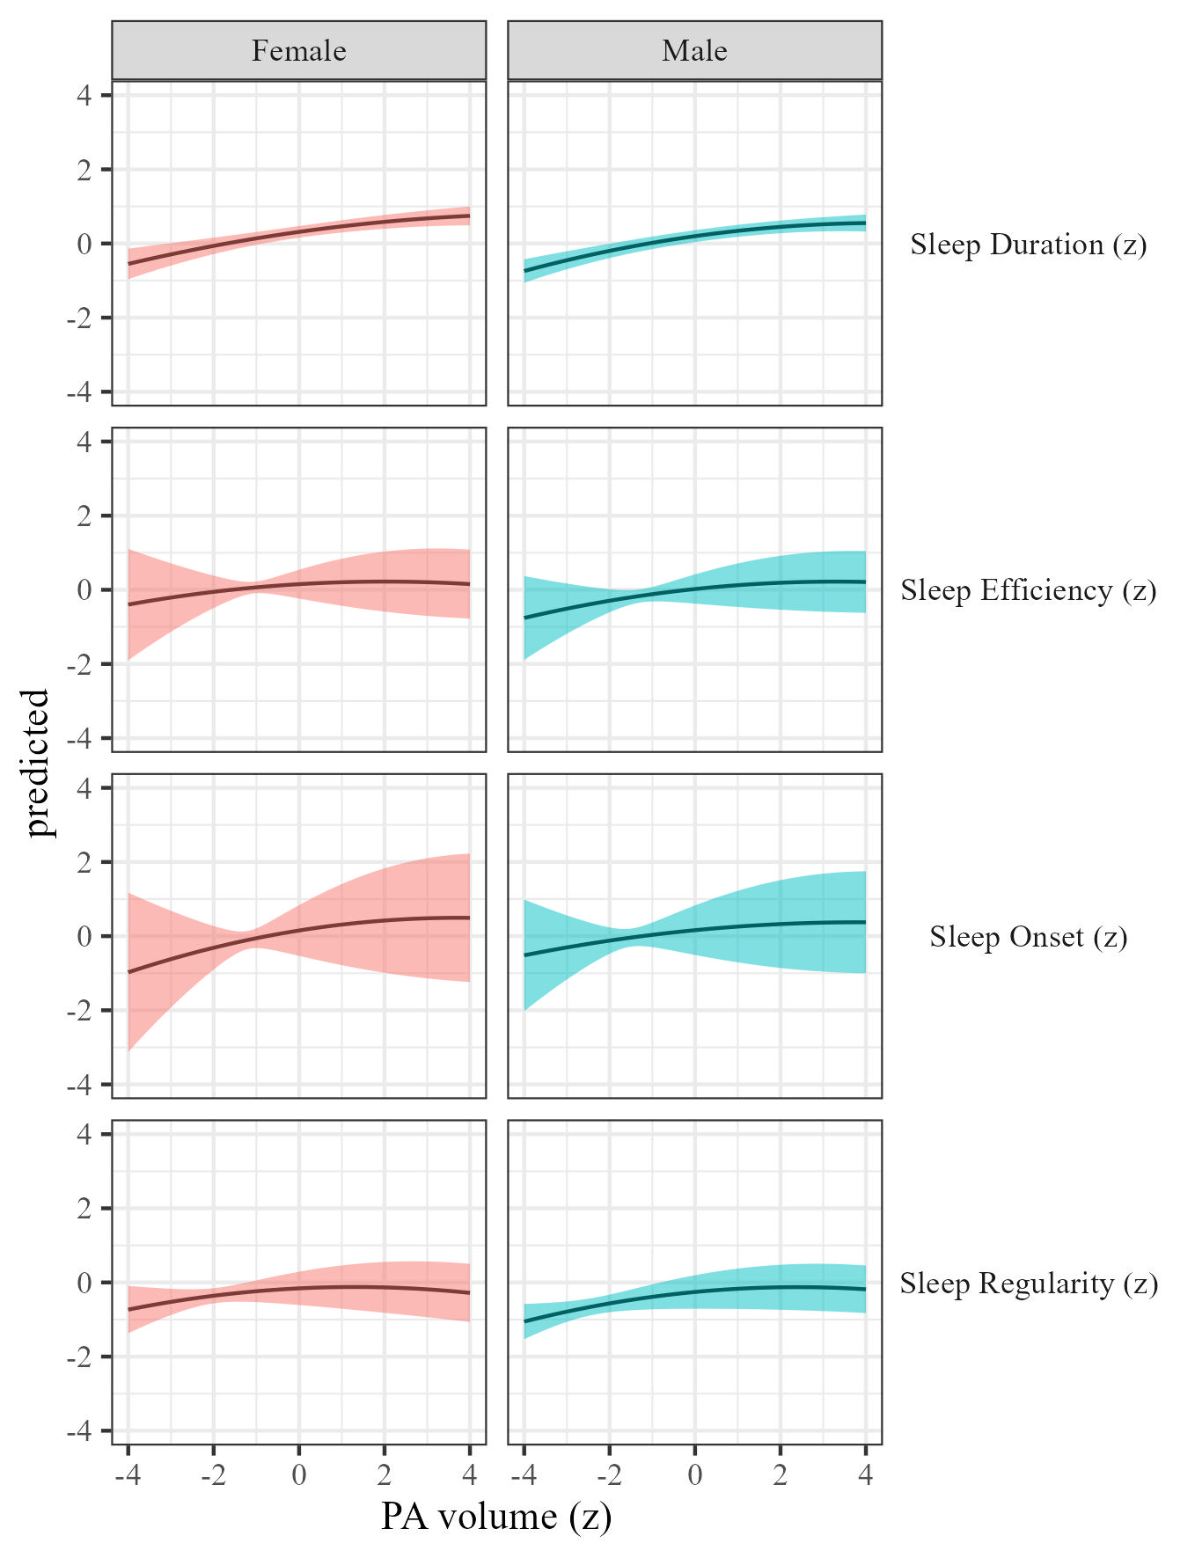

Figure 19: Sleep metrics on Physical activity volume by sex

### The effects of physical activity intensity on sleep by sex.

We estimated how physical activity intensity affects sleep across sex We present the results in Table 7 and Figure 20.

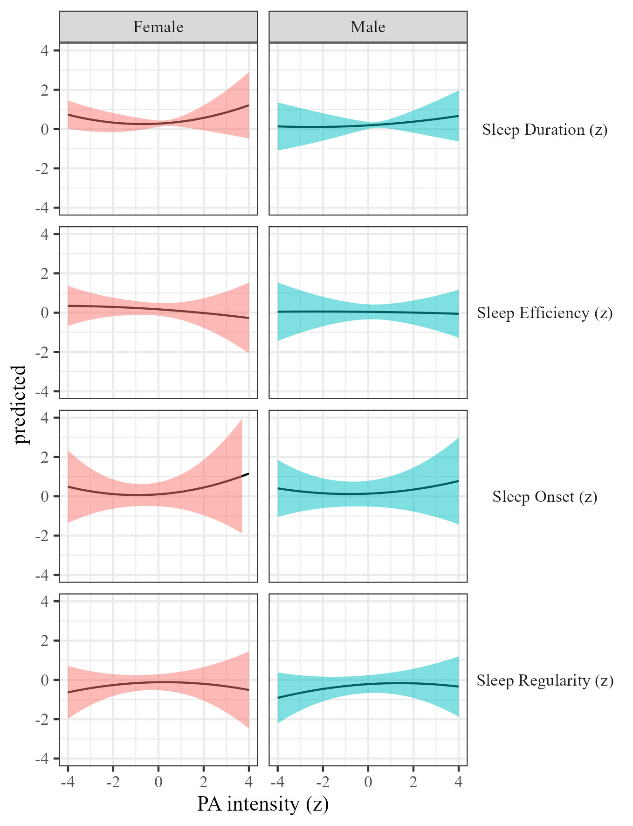

Figure 20: Sleep metrics on Physical activity intensity moderated by sex

### The effects of sleep duration on physical activity.

We estimated the effect of sleep duration on physical activity by sex Results, controlling for sex, SES, and BMI are presented in Table 2 and Figure 21.

Table 8:

*Sleep on physical activity controlling for SES, gender and BMI*

| Term | $β$ [95% CI] | SE | t | p | $β$ [95% CI] | SE | t | p |
| --- | --- | --- | --- | --- | --- | --- | --- | --- |
| Sleep duration |  |  |  |  |  |  |  |  |
| (Intercept) | 1.45 [0.95, 1.95] | 0.25 | 5.68 | .001 | 1.04 [0.49, 1.59] | 0.28 | 3.69 | .043 |
| Sleep duration | -0.03 [-0.06, 0.00] | 0.02 | -1.88 | .112 | 0.00 [-0.05, 0.05] | 0.02 | -0.06 | .956 |
| Sleep duration $​^{2}$ | 0.02 [0.00, 0.04] | 0.01 | 1.69 | .188 | -0.01 [-0.09, 0.07] | 0.04 | -0.20 | .862 |
| Age | -0.02 [-0.02, -0.01] | 0.00 | -8.25 | < .001 | -0.02 [-0.02, -0.01] | 0.00 | -12.13 | < .001 |
| Sleep duration $×$ sexmale | 0.02 [-0.01, 0.06] | 0.02 | 1.30 | .218 | 0.01 [-0.05, 0.06] | 0.03 | 0.24 | .828 |
| Sleep efficency |  |  |  |  |  |  |  |  |
| (Intercept) | 1.45 [0.92, 1.98] | 0.27 | 5.38 | .003 | 1.04 [0.43, 1.64] | 0.31 | 3.36 | .056 |
| Sleep efficiency | 0.03 [0.00, 0.06] | 0.02 | 2.03 | .042 | 0.00 [-0.08, 0.09] | 0.04 | 0.03 | .981 |
| Sleep efficiency $​^{2}$ | 0.01 [0.00, 0.02] | 0.00 | 1.85 | .065 | 0.00 [-0.03, 0.03] | 0.01 | 0.02 | .986 |
| Age | -0.02 [-0.02, -0.01] | 0.00 | -8.12 | < .001 | -0.02 [-0.02, -0.01] | 0.00 | -11.99 | < .001 |
| Sleep efficiency $×$ sexmale | -0.03 [-0.08, 0.01] | 0.02 | -1.42 | .161 | 0.00 [-0.07, 0.07] | 0.03 | 0.02 | .988 |
| Sleep onset |  |  |  |  |  |  |  |  |
| (Intercept) | 1.46 [0.93, 1.99] | 0.27 | 5.39 | .003 | 1.03 [0.43, 1.63] | 0.30 | 3.38 | .055 |
| Sleep onset | -0.01 [-0.05, 0.03] | 0.02 | -0.54 | .614 | -0.02 [-0.08, 0.04] | 0.03 | -0.58 | .606 |
| Sleep onset $​^{2}$ | 0.00 [-0.02, 0.02] | 0.01 | -0.12 | .910 | 0.00 [-0.03, 0.04] | 0.02 | 0.10 | .926 |
| Age | -0.02 [-0.02, -0.01] | 0.00 | -8.10 | < .001 | -0.02 [-0.02, -0.01] | 0.00 | -11.87 | < .001 |
| Sleep onset $×$ sexmale | -0.04 [-0.07, -0.01] | 0.02 | -2.75 | .006 | 0.03 [-0.01, 0.06] | 0.02 | 1.47 | .183 |
| Sleep regularity |  |  |  |  |  |  |  |  |
| (Intercept) | 1.36 [0.84, 1.88] | 0.26 | 5.15 | .003 | 1.00 [0.44, 1.55] | 0.28 | 3.53 | .047 |
| Sleep regularity | 0.08 [0.04, 0.13] | 0.02 | 3.57 | .035 | 0.03 [0.00, 0.06] | 0.02 | 1.97 | .118 |
| Sleep regularity $​^{2}$ | 0.03 [0.01, 0.05] | 0.01 | 2.78 | .026 | 0.00 [-0.02, 0.03] | 0.01 | 0.30 | .784 |
| Age | -0.02 [-0.02, -0.01] | 0.00 | -8.00 | < .001 | -0.02 [-0.02, -0.01] | 0.00 | -11.78 | < .001 |
| Sleep regularity $×$ sexmale | 0.01 [-0.03, 0.04] | 0.02 | 0.31 | .760 | 0.02 [-0.03, 0.06] | 0.02 | 0.63 | .569 |

*Note.* Adjusted for SES, BMI, and sex.

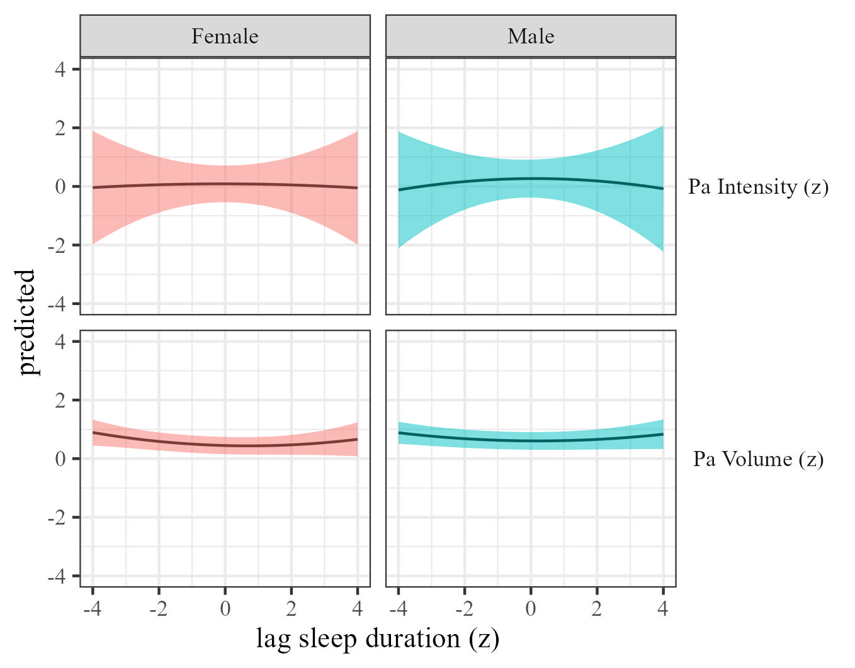

Figure 21: Physical activty by sleep duration moderated by sex

### The effects of sleep efficiency on physical activity.

We estimated the effect of sleep efficiency on physical activity by sex. Results, controlling for sex, SES, and BMI are presented in Table 8 and Figure 22.

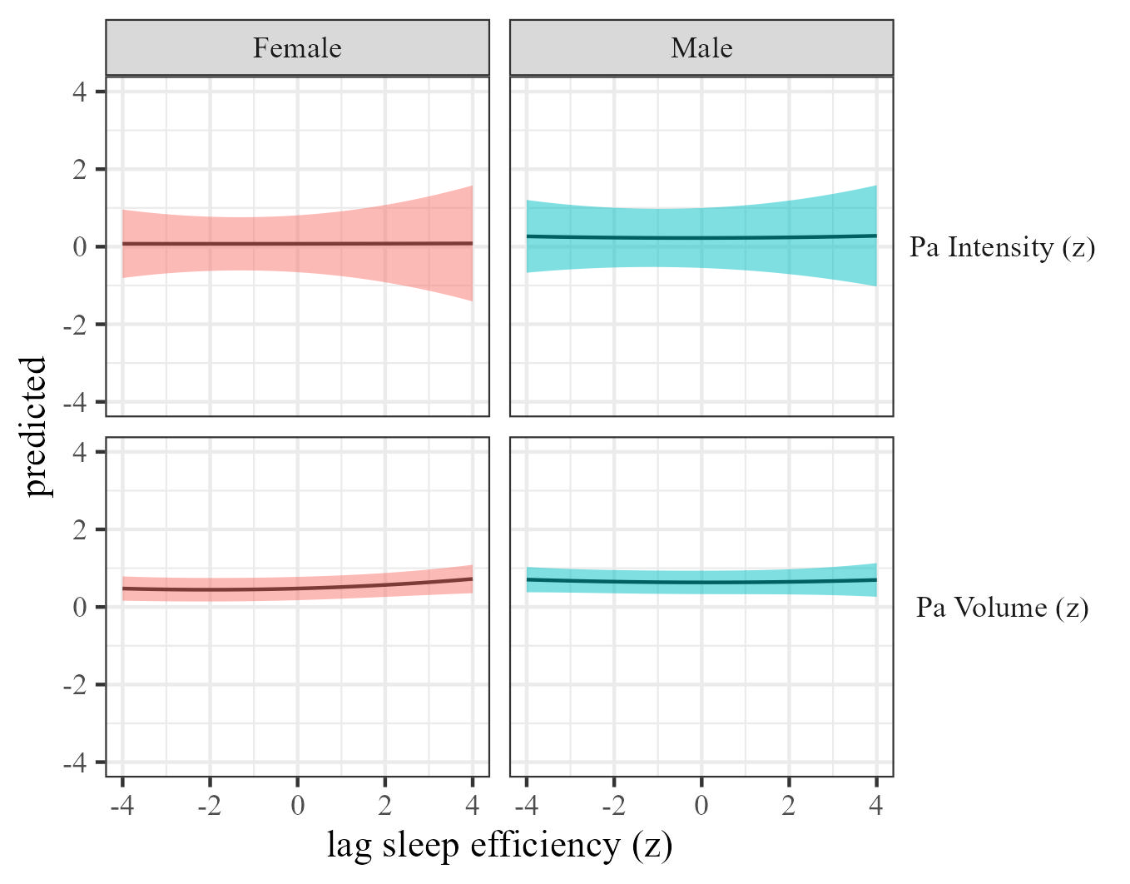

Figure 22: Physical activty by sleep efficiency moderated by sex

### The effects of sleep onset on physical activity.

We estimated the effect of sleep onset on physical activity by sex Results, controlling for sex, SES, and BMI are presented in Table 2 and Figure 23.

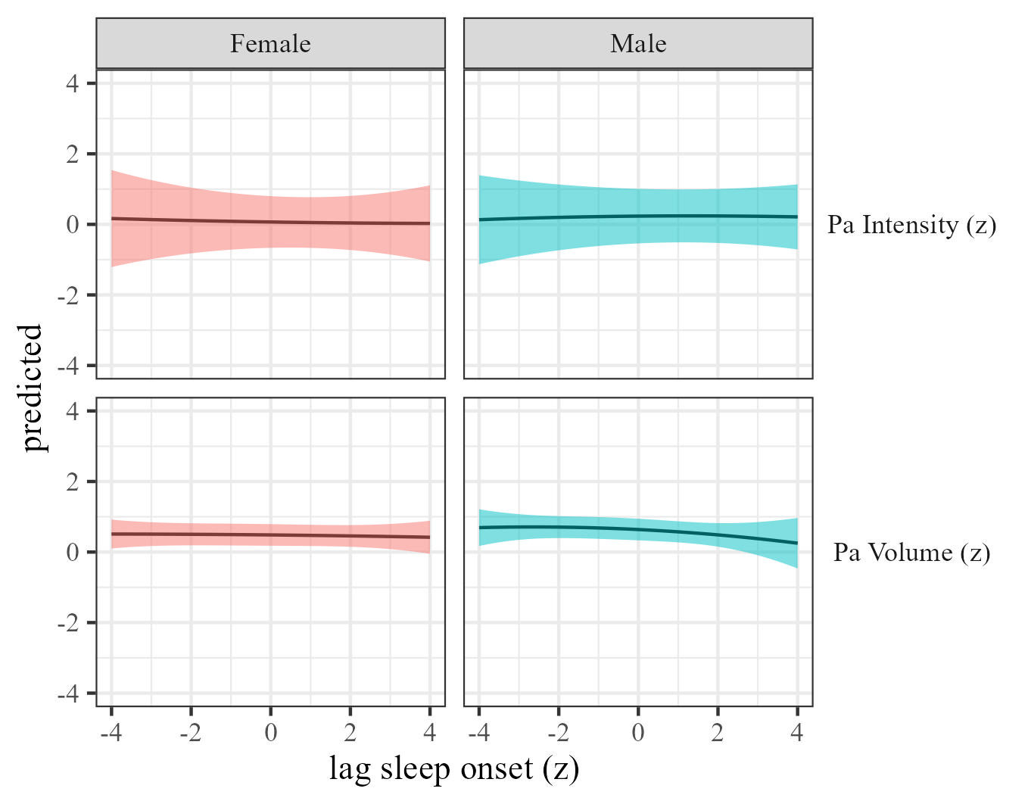

Figure 23: Physical activty by sleep onset moderated by sex

### The effects of sleep regularity on physical activity.

We estimated the effect of sleep regularity on physical activity by sex. Results are presented in Table 2 and Figure 24.

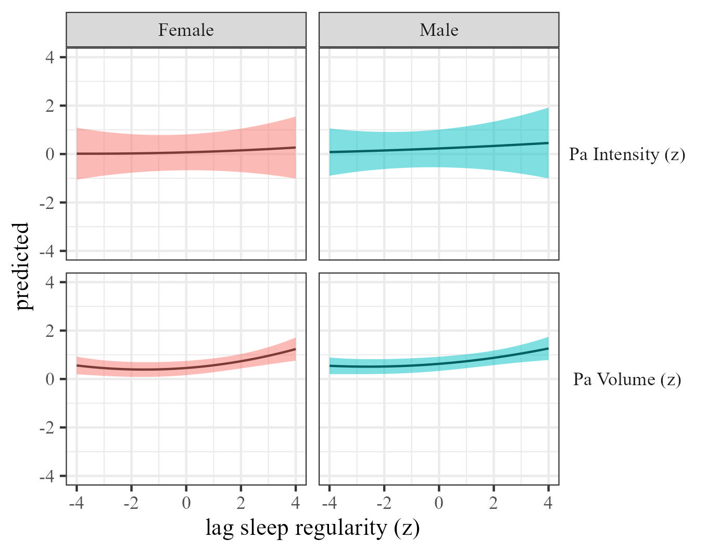 ## weekday

### The effects of physical activity volume on sleep.

We estimated the effects of physical activity on sleep (RQ1) using mixed-effects models We estimated the effect of physical activity volume on sleep by weekday, and the results are presented in Table 9 and Figure 25

Table 9:

*Physical activity on sleep controlling for SES, gender and BMI*

| Term | $β$ [95% CI] | SE | t | p | $β$ [95% CI] | SE | t | p |
| --- | --- | --- | --- | --- | --- | --- | --- | --- |
| Sleep duration |  |  |  |  |  |  |  |  |
| (Intercept) | 0.38 [0.08, 0.68] | 0.15 | 2.50 | .039 | 0.46 [-0.10, 1.02] | 0.29 | 1.62 | .218 |
| Physical activity | 0.13 [0.05, 0.22] | 0.04 | 3.03 | .028 | 0.07 [-0.20, 0.34] | 0.14 | 0.49 | .671 |
| Weekday xmonday | 0.02 [-0.04, 0.09] | 0.03 | 0.72 | .476 | 0.01 [-0.07, 0.09] | 0.04 | 0.32 | .753 |
| Weekday xsaturday | 0.10 [0.04, 0.16] | 0.03 | 3.13 | .003 | 0.10 [0.03, 0.17] | 0.03 | 2.86 | .004 |
| Weekday xsunday | 0.10 [0.04, 0.17] | 0.03 | 3.28 | .001 | 0.09 [0.01, 0.17] | 0.04 | 2.20 | .041 |
| Weekday xthursday | -0.01 [-0.07, 0.05] | 0.03 | -0.28 | .777 | 0.00 [-0.07, 0.07] | 0.03 | -0.07 | .948 |
| Weekday xtuesday | -0.01 [-0.08, 0.06] | 0.03 | -0.23 | .819 | -0.03 [-0.10, 0.04] | 0.04 | -0.85 | .397 |
| Weekday xwednesday | 0.02 [-0.05, 0.08] | 0.03 | 0.50 | .614 | -0.01 [-0.09, 0.07] | 0.04 | -0.27 | .792 |
| Physical activity $​^{2}$ | -0.01 [-0.03, 0.01] | 0.01 | -1.12 | .261 | 0.03 [-0.01, 0.07] | 0.02 | 1.63 | .138 |
| Age | 0.00 [-0.01, 0.00] | 0.00 | -1.20 | .232 | 0.00 [-0.01, 0.00] | 0.00 | -1.18 | .310 |
| Physical activity $×$ weekday xmonday | 0.03 [-0.05, 0.11] | 0.04 | 0.78 | .442 | 0.01 [-0.05, 0.06] | 0.03 | 0.26 | .797 |
| Physical activity $×$ weekday xsaturday | 0.03 [-0.05, 0.11] | 0.04 | 0.74 | .465 | -0.04 [-0.09, 0.02] | 0.03 | -1.34 | .185 |
| Physical activity $×$ weekday xsunday | 0.07 [-0.01, 0.16] | 0.04 | 1.69 | .109 | -0.02 [-0.08, 0.05] | 0.03 | -0.45 | .665 |
| Physical activity $×$ weekday xthursday | 0.03 [-0.06, 0.13] | 0.05 | 0.70 | .500 | 0.01 [-0.05, 0.07] | 0.03 | 0.25 | .806 |
| Physical activity $×$ weekday xtuesday | 0.04 [-0.05, 0.12] | 0.05 | 0.78 | .451 | 0.01 [-0.06, 0.07] | 0.03 | 0.23 | .825 |
| Physical activity $×$ weekday xwednesday | 0.03 [-0.06, 0.12] | 0.05 | 0.62 | .545 | 0.01 [-0.06, 0.09] | 0.04 | 0.38 | .717 |
| Weekday xmonday $×$ Physical activity $​^{2}$ | 0.00 [-0.02, 0.02] | 0.01 | 0.01 | .994 | 0.00 [-0.05, 0.05] | 0.03 | -0.08 | .942 |
| Weekday xsaturday $×$ Physical activity $​^{2}$ | -0.02 [-0.04, 0.01] | 0.01 | -1.33 | .185 | -0.02 [-0.09, 0.06] | 0.04 | -0.47 | .665 |
| Weekday xsunday $×$ Physical activity $​^{2}$ | -0.01 [-0.04, 0.01] | 0.01 | -0.97 | .336 | -0.01 [-0.05, 0.03] | 0.02 | -0.50 | .617 |
| Weekday xthursday $×$ Physical activity $​^{2}$ | -0.01 [-0.03, 0.02] | 0.01 | -0.39 | .695 | -0.01 [-0.06, 0.03] | 0.02 | -0.50 | .622 |
| Weekday xtuesday $×$ Physical activity $​^{2}$ | -0.01 [-0.03, 0.02] | 0.01 | -0.58 | .564 | 0.01 [-0.03, 0.06] | 0.02 | 0.59 | .558 |
| Weekday xwednesday $×$ Physical activity $​^{2}$ | -0.01 [-0.04, 0.02] | 0.02 | -0.73 | .478 | 0.00 [-0.05, 0.05] | 0.03 | 0.16 | .879 |
| Sleep efficency |  |  |  |  |  |  |  |  |
| (Intercept) | 0.08 [-0.17, 0.34] | 0.13 | 0.63 | .540 | 0.24 [-0.23, 0.71] | 0.24 | 0.99 | .394 |
| Physical activity | 0.07 [-0.18, 0.32] | 0.13 | 0.55 | .635 | -0.06 [-0.21, 0.10] | 0.08 | -0.72 | .541 |
| Weekday xmonday | 0.03 [-0.03, 0.10] | 0.03 | 1.06 | .296 | 0.00 [-0.07, 0.06] | 0.03 | -0.11 | .913 |
| Weekday xsaturday | -0.03 [-0.08, 0.03] | 0.03 | -1.00 | .319 | -0.05 [-0.12, 0.01] | 0.03 | -1.68 | .092 |
| Weekday xsunday | -0.03 [-0.08, 0.03] | 0.03 | -0.84 | .405 | -0.08 [-0.14, -0.01] | 0.03 | -2.36 | .019 |
| Weekday xthursday | -0.02 [-0.08, 0.05] | 0.04 | -0.46 | .654 | -0.02 [-0.08, 0.05] | 0.03 | -0.46 | .643 |
| Weekday xtuesday | 0.00 [-0.06, 0.06] | 0.03 | -0.02 | .986 | -0.01 [-0.09, 0.07] | 0.04 | -0.23 | .824 |
| Weekday xwednesday | 0.03 [-0.03, 0.09] | 0.03 | 0.97 | .338 | 0.01 [-0.05, 0.07] | 0.03 | 0.31 | .756 |
| Physical activity $​^{2}$ | -0.01 [-0.05, 0.03] | 0.02 | -0.46 | .681 | -0.01 [-0.05, 0.04] | 0.02 | -0.35 | .742 |
| Age | 0.00 [0.00, 0.01] | 0.00 | 1.53 | .171 | 0.00 [0.00, 0.01] | 0.00 | 0.62 | .549 |
| Physical activity $×$ weekday xmonday | 0.02 [-0.05, 0.09] | 0.04 | 0.59 | .558 | 0.04 [-0.02, 0.09] | 0.03 | 1.36 | .175 |
| Physical activity $×$ weekday xsaturday | 0.08 [0.00, 0.16] | 0.04 | 1.96 | .066 | -0.01 [-0.08, 0.07] | 0.04 | -0.17 | .870 |
| Physical activity $×$ weekday xsunday | 0.07 [0.01, 0.14] | 0.03 | 2.12 | .034 | 0.02 [-0.04, 0.08] | 0.03 | 0.61 | .556 |
| Physical activity $×$ weekday xthursday | 0.03 [-0.08, 0.15] | 0.06 | 0.54 | .617 | 0.02 [-0.03, 0.08] | 0.03 | 0.79 | .439 |
| Physical activity $×$ weekday xtuesday | 0.00 [-0.07, 0.07] | 0.03 | -0.07 | .944 | 0.01 [-0.04, 0.06] | 0.03 | 0.31 | .756 |
| Physical activity $×$ weekday xwednesday | 0.00 [-0.09, 0.10] | 0.05 | 0.08 | .938 | -0.01 [-0.06, 0.04] | 0.03 | -0.33 | .740 |
| Weekday xmonday $×$ Physical activity $​^{2}$ | -0.01 [-0.03, 0.01] | 0.01 | -0.69 | .491 | 0.01 [-0.02, 0.05] | 0.02 | 0.71 | .481 |
| Weekday xsaturday $×$ Physical activity $​^{2}$ | -0.02 [-0.05, 0.00] | 0.01 | -1.93 | .060 | 0.00 [-0.04, 0.04] | 0.02 | -0.01 | .995 |
| Weekday xsunday $×$ Physical activity $​^{2}$ | -0.03 [-0.06, 0.00] | 0.01 | -1.98 | .059 | 0.01 [-0.03, 0.05] | 0.02 | 0.41 | .685 |
| Weekday xthursday $×$ Physical activity $​^{2}$ | -0.01 [-0.04, 0.02] | 0.02 | -0.70 | .500 | -0.01 [-0.06, 0.04] | 0.03 | -0.38 | .716 |
| Weekday xtuesday $×$ Physical activity $​^{2}$ | 0.00 [-0.02, 0.02] | 0.01 | 0.35 | .724 | 0.01 [-0.03, 0.04] | 0.02 | 0.35 | .729 |
| Weekday xwednesday $×$ Physical activity $​^{2}$ | -0.01 [-0.03, 0.02] | 0.01 | -0.55 | .588 | 0.01 [-0.03, 0.04] | 0.02 | 0.27 | .788 |
| Sleep onset |  |  |  |  |  |  |  |  |
| (Intercept) | -0.16 [-0.45, 0.12] | 0.14 | -1.14 | .257 | -0.11 [-0.56, 0.35] | 0.23 | -0.46 | .665 |
| Physical activity | 0.12 [-0.27, 0.52] | 0.20 | 0.61 | .601 | 0.06 [-0.03, 0.15] | 0.05 | 1.36 | .278 |
| Weekday xmonday | -0.01 [-0.14, 0.12] | 0.07 | -0.11 | .918 | -0.04 [-0.11, 0.03] | 0.04 | -1.02 | .324 |
| Weekday xsaturday | 0.10 [0.01, 0.18] | 0.04 | 2.20 | .093 | 0.08 [0.01, 0.14] | 0.03 | 2.33 | .026 |
| Weekday xsunday | 0.13 [0.00, 0.25] | 0.06 | 1.94 | .158 | 0.07 [0.00, 0.14] | 0.04 | 1.98 | .068 |
| Weekday xthursday | -0.04 [-0.11, 0.03] | 0.04 | -1.05 | .330 | -0.07 [-0.13, -0.01] | 0.03 | -2.36 | .020 |
| Weekday xtuesday | -0.05 [-0.10, 0.00] | 0.03 | -2.00 | .046 | -0.08 [-0.17, 0.01] | 0.04 | -1.77 | .123 |
| Weekday xwednesday | -0.02 [-0.11, 0.07] | 0.05 | -0.46 | .673 | -0.07 [-0.15, 0.02] | 0.04 | -1.50 | .180 |
| Physical activity $​^{2}$ | -0.01 [-0.06, 0.03] | 0.02 | -0.60 | .600 | 0.02 [-0.05, 0.09] | 0.04 | 0.61 | .595 |
| Age | 0.00 [0.00, 0.01] | 0.00 | 0.78 | .487 | 0.00 [0.00, 0.00] | 0.00 | 0.69 | .493 |
| Physical activity $×$ weekday xmonday | -0.01 [-0.08, 0.05] | 0.03 | -0.31 | .758 | 0.01 [-0.10, 0.12] | 0.06 | 0.23 | .837 |
| Physical activity $×$ weekday xsaturday | 0.05 [-0.02, 0.12] | 0.03 | 1.44 | .165 | 0.04 [-0.03, 0.10] | 0.03 | 1.13 | .309 |
| Physical activity $×$ weekday xsunday | 0.04 [-0.04, 0.11] | 0.04 | 1.03 | .323 | 0.01 [-0.07, 0.09] | 0.04 | 0.24 | .823 |
| Physical activity $×$ weekday xthursday | 0.05 [-0.07, 0.16] | 0.06 | 0.85 | .448 | 0.00 [-0.10, 0.11] | 0.05 | 0.03 | .982 |
| Physical activity $×$ weekday xtuesday | 0.02 [-0.05, 0.08] | 0.03 | 0.47 | .643 | -0.01 [-0.06, 0.04] | 0.03 | -0.44 | .664 |
| Physical activity $×$ weekday xwednesday | 0.05 [-0.06, 0.16] | 0.06 | 0.90 | .418 | 0.01 [-0.06, 0.09] | 0.04 | 0.36 | .739 |
| Weekday xmonday $×$ Physical activity $​^{2}$ | 0.00 [-0.02, 0.02] | 0.01 | 0.17 | .869 | 0.01 [-0.04, 0.06] | 0.02 | 0.50 | .637 |
| Weekday xsaturday $×$ Physical activity $​^{2}$ | 0.00 [-0.03, 0.02] | 0.01 | -0.30 | .768 | 0.02 [-0.04, 0.07] | 0.03 | 0.68 | .530 |
| Weekday xsunday $×$ Physical activity $​^{2}$ | -0.02 [-0.05, 0.00] | 0.01 | -1.89 | .064 | 0.02 [-0.03, 0.07] | 0.03 | 0.77 | .481 |
| Weekday xthursday $×$ Physical activity $​^{2}$ | -0.01 [-0.04, 0.02] | 0.01 | -0.90 | .394 | 0.01 [-0.04, 0.07] | 0.03 | 0.53 | .622 |
| Weekday xtuesday $×$ Physical activity $​^{2}$ | 0.00 [-0.02, 0.01] | 0.01 | -0.52 | .604 | 0.02 [-0.04, 0.07] | 0.03 | 0.61 | .573 |
| Weekday xwednesday $×$ Physical activity $​^{2}$ | -0.01 [-0.06, 0.03] | 0.02 | -0.58 | .598 | 0.02 [-0.04, 0.09] | 0.03 | 0.71 | .524 |
| Sleep regularity |  |  |  |  |  |  |  |  |
| (Intercept) | 0.22 [-0.28, 0.73] | 0.26 | 0.86 | .449 | 0.28 [-0.31, 0.88] | 0.30 | 0.94 | .424 |
| Physical activity | 0.07 [-0.08, 0.22] | 0.08 | 0.91 | .442 | 0.00 [-0.08, 0.09] | 0.04 | 0.06 | .955 |
| Weekday xmonday | 0.01 [-0.04, 0.07] | 0.03 | 0.50 | .616 | -0.01 [-0.08, 0.06] | 0.03 | -0.33 | .741 |
| Weekday xsaturday | -0.11 [-0.16, -0.05] | 0.03 | -3.91 | < .001 | -0.12 [-0.19, -0.06] | 0.03 | -3.74 | < .001 |
| Weekday xsunday | -0.13 [-0.19, -0.06] | 0.03 | -3.61 | .003 | -0.18 [-0.24, -0.12] | 0.03 | -5.81 | < .001 |
| Weekday xthursday | 0.16 [0.09, 0.23] | 0.04 | 4.42 | .002 | 0.15 [0.09, 0.22] | 0.03 | 4.81 | < .001 |
| Weekday xtuesday | 0.15 [0.09, 0.22] | 0.03 | 4.77 | < .001 | 0.14 [0.06, 0.21] | 0.04 | 3.66 | .001 |
| Weekday xwednesday | 0.15 [0.09, 0.20] | 0.03 | 5.03 | < .001 | 0.15 [0.06, 0.25] | 0.05 | 3.33 | .013 |
| Physical activity $​^{2}$ | -0.01 [-0.04, 0.01] | 0.01 | -1.33 | .229 | -0.02 [-0.06, 0.01] | 0.02 | -1.24 | .267 |
| Age | 0.00 [-0.01, 0.00] | 0.00 | -0.32 | .760 | 0.00 [0.00, 0.00] | 0.00 | -0.38 | .707 |
| Physical activity $×$ weekday xmonday | 0.06 [-0.01, 0.12] | 0.03 | 1.71 | .087 | 0.08 [0.03, 0.12] | 0.02 | 3.10 | .002 |
| Physical activity $×$ weekday xsaturday | 0.04 [-0.02, 0.11] | 0.03 | 1.23 | .220 | -0.01 [-0.11, 0.08] | 0.05 | -0.25 | .815 |
| Physical activity $×$ weekday xsunday | 0.09 [0.03, 0.16] | 0.03 | 2.74 | .006 | -0.02 [-0.09, 0.06] | 0.04 | -0.50 | .640 |
| Physical activity $×$ weekday xthursday | -0.01 [-0.09, 0.06] | 0.04 | -0.35 | .727 | 0.06 [-0.01, 0.14] | 0.04 | 1.73 | .146 |
| Physical activity $×$ weekday xtuesday | -0.04 [-0.10, 0.03] | 0.03 | -1.11 | .268 | 0.06 [0.00, 0.12] | 0.03 | 1.85 | .096 |
| Physical activity $×$ weekday xwednesday | -0.08 [-0.15, -0.01] | 0.04 | -2.17 | .035 | 0.05 [-0.03, 0.12] | 0.04 | 1.24 | .266 |
| Weekday xmonday $×$ Physical activity $​^{2}$ | -0.01 [-0.03, 0.01] | 0.01 | -1.05 | .294 | 0.00 [-0.05, 0.06] | 0.03 | 0.04 | .966 |
| Weekday xsaturday $×$ Physical activity $​^{2}$ | -0.02 [-0.04, 0.01] | 0.01 | -1.44 | .149 | -0.01 [-0.05, 0.03] | 0.02 | -0.29 | .779 |
| Weekday xsunday $×$ Physical activity $​^{2}$ | -0.03 [-0.06, -0.01] | 0.01 | -2.49 | .019 | 0.00 [-0.03, 0.04] | 0.02 | 0.18 | .854 |
| Weekday xthursday $×$ Physical activity $​^{2}$ | -0.01 [-0.03, 0.02] | 0.01 | -0.49 | .630 | -0.02 [-0.09, 0.05] | 0.04 | -0.50 | .649 |
| Weekday xtuesday $×$ Physical activity $​^{2}$ | 0.01 [-0.01, 0.03] | 0.01 | 0.69 | .490 | 0.00 [-0.07, 0.08] | 0.04 | 0.03 | .977 |
| Weekday xwednesday $×$ Physical activity $​^{2}$ | 0.01 [-0.01, 0.03] | 0.01 | 0.91 | .366 | -0.02 [-0.09, 0.05] | 0.03 | -0.60 | .587 |

*Note.* Adjusted for SES, BMI, and sex.

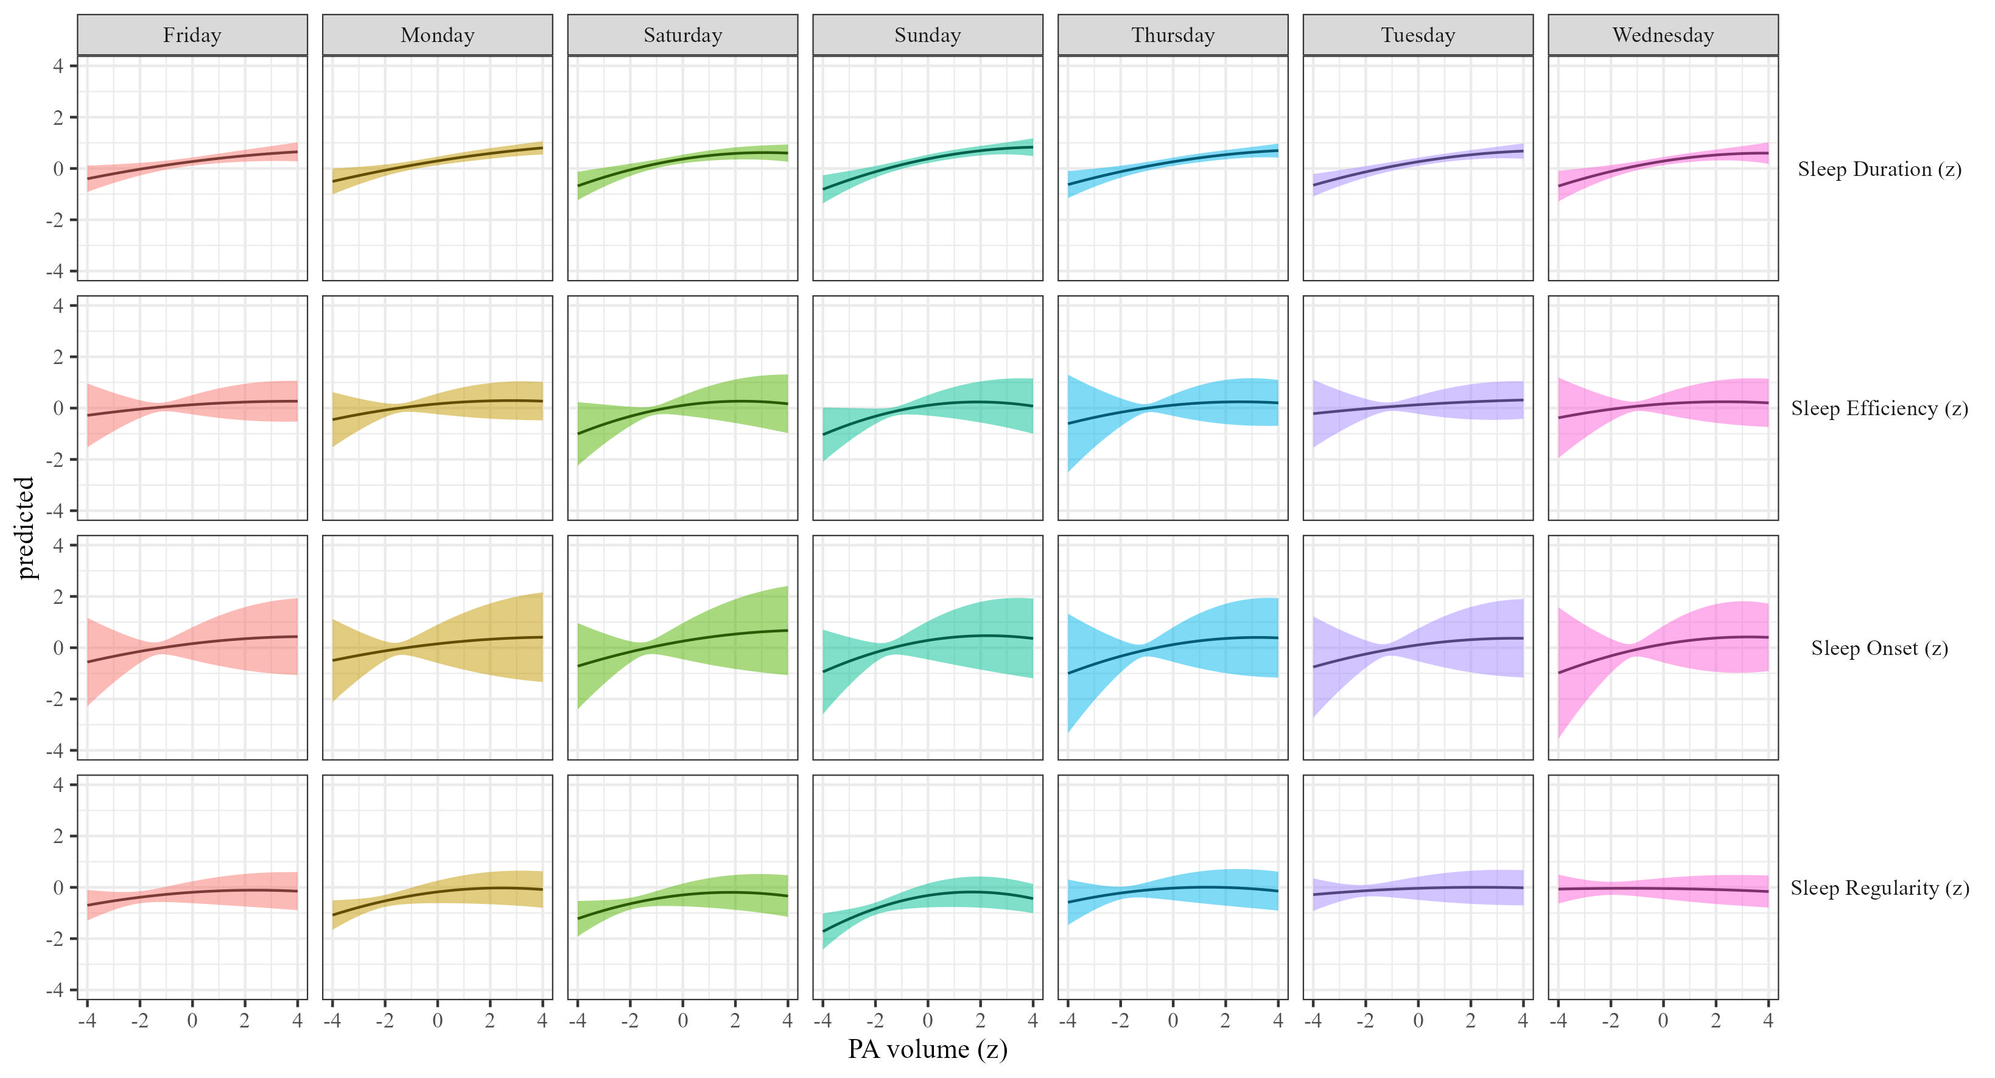

Figure 25: Sleep metrics on Physical activity volume by weekday

### The effects of physical activity intensity on sleep by weekday.

We estimated how physical activity intensity affects sleep across weekday We present the results in Table 9 and Figure 26.

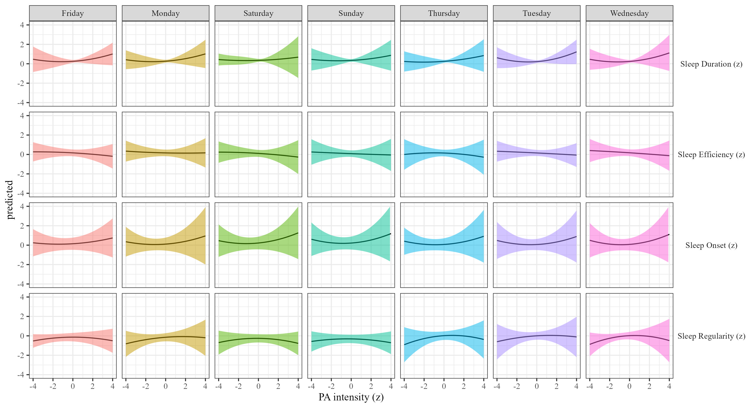

Figure 26: Sleep metrics on Physical activity intensity moderated by weekday

### The effects of sleep duration on physical activity.

We estimated the effect of sleep duration on physical activity by weekday Results, controlling for sex, SES, and BMI are presented in Table 2 and Figure 27.

Table 10:

*Sleep on physical activity controlling for SES, gender and BMI*

| Term | $β$ [95% CI] | SE | t | p | $β$ [95% CI] | SE | t | p |
| --- | --- | --- | --- | --- | --- | --- | --- | --- |
| Sleep duration |  |  |  |  |  |  |  |  |
| (Intercept) | 1.56 [1.04, 2.07] | 0.26 | 5.93 | .001 | 1.13 [0.56, 1.70] | 0.29 | 3.91 | .039 |
| Sleep duration | 0.01 [-0.07, 0.10] | 0.04 | 0.33 | .762 | 0.03 [0.00, 0.06] | 0.02 | 2.05 | .042 |
| Weekday xmonday | -0.21 [-0.29, -0.14] | 0.04 | -5.41 | < .001 | -0.07 [-0.13, -0.02] | 0.03 | -2.59 | .012 |
| Weekday xsaturday | -0.14 [-0.20, -0.08] | 0.03 | -4.54 | < .001 | -0.07 [-0.12, -0.03] | 0.03 | -2.95 | .004 |
| Weekday xsunday | -0.21 [-0.28, -0.15] | 0.03 | -6.68 | < .001 | -0.14 [-0.19, -0.10] | 0.02 | -5.93 | < .001 |
| Weekday xthursday | -0.08 [-0.16, 0.01] | 0.04 | -1.74 | .126 | 0.01 [-0.04, 0.07] | 0.03 | 0.44 | .663 |
| Weekday xtuesday | -0.10 [-0.18, -0.02] | 0.04 | -2.55 | .026 | -0.01 [-0.08, 0.05] | 0.03 | -0.34 | .738 |
| Weekday xwednesday | -0.12 [-0.22, -0.02] | 0.05 | -2.35 | .068 | -0.03 [-0.09, 0.03] | 0.03 | -0.94 | .362 |
| Sleep duration $​^{2}$ | -0.01 [-0.03, 0.02] | 0.01 | -0.52 | .608 | -0.02 [-0.09, 0.06] | 0.04 | -0.45 | .695 |
| Age | -0.02 [-0.02, -0.01] | 0.00 | -8.37 | < .001 | -0.02 [-0.02, -0.02] | 0.00 | -12.35 | < .001 |
| Sleep duration $×$ weekday xmonday | -0.04 [-0.11, 0.03] | 0.04 | -1.09 | .313 | -0.06 [-0.12, -0.01] | 0.03 | -2.14 | .071 |
| Sleep duration $×$ weekday xsaturday | -0.06 [-0.11, 0.00] | 0.03 | -1.89 | .079 | -0.06 [-0.13, 0.02] | 0.04 | -1.41 | .243 |
| Sleep duration $×$ weekday xsunday | -0.08 [-0.13, -0.04] | 0.02 | -3.50 | < .001 | -0.05 [-0.12, 0.02] | 0.04 | -1.37 | .249 |
| Sleep duration $×$ weekday xthursday | -0.01 [-0.07, 0.06] | 0.03 | -0.20 | .848 | 0.01 [-0.04, 0.05] | 0.02 | 0.26 | .796 |
| Sleep duration $×$ weekday xtuesday | -0.03 [-0.12, 0.07] | 0.05 | -0.57 | .600 | -0.02 [-0.07, 0.04] | 0.03 | -0.56 | .587 |
| Sleep duration $×$ weekday xwednesday | 0.01 [-0.16, 0.19] | 0.09 | 0.14 | .902 | 0.00 [-0.09, 0.08] | 0.04 | -0.06 | .953 |
| Weekday xmonday $×$ Sleep duration $​^{2}$ | 0.04 [0.00, 0.07] | 0.02 | 1.80 | .096 | -0.01 [-0.06, 0.05] | 0.03 | -0.20 | .854 |
| Weekday xsaturday $×$ Sleep duration $​^{2}$ | 0.03 [0.00, 0.06] | 0.01 | 2.19 | .029 | 0.00 [-0.04, 0.04] | 0.02 | -0.10 | .928 |
| Weekday xsunday $×$ Sleep duration $​^{2}$ | 0.03 [0.00, 0.05] | 0.01 | 1.92 | .054 | 0.00 [-0.03, 0.03] | 0.01 | 0.04 | .971 |
| Weekday xthursday $×$ Sleep duration $​^{2}$ | 0.01 [-0.02, 0.05] | 0.02 | 0.73 | .476 | 0.00 [-0.03, 0.03] | 0.01 | 0.04 | .972 |
| Weekday xtuesday $×$ Sleep duration $​^{2}$ | 0.01 [-0.02, 0.04] | 0.02 | 0.57 | .573 | 0.01 [-0.02, 0.04] | 0.01 | 0.67 | .510 |
| Weekday xwednesday $×$ Sleep duration $​^{2}$ | 0.04 [0.00, 0.09] | 0.02 | 1.89 | .110 | 0.02 [-0.02, 0.06] | 0.02 | 0.86 | .438 |
| Sleep efficency |  |  |  |  |  |  |  |  |
| (Intercept) | 1.54 [1.03, 2.06] | 0.26 | 5.84 | .002 | 1.12 [0.50, 1.73] | 0.31 | 3.56 | .051 |
| Sleep efficiency | 0.00 [-0.05, 0.05] | 0.03 | 0.01 | .994 | -0.03 [-0.14, 0.08] | 0.06 | -0.49 | .664 |
| Weekday xmonday | -0.19 [-0.25, -0.14] | 0.03 | -6.93 | < .001 | -0.08 [-0.13, -0.03] | 0.02 | -3.43 | .001 |
| Weekday xsaturday | -0.11 [-0.17, -0.06] | 0.03 | -3.87 | .001 | -0.08 [-0.13, -0.04] | 0.02 | -3.65 | < .001 |
| Weekday xsunday | -0.22 [-0.28, -0.16] | 0.03 | -7.36 | < .001 | -0.15 [-0.20, -0.10] | 0.03 | -5.60 | < .001 |
| Weekday xthursday | -0.07 [-0.12, -0.02] | 0.03 | -2.82 | .005 | 0.01 [-0.04, 0.05] | 0.02 | 0.39 | .696 |
| Weekday xtuesday | -0.10 [-0.17, -0.03] | 0.03 | -2.88 | .014 | 0.00 [-0.09, 0.08] | 0.04 | -0.10 | .929 |
| Weekday xwednesday | -0.08 [-0.13, -0.03] | 0.03 | -2.92 | .004 | -0.01 [-0.05, 0.04] | 0.02 | -0.34 | .737 |
| Sleep efficiency $​^{2}$ | -0.02 [-0.03, 0.00] | 0.01 | -1.95 | .052 | 0.00 [-0.02, 0.01] | 0.01 | -0.37 | .711 |
| Age | -0.02 [-0.02, -0.01] | 0.00 | -8.25 | < .001 | -0.02 [-0.02, -0.02] | 0.00 | -12.24 | < .001 |
| Sleep efficiency $×$ weekday xmonday | 0.02 [-0.05, 0.09] | 0.04 | 0.53 | .597 | 0.06 [-0.02, 0.13] | 0.04 | 1.46 | .178 |
| Sleep efficiency $×$ weekday xsaturday | 0.02 [-0.06, 0.09] | 0.04 | 0.44 | .658 | 0.04 [-0.03, 0.12] | 0.04 | 1.12 | .289 |
| Sleep efficiency $×$ weekday xsunday | 0.06 [-0.01, 0.12] | 0.04 | 1.59 | .113 | 0.06 [0.00, 0.12] | 0.03 | 2.03 | .045 |
| Sleep efficiency $×$ weekday xthursday | 0.00 [-0.09, 0.09] | 0.05 | 0.06 | .950 | 0.02 [-0.10, 0.13] | 0.06 | 0.32 | .765 |
| Sleep efficiency $×$ weekday xtuesday | 0.03 [-0.07, 0.12] | 0.05 | 0.56 | .590 | 0.00 [-0.07, 0.07] | 0.03 | 0.00 | .999 |
| Sleep efficiency $×$ weekday xwednesday | -0.02 [-0.10, 0.06] | 0.04 | -0.42 | .677 | 0.01 [-0.07, 0.08] | 0.04 | 0.18 | .862 |
| Weekday xmonday $×$ Sleep efficiency $​^{2}$ | 0.02 [0.00, 0.05] | 0.01 | 1.79 | .102 | 0.01 [-0.03, 0.04] | 0.02 | 0.30 | .782 |
| Weekday xsaturday $×$ Sleep efficiency $​^{2}$ | 0.03 [0.01, 0.06] | 0.01 | 2.50 | .021 | 0.01 [-0.03, 0.04] | 0.02 | 0.43 | .689 |
| Weekday xsunday $×$ Sleep efficiency $​^{2}$ | 0.05 [0.03, 0.08] | 0.01 | 4.57 | < .001 | 0.01 [-0.08, 0.10] | 0.05 | 0.19 | .867 |
| Weekday xthursday $×$ Sleep efficiency $​^{2}$ | 0.02 [-0.01, 0.04] | 0.01 | 1.25 | .228 | 0.00 [-0.02, 0.02] | 0.01 | 0.10 | .920 |
| Weekday xtuesday $×$ Sleep efficiency $​^{2}$ | 0.01 [-0.01, 0.04] | 0.01 | 1.07 | .310 | 0.00 [-0.02, 0.03] | 0.01 | 0.32 | .761 |
| Weekday xwednesday $×$ Sleep efficiency $​^{2}$ | 0.01 [-0.01, 0.04] | 0.01 | 0.96 | .342 | 0.00 [-0.04, 0.04] | 0.02 | 0.04 | .968 |
| Sleep onset |  |  |  |  |  |  |  |  |
| (Intercept) | 1.53 [0.99, 2.08] | 0.28 | 5.51 | .003 | 1.09 [0.49, 1.70] | 0.31 | 3.54 | .050 |
| Sleep onset | -0.03 [-0.07, 0.01] | 0.02 | -1.44 | .153 | -0.05 [-0.09, 0.00] | 0.02 | -2.14 | .062 |
| Weekday xmonday | -0.16 [-0.23, -0.10] | 0.03 | -4.72 | < .001 | -0.06 [-0.13, 0.02] | 0.04 | -1.52 | .162 |
| Weekday xsaturday | -0.10 [-0.16, -0.03] | 0.03 | -2.85 | .006 | -0.06 [-0.11, 0.00] | 0.03 | -2.02 | .050 |
| Weekday xsunday | -0.16 [-0.23, -0.10] | 0.03 | -4.98 | < .001 | -0.11 [-0.18, -0.04] | 0.03 | -3.22 | .008 |
| Weekday xthursday | -0.08 [-0.15, -0.01] | 0.04 | -2.28 | .026 | 0.01 [-0.04, 0.07] | 0.03 | 0.53 | .597 |
| Weekday xtuesday | -0.09 [-0.17, -0.01] | 0.04 | -2.08 | .056 | 0.01 [-0.09, 0.11] | 0.05 | 0.12 | .908 |
| Weekday xwednesday | -0.09 [-0.20, 0.02] | 0.06 | -1.59 | .180 | 0.01 [-0.06, 0.08] | 0.04 | 0.39 | .701 |
| Sleep onset $​^{2}$ | -0.01 [-0.07, 0.05] | 0.03 | -0.38 | .725 | 0.00 [-0.02, 0.03] | 0.01 | 0.30 | .772 |
| Age | -0.02 [-0.02, -0.01] | 0.00 | -8.28 | < .001 | -0.02 [-0.02, -0.02] | 0.00 | -12.13 | < .001 |
| Sleep onset $×$ weekday xmonday | 0.00 [-0.08, 0.08] | 0.04 | 0.01 | .989 | 0.09 [0.03, 0.16] | 0.03 | 2.95 | .027 |
| Sleep onset $×$ weekday xsaturday | -0.01 [-0.08, 0.07] | 0.04 | -0.17 | .874 | 0.06 [-0.02, 0.13] | 0.04 | 1.49 | .214 |
| Sleep onset $×$ weekday xsunday | 0.01 [-0.06, 0.09] | 0.04 | 0.37 | .723 | 0.09 [0.03, 0.16] | 0.03 | 2.72 | .045 |
| Sleep onset $×$ weekday xthursday | -0.01 [-0.08, 0.06] | 0.04 | -0.33 | .747 | 0.03 [-0.02, 0.08] | 0.02 | 1.22 | .233 |
| Sleep onset $×$ weekday xtuesday | 0.02 [-0.03, 0.08] | 0.03 | 0.89 | .375 | 0.02 [-0.03, 0.07] | 0.03 | 0.87 | .397 |
| Sleep onset $×$ weekday xwednesday | 0.00 [-0.06, 0.07] | 0.03 | 0.13 | .898 | 0.04 [-0.04, 0.12] | 0.04 | 1.00 | .375 |
| Weekday xmonday $×$ Sleep onset $​^{2}$ | -0.01 [-0.05, 0.04] | 0.02 | -0.25 | .807 | -0.01 [-0.05, 0.03] | 0.02 | -0.56 | .585 |
| Weekday xsaturday $×$ Sleep onset $​^{2}$ | 0.01 [-0.05, 0.07] | 0.03 | 0.45 | .672 | 0.00 [-0.04, 0.03] | 0.02 | -0.09 | .929 |
| Weekday xsunday $×$ Sleep onset $​^{2}$ | 0.00 [-0.06, 0.05] | 0.03 | -0.06 | .952 | -0.02 [-0.05, 0.01] | 0.02 | -1.23 | .219 |
| Weekday xthursday $×$ Sleep onset $​^{2}$ | 0.01 [-0.03, 0.06] | 0.02 | 0.56 | .577 | 0.00 [-0.03, 0.04] | 0.02 | 0.24 | .815 |
| Weekday xtuesday $×$ Sleep onset $​^{2}$ | 0.00 [-0.04, 0.04] | 0.02 | 0.11 | .914 | 0.00 [-0.04, 0.04] | 0.02 | -0.02 | .986 |
| Weekday xwednesday $×$ Sleep onset $​^{2}$ | 0.02 [-0.06, 0.10] | 0.04 | 0.51 | .639 | -0.01 [-0.06, 0.04] | 0.02 | -0.38 | .716 |
| Sleep regularity |  |  |  |  |  |  |  |  |
| (Intercept) | 1.42 [0.93, 1.91] | 0.25 | 5.70 | .001 | 1.08 [0.55, 1.62] | 0.27 | 3.96 | .035 |
| Sleep regularity | 0.09 [-0.02, 0.20] | 0.06 | 1.62 | .224 | 0.03 [-0.06, 0.11] | 0.04 | 0.68 | .556 |
| Weekday xmonday | -0.15 [-0.23, -0.08] | 0.04 | -4.10 | < .001 | -0.09 [-0.16, -0.02] | 0.04 | -2.66 | .023 |
| Weekday xsaturday | -0.06 [-0.15, 0.04] | 0.05 | -1.17 | .290 | -0.06 [-0.15, 0.02] | 0.04 | -1.47 | .204 |
| Weekday xsunday | -0.13 [-0.22, -0.05] | 0.04 | -3.04 | .015 | -0.13 [-0.20, -0.06] | 0.04 | -3.63 | .006 |
| Weekday xthursday | -0.04 [-0.10, 0.03] | 0.03 | -1.10 | .271 | 0.00 [-0.06, 0.06] | 0.03 | 0.05 | .960 |
| Weekday xtuesday | -0.08 [-0.17, 0.01] | 0.05 | -1.76 | .122 | -0.01 [-0.11, 0.08] | 0.05 | -0.25 | .818 |
| Weekday xwednesday | -0.08 [-0.17, 0.01] | 0.05 | -1.69 | .130 | -0.02 [-0.10, 0.06] | 0.04 | -0.46 | .664 |
| Sleep regularity $​^{2}$ | 0.03 [-0.02, 0.08] | 0.02 | 1.32 | .265 | 0.00 [-0.04, 0.04] | 0.02 | -0.14 | .897 |
| Age | -0.02 [-0.02, -0.01] | 0.00 | -8.03 | < .001 | -0.02 [-0.02, -0.01] | 0.00 | -11.94 | < .001 |
| Sleep regularity $×$ weekday xmonday | -0.02 [-0.08, 0.05] | 0.03 | -0.52 | .613 | 0.02 [-0.07, 0.10] | 0.04 | 0.42 | .703 |
| Sleep regularity $×$ weekday xsaturday | -0.01 [-0.14, 0.11] | 0.06 | -0.20 | .858 | 0.01 [-0.07, 0.09] | 0.04 | 0.26 | .809 |
| Sleep regularity $×$ weekday xsunday | 0.01 [-0.13, 0.14] | 0.07 | 0.07 | .947 | 0.01 [-0.10, 0.11] | 0.05 | 0.13 | .908 |
| Sleep regularity $×$ weekday xthursday | -0.01 [-0.07, 0.05] | 0.03 | -0.30 | .772 | 0.01 [-0.03, 0.05] | 0.02 | 0.53 | .599 |
| Sleep regularity $×$ weekday xtuesday | -0.01 [-0.14, 0.12] | 0.07 | -0.11 | .919 | 0.00 [-0.08, 0.08] | 0.04 | -0.02 | .984 |
| Sleep regularity $×$ weekday xwednesday | -0.02 [-0.14, 0.10] | 0.06 | -0.33 | .763 | -0.02 [-0.07, 0.03] | 0.02 | -0.70 | .496 |
| Weekday xmonday $×$ Sleep regularity $​^{2}$ | 0.00 [-0.05, 0.04] | 0.02 | -0.16 | .878 | 0.02 [-0.02, 0.06] | 0.02 | 1.02 | .344 |
| Weekday xsaturday $×$ Sleep regularity $​^{2}$ | -0.02 [-0.09, 0.04] | 0.03 | -0.66 | .547 | 0.00 [-0.04, 0.03] | 0.02 | -0.21 | .839 |
| Weekday xsunday $×$ Sleep regularity $​^{2}$ | -0.02 [-0.08, 0.04] | 0.03 | -0.70 | .522 | -0.01 [-0.04, 0.03] | 0.02 | -0.39 | .705 |
| Weekday xthursday $×$ Sleep regularity $​^{2}$ | -0.02 [-0.06, 0.01] | 0.02 | -1.20 | .235 | 0.01 [-0.03, 0.05] | 0.02 | 0.35 | .740 |
| Weekday xtuesday $×$ Sleep regularity $​^{2}$ | 0.00 [-0.08, 0.08] | 0.04 | -0.06 | .957 | 0.01 [-0.04, 0.06] | 0.02 | 0.39 | .711 |
| Weekday xwednesday $×$ Sleep regularity $​^{2}$ | 0.00 [-0.06, 0.06] | 0.03 | -0.06 | .958 | 0.01 [-0.04, 0.06] | 0.03 | 0.35 | .740 |

*Note.* Adjusted for SES, BMI, and sex.

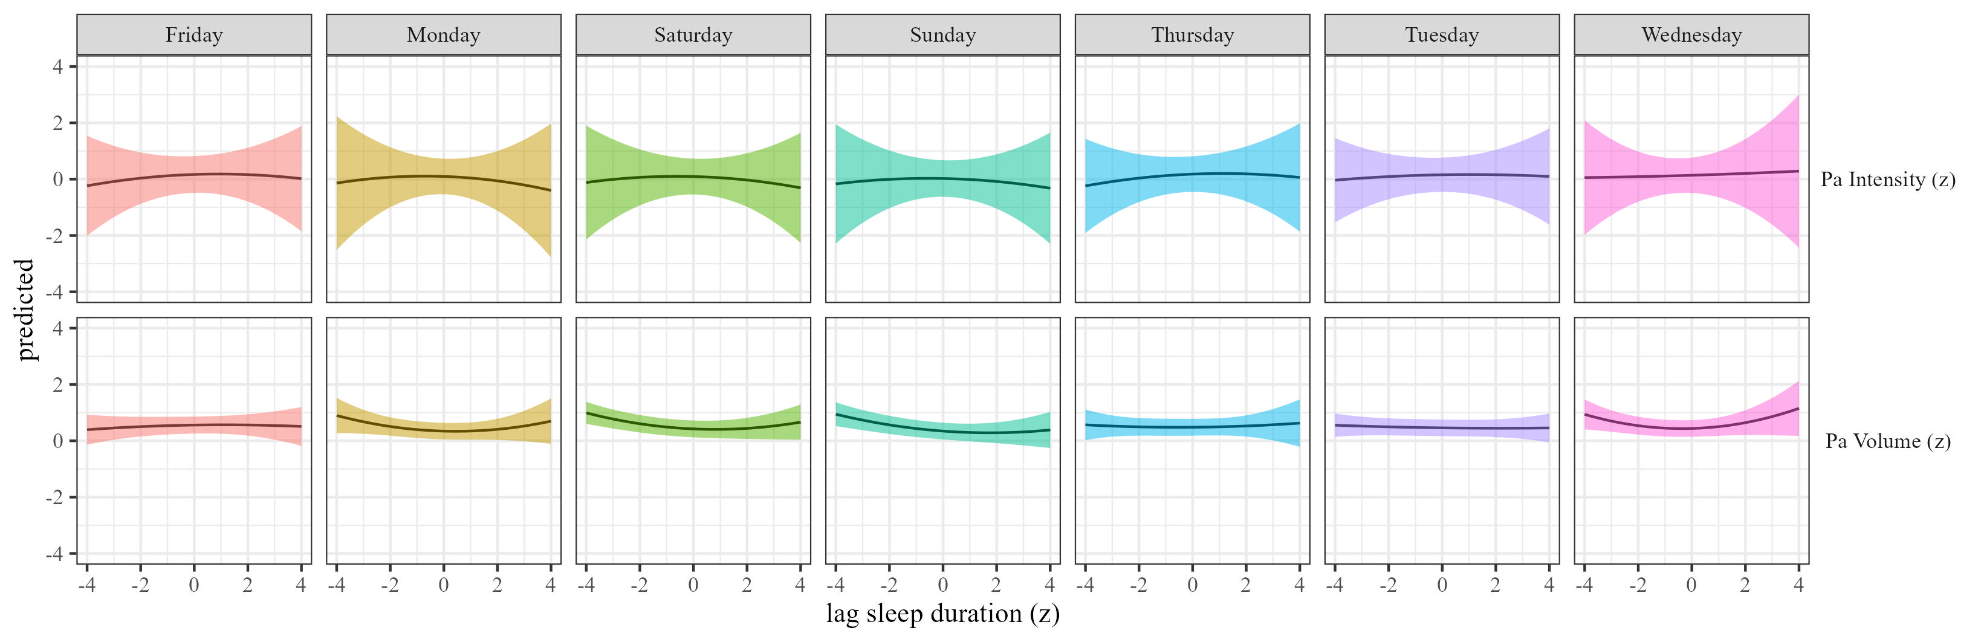

Figure 27: Physical activty by sleep duration moderated by weekday

### The effects of sleep efficiency on physical activity.

We estimated the effect of sleep efficiency on physical activity by weekday. Results, controlling for sex, SES, and BMI are presented in Table 10 and Figure 28.

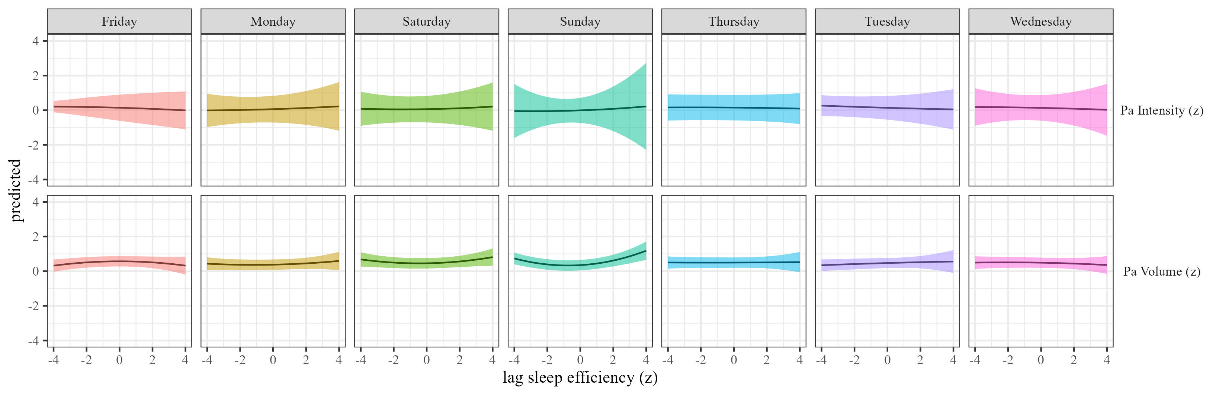

Figure 28: Physical activty by sleep efficiency moderated by weekday

### The effects of sleep onset on physical activity.

We estimated the effect of sleep onset on physical activity by weekday Results, controlling for sex, SES, and BMI are presented in Table 2 and Figure 29.

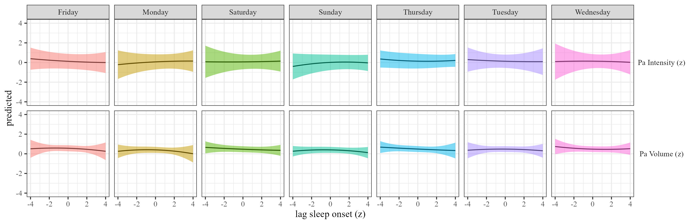

Figure 29: Physical activty by sleep onset moderated by weekday

### The effects of sleep regularity on physical activity.

We estimated the effect of sleep regularity on physical activity by weekday. Results are presented in Table 2 and Figure 30.

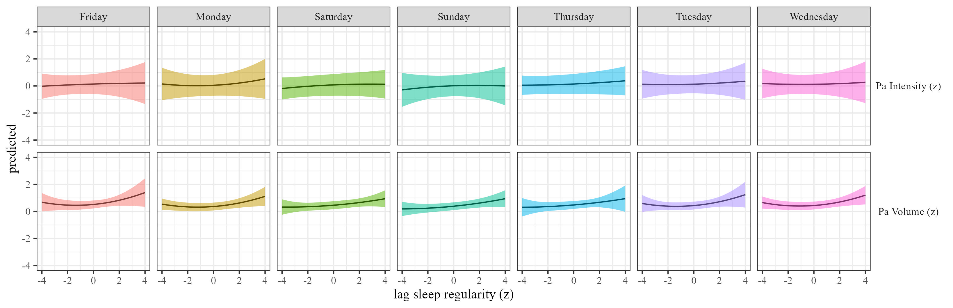 ## season

### The effects of physical activity volume on sleep.

We estimated the effects of physical activity on sleep (RQ1) using mixed-effects models We estimated the effect of physical activity volume on sleep by season, and the results are presented in Table 11 and Figure 31

Table 11:

*Physical activity on sleep controlling for SES, gender and BMI*

| Term | $β$ [95% CI] | SE | t | p | $β$ [95% CI] | SE | t | p |
| --- | --- | --- | --- | --- | --- | --- | --- | --- |
| Sleep duration |  |  |  |  |  |  |  |  |
| (Intercept) | 0.41 [0.13, 0.70] | 0.15 | 2.84 | .020 | 0.51 [-0.04, 1.06] | 0.28 | 1.81 | .183 |
| Physical activity | 0.19 [0.13, 0.25] | 0.03 | 6.19 | < .001 | 0.06 [-0.22, 0.35] | 0.15 | 0.43 | .711 |
| Seasonspring | -0.02 [-0.09, 0.04] | 0.03 | -0.69 | .493 | -0.03 [-0.11, 0.05] | 0.04 | -0.70 | .484 |
| Seasonsummer | -0.11 [-0.21, -0.02] | 0.05 | -2.28 | .047 | -0.15 [-0.23, -0.07] | 0.04 | -3.64 | < .001 |
| Seasonwinter | 0.06 [0.00, 0.13] | 0.03 | 1.85 | .065 | 0.03 [-0.06, 0.12] | 0.05 | 0.64 | .533 |
| Physical activity $​^{2}$ | -0.02 [-0.03, -0.01] | 0.01 | -3.86 | < .001 | 0.01 [-0.02, 0.03] | 0.01 | 0.66 | .508 |
| Age | 0.00 [-0.01, 0.00] | 0.00 | -1.09 | .278 | 0.00 [-0.01, 0.00] | 0.00 | -1.13 | .327 |
| Physical activity $×$ seasonspring | -0.04 [-0.11, 0.03] | 0.04 | -1.14 | .269 | 0.00 [-0.05, 0.05] | 0.02 | 0.08 | .938 |
| Physical activity $×$ seasonsummer | -0.01 [-0.10, 0.07] | 0.04 | -0.27 | .793 | 0.02 [-0.10, 0.14] | 0.06 | 0.35 | .753 |
| Physical activity $×$ seasonwinter | -0.05 [-0.12, 0.01] | 0.03 | -1.69 | .098 | -0.01 [-0.06, 0.05] | 0.03 | -0.26 | .796 |
| Seasonspring $×$ Physical activity $​^{2}$ | 0.01 [-0.01, 0.03] | 0.01 | 1.11 | .278 | 0.01 [-0.04, 0.06] | 0.03 | 0.45 | .671 |
| Seasonsummer $×$ Physical activity $​^{2}$ | 0.02 [-0.02, 0.06] | 0.02 | 1.01 | .352 | 0.05 [-0.02, 0.11] | 0.03 | 1.43 | .218 |
| Seasonwinter $×$ Physical activity $​^{2}$ | 0.01 [-0.01, 0.03] | 0.01 | 0.68 | .500 | 0.02 [-0.02, 0.06] | 0.02 | 1.13 | .278 |
| Sleep efficency |  |  |  |  |  |  |  |  |
| (Intercept) | 0.05 [-0.20, 0.29] | 0.12 | 0.39 | .702 | 0.19 [-0.25, 0.63] | 0.23 | 0.85 | .452 |
| Physical activity | 0.13 [-0.12, 0.37] | 0.12 | 1.02 | .410 | 0.00 [-0.21, 0.20] | 0.10 | -0.02 | .989 |
| Seasonspring | 0.05 [-0.03, 0.13] | 0.04 | 1.14 | .274 | 0.04 [-0.04, 0.13] | 0.04 | 1.02 | .320 |
| Seasonsummer | 0.00 [-0.08, 0.08] | 0.04 | -0.11 | .912 | -0.04 [-0.13, 0.04] | 0.05 | -0.98 | .337 |
| Seasonwinter | 0.07 [-0.02, 0.16] | 0.05 | 1.52 | .174 | 0.06 [-0.02, 0.15] | 0.04 | 1.40 | .180 |
| Physical activity $​^{2}$ | -0.02 [-0.05, 0.01] | 0.02 | -1.29 | .301 | -0.02 [-0.10, 0.06] | 0.04 | -0.43 | .701 |
| Age | 0.00 [0.00, 0.01] | 0.00 | 1.51 | .176 | 0.00 [0.00, 0.01] | 0.00 | 0.65 | .532 |
| Physical activity $×$ seasonspring | -0.07 [-0.14, 0.00] | 0.03 | -2.10 | .052 | -0.06 [-0.14, 0.03] | 0.04 | -1.28 | .283 |
| Physical activity $×$ seasonsummer | 0.01 [-0.07, 0.08] | 0.04 | 0.19 | .854 | -0.05 [-0.16, 0.07] | 0.06 | -0.81 | .483 |
| Physical activity $×$ seasonwinter | -0.05 [-0.17, 0.07] | 0.06 | -0.75 | .509 | -0.06 [-0.14, 0.03] | 0.04 | -1.35 | .259 |
| Seasonspring $×$ Physical activity $​^{2}$ | 0.01 [-0.01, 0.03] | 0.01 | 1.30 | .201 | 0.01 [-0.04, 0.06] | 0.03 | 0.43 | .689 |
| Seasonsummer $×$ Physical activity $​^{2}$ | -0.01 [-0.04, 0.01] | 0.01 | -1.08 | .283 | 0.03 [-0.03, 0.09] | 0.03 | 1.04 | .346 |
| Seasonwinter $×$ Physical activity $​^{2}$ | 0.00 [-0.03, 0.03] | 0.02 | 0.28 | .791 | 0.01 [-0.04, 0.06] | 0.02 | 0.44 | .674 |
| Sleep onset |  |  |  |  |  |  |  |  |
| (Intercept) | -0.18 [-0.47, 0.11] | 0.15 | -1.20 | .239 | -0.14 [-0.60, 0.32] | 0.23 | -0.60 | .577 |
| Physical activity | 0.14 [-0.27, 0.56] | 0.21 | 0.68 | .569 | 0.08 [-0.07, 0.22] | 0.07 | 1.05 | .397 |
| Seasonspring | 0.05 [-0.03, 0.13] | 0.04 | 1.24 | .256 | 0.04 [-0.03, 0.12] | 0.04 | 1.12 | .280 |
| Seasonsummer | 0.07 [0.01, 0.14] | 0.03 | 2.16 | .036 | 0.07 [0.00, 0.14] | 0.04 | 1.96 | .053 |
| Seasonwinter | 0.03 [-0.05, 0.12] | 0.04 | 0.82 | .448 | 0.03 [-0.05, 0.11] | 0.04 | 0.64 | .535 |
| Physical activity $​^{2}$ | -0.01 [-0.06, 0.03] | 0.02 | -0.62 | .591 | 0.04 [-0.05, 0.13] | 0.05 | 0.82 | .491 |
| Age | 0.00 [0.00, 0.01] | 0.00 | 0.75 | .501 | 0.00 [0.00, 0.00] | 0.00 | 0.59 | .557 |
| Physical activity $×$ seasonspring | -0.01 [-0.06, 0.04] | 0.02 | -0.52 | .602 | -0.02 [-0.08, 0.04] | 0.03 | -0.54 | .610 |
| Physical activity $×$ seasonsummer | 0.01 [-0.05, 0.07] | 0.03 | 0.21 | .837 | -0.01 [-0.06, 0.03] | 0.02 | -0.62 | .540 |
| Physical activity $×$ seasonwinter | 0.04 [-0.04, 0.12] | 0.04 | 0.95 | .395 | -0.01 [-0.08, 0.05] | 0.03 | -0.35 | .740 |
| Seasonspring $×$ Physical activity $​^{2}$ | -0.01 [-0.02, 0.01] | 0.01 | -0.62 | .540 | 0.00 [-0.05, 0.06] | 0.03 | 0.07 | .947 |
| Seasonsummer $×$ Physical activity $​^{2}$ | -0.02 [-0.05, 0.01] | 0.02 | -1.23 | .255 | -0.01 [-0.05, 0.03] | 0.02 | -0.55 | .593 |
| Seasonwinter $×$ Physical activity $​^{2}$ | -0.01 [-0.04, 0.01] | 0.01 | -1.08 | .340 | -0.01 [-0.05, 0.04] | 0.02 | -0.27 | .800 |
| Sleep regularity |  |  |  |  |  |  |  |  |
| (Intercept) | 0.29 [-0.19, 0.78] | 0.25 | 1.18 | .318 | 0.34 [-0.18, 0.87] | 0.27 | 1.29 | .285 |
| Physical activity | 0.03 [-0.13, 0.19] | 0.08 | 0.37 | .742 | 0.03 [-0.02, 0.09] | 0.03 | 1.30 | .246 |
| Seasonspring | -0.11 [-0.18, -0.04] | 0.04 | -2.97 | .006 | -0.13 [-0.23, -0.03] | 0.05 | -2.44 | .048 |
| Seasonsummer | -0.03 [-0.10, 0.05] | 0.04 | -0.72 | .474 | -0.08 [-0.16, 0.00] | 0.04 | -2.03 | .044 |
| Seasonwinter | -0.05 [-0.13, 0.04] | 0.04 | -1.12 | .291 | -0.06 [-0.19, 0.07] | 0.07 | -0.89 | .430 |
| Physical activity $​^{2}$ | -0.01 [-0.04, 0.01] | 0.01 | -1.05 | .366 | -0.04 [-0.13, 0.05] | 0.05 | -0.95 | .433 |
| Age | 0.00 [-0.01, 0.00] | 0.00 | -0.17 | .872 | 0.00 [0.00, 0.00] | 0.00 | -0.10 | .921 |
| Physical activity $×$ seasonspring | 0.07 [0.00, 0.14] | 0.04 | 1.85 | .101 | 0.01 [-0.05, 0.07] | 0.03 | 0.27 | .791 |
| Physical activity $×$ seasonsummer | 0.14 [0.06, 0.23] | 0.04 | 3.25 | .010 | 0.03 [-0.02, 0.08] | 0.03 | 0.99 | .324 |
| Physical activity $×$ seasonwinter | 0.05 [-0.01, 0.11] | 0.03 | 1.69 | .097 | 0.01 [-0.03, 0.06] | 0.02 | 0.52 | .608 |
| Seasonspring $×$ Physical activity $​^{2}$ | -0.01 [-0.03, 0.01] | 0.01 | -1.24 | .222 | 0.02 [-0.02, 0.06] | 0.02 | 1.09 | .305 |
| Seasonsummer $×$ Physical activity $​^{2}$ | -0.04 [-0.07, -0.01] | 0.01 | -2.71 | .016 | 0.03 [-0.01, 0.08] | 0.02 | 1.41 | .194 |
| Seasonwinter $×$ Physical activity $​^{2}$ | -0.01 [-0.02, 0.01] | 0.01 | -0.82 | .410 | 0.02 [-0.04, 0.08] | 0.03 | 0.62 | .570 |

*Note.* Adjusted for SES, BMI, and sex.

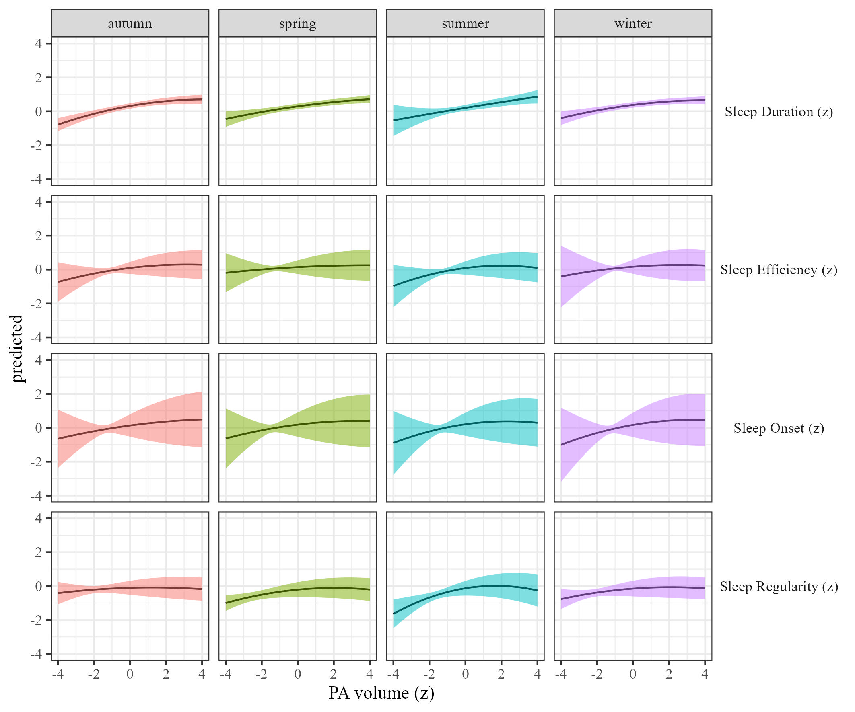

Figure 31: Sleep metrics on Physical activity volume by season

### The effects of physical activity intensity on sleep by season.

We estimated how physical activity intensity affects sleep across season We present the results in Table 11 and Figure 32.

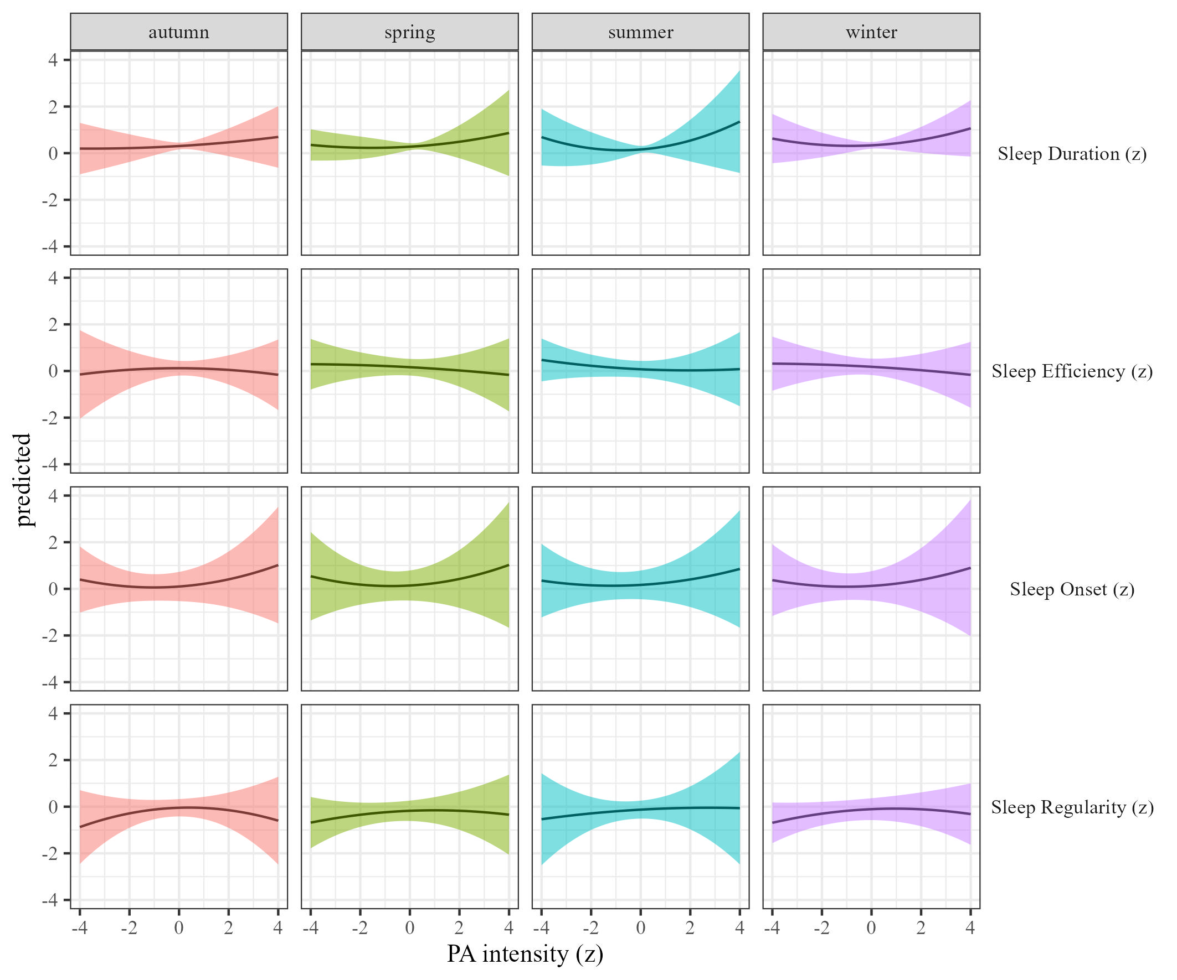

Figure 32: Sleep metrics on Physical activity intensity moderated by season

### The effects of sleep duration on physical activity.

We estimated the effect of sleep duration on physical activity by season Results, controlling for sex, SES, and BMI are presented in Table 2 and Figure 33.

Table 12:

*Sleep on physical activity controlling for SES, gender and BMI*

| Term | $β$ [95% CI] | SE | t | p | $β$ [95% CI] | SE | t | p |
| --- | --- | --- | --- | --- | --- | --- | --- | --- |
| Sleep duration |  |  |  |  |  |  |  |  |
| (Intercept) | 1.44 [0.94, 1.94] | 0.26 | 5.62 | .002 | 1.12 [0.57, 1.67] | 0.28 | 3.97 | .037 |
| Sleep duration | 0.00 [-0.06, 0.05] | 0.03 | -0.17 | .875 | 0.00 [-0.03, 0.03] | 0.01 | 0.25 | .811 |
| Seasonspring | -0.01 [-0.07, 0.06] | 0.03 | -0.19 | .850 | -0.06 [-0.12, 0.00] | 0.03 | -1.92 | .065 |
| Seasonsummer | -0.01 [-0.09, 0.08] | 0.04 | -0.18 | .861 | -0.05 [-0.12, 0.03] | 0.04 | -1.28 | .217 |
| Seasonwinter | -0.03 [-0.10, 0.03] | 0.03 | -0.92 | .357 | -0.05 [-0.11, 0.02] | 0.03 | -1.30 | .214 |
| Sleep duration $​^{2}$ | 0.02 [-0.01, 0.04] | 0.01 | 1.22 | .273 | -0.01 [-0.09, 0.07] | 0.04 | -0.34 | .767 |
| Age | -0.02 [-0.02, -0.01] | 0.00 | -8.48 | < .001 | -0.02 [-0.02, -0.01] | 0.00 | -12.24 | < .001 |
| Sleep duration $×$ seasonspring | -0.02 [-0.07, 0.03] | 0.03 | -0.68 | .515 | 0.00 [-0.03, 0.03] | 0.02 | -0.08 | .939 |
| Sleep duration $×$ seasonsummer | -0.03 [-0.13, 0.06] | 0.05 | -0.68 | .546 | -0.01 [-0.06, 0.05] | 0.03 | -0.27 | .801 |
| Sleep duration $×$ seasonwinter | -0.01 [-0.08, 0.06] | 0.03 | -0.32 | .765 | 0.00 [-0.05, 0.05] | 0.03 | -0.10 | .923 |
| Seasonspring $×$ Sleep duration $​^{2}$ | 0.00 [-0.02, 0.03] | 0.01 | 0.26 | .796 | 0.00 [-0.02, 0.02] | 0.01 | -0.05 | .963 |
| Seasonsummer $×$ Sleep duration $​^{2}$ | -0.02 [-0.07, 0.03] | 0.03 | -0.65 | .555 | 0.00 [-0.03, 0.02] | 0.01 | -0.39 | .701 |
| Seasonwinter $×$ Sleep duration $​^{2}$ | 0.01 [-0.01, 0.04] | 0.01 | 1.17 | .257 | 0.00 [-0.02, 0.02] | 0.01 | -0.31 | .763 |
| Sleep efficency |  |  |  |  |  |  |  |  |
| (Intercept) | 1.44 [0.92, 1.96] | 0.26 | 5.44 | .003 | 1.11 [0.52, 1.70] | 0.30 | 3.67 | .046 |
| Sleep efficiency | 0.02 [-0.02, 0.07] | 0.02 | 1.03 | .306 | 0.00 [-0.09, 0.09] | 0.05 | 0.00 | .997 |
| Seasonspring | 0.00 [-0.06, 0.06] | 0.03 | -0.03 | .977 | -0.07 [-0.14, 0.00] | 0.04 | -1.86 | .096 |
| Seasonsummer | -0.01 [-0.10, 0.07] | 0.04 | -0.32 | .753 | -0.05 [-0.13, 0.03] | 0.04 | -1.21 | .263 |
| Seasonwinter | -0.02 [-0.08, 0.04] | 0.03 | -0.64 | .525 | -0.06 [-0.13, 0.02] | 0.04 | -1.40 | .212 |
| Sleep efficiency $​^{2}$ | 0.00 [-0.01, 0.01] | 0.01 | 0.26 | .792 | 0.00 [-0.02, 0.02] | 0.01 | 0.05 | .964 |
| Age | -0.02 [-0.02, -0.01] | 0.00 | -8.22 | < .001 | -0.02 [-0.02, -0.01] | 0.00 | -12.12 | < .001 |
| Sleep efficiency $×$ seasonspring | -0.04 [-0.10, 0.02] | 0.03 | -1.36 | .175 | 0.00 [-0.09, 0.08] | 0.04 | -0.03 | .978 |
| Sleep efficiency $×$ seasonsummer | 0.02 [-0.05, 0.09] | 0.04 | 0.66 | .517 | 0.01 [-0.04, 0.06] | 0.03 | 0.48 | .630 |
| Sleep efficiency $×$ seasonwinter | -0.01 [-0.07, 0.05] | 0.03 | -0.29 | .770 | 0.00 [-0.06, 0.05] | 0.03 | -0.10 | .925 |
| Seasonspring $×$ Sleep efficiency $​^{2}$ | 0.00 [-0.01, 0.02] | 0.01 | 0.44 | .664 | 0.00 [-0.01, 0.02] | 0.01 | 0.17 | .867 |
| Seasonsummer $×$ Sleep efficiency $​^{2}$ | -0.01 [-0.03, 0.02] | 0.01 | -0.48 | .636 | 0.00 [-0.02, 0.01] | 0.01 | -0.21 | .836 |
| Seasonwinter $×$ Sleep efficiency $​^{2}$ | 0.01 [-0.01, 0.03] | 0.01 | 1.14 | .267 | 0.00 [-0.02, 0.03] | 0.01 | 0.27 | .798 |
| Sleep onset |  |  |  |  |  |  |  |  |
| (Intercept) | 1.45 [0.93, 1.98] | 0.27 | 5.41 | .003 | 1.10 [0.49, 1.71] | 0.31 | 3.54 | .051 |
| Sleep onset | -0.02 [-0.07, 0.03] | 0.03 | -0.74 | .487 | 0.00 [-0.04, 0.03] | 0.02 | -0.23 | .823 |
| Seasonspring | -0.03 [-0.10, 0.04] | 0.04 | -0.78 | .434 | -0.05 [-0.10, 0.01] | 0.03 | -1.62 | .104 |
| Seasonsummer | -0.03 [-0.14, 0.07] | 0.06 | -0.61 | .559 | -0.06 [-0.12, 0.01] | 0.03 | -1.67 | .101 |
| Seasonwinter | -0.03 [-0.10, 0.04] | 0.04 | -0.91 | .361 | -0.05 [-0.11, 0.01] | 0.03 | -1.68 | .095 |
| Sleep onset $​^{2}$ | -0.02 [-0.05, 0.02] | 0.02 | -1.08 | .335 | 0.00 [-0.02, 0.02] | 0.01 | 0.23 | .815 |
| Age | -0.02 [-0.02, -0.01] | 0.00 | -8.28 | < .001 | -0.02 [-0.02, -0.01] | 0.00 | -12.15 | < .001 |
| Sleep onset $×$ seasonspring | -0.03 [-0.07, 0.01] | 0.02 | -1.44 | .150 | 0.01 [-0.05, 0.06] | 0.03 | 0.27 | .800 |
| Sleep onset $×$ seasonsummer | 0.01 [-0.05, 0.08] | 0.03 | 0.39 | .709 | 0.01 [-0.04, 0.06] | 0.03 | 0.29 | .779 |
| Sleep onset $×$ seasonwinter | -0.04 [-0.08, 0.00] | 0.02 | -1.84 | .066 | -0.01 [-0.08, 0.07] | 0.04 | -0.14 | .895 |
| Seasonspring $×$ Sleep onset $​^{2}$ | 0.02 [-0.01, 0.06] | 0.02 | 1.40 | .176 | -0.02 [-0.07, 0.04] | 0.03 | -0.56 | .615 |
| Seasonsummer $×$ Sleep onset $​^{2}$ | 0.02 [-0.03, 0.06] | 0.02 | 0.67 | .525 | 0.01 [-0.02, 0.04] | 0.02 | 0.52 | .605 |
| Seasonwinter $×$ Sleep onset $​^{2}$ | 0.01 [-0.02, 0.04] | 0.02 | 0.77 | .443 | 0.00 [-0.06, 0.05] | 0.03 | -0.05 | .963 |
| Sleep regularity |  |  |  |  |  |  |  |  |
| (Intercept) | 1.34 [0.83, 1.85] | 0.26 | 5.13 | .003 | 1.06 [0.52, 1.60] | 0.27 | 3.87 | .037 |
| Sleep regularity | 0.08 [0.03, 0.13] | 0.02 | 3.23 | .026 | 0.03 [-0.02, 0.09] | 0.03 | 1.34 | .269 |
| Seasonspring | 0.02 [-0.05, 0.08] | 0.03 | 0.50 | .619 | -0.06 [-0.16, 0.03] | 0.05 | -1.27 | .265 |
| Seasonsummer | -0.01 [-0.11, 0.09] | 0.05 | -0.22 | .830 | -0.03 [-0.12, 0.05] | 0.04 | -0.81 | .441 |
| Seasonwinter | 0.00 [-0.06, 0.07] | 0.03 | 0.10 | .924 | -0.04 [-0.13, 0.05] | 0.05 | -0.91 | .406 |
| Sleep regularity $​^{2}$ | 0.03 [0.00, 0.05] | 0.01 | 2.24 | .041 | 0.01 [-0.02, 0.04] | 0.02 | 0.46 | .674 |
| Age | -0.02 [-0.02, -0.01] | 0.00 | -8.22 | < .001 | -0.02 [-0.02, -0.01] | 0.00 | -12.17 | < .001 |
| Sleep regularity $×$ seasonspring | 0.01 [-0.04, 0.05] | 0.02 | 0.37 | .716 | 0.01 [-0.03, 0.04] | 0.02 | 0.51 | .610 |
| Sleep regularity $×$ seasonsummer | 0.00 [-0.05, 0.06] | 0.03 | 0.14 | .890 | -0.01 [-0.07, 0.04] | 0.03 | -0.50 | .635 |
| Sleep regularity $×$ seasonwinter | 0.02 [-0.01, 0.06] | 0.02 | 1.19 | .233 | 0.01 [-0.04, 0.07] | 0.03 | 0.51 | .633 |
| Seasonspring $×$ Sleep regularity $​^{2}$ | -0.01 [-0.03, 0.02] | 0.01 | -0.62 | .534 | 0.00 [-0.03, 0.03] | 0.01 | -0.06 | .954 |
| Seasonsummer $×$ Sleep regularity $​^{2}$ | 0.00 [-0.04, 0.03] | 0.02 | -0.31 | .754 | -0.01 [-0.04, 0.01] | 0.01 | -0.94 | .354 |
| Seasonwinter $×$ Sleep regularity $​^{2}$ | -0.01 [-0.03, 0.02] | 0.01 | -0.58 | .560 | -0.01 [-0.03, 0.02] | 0.01 | -0.46 | .650 |

*Note.* Adjusted for SES, BMI, and sex.

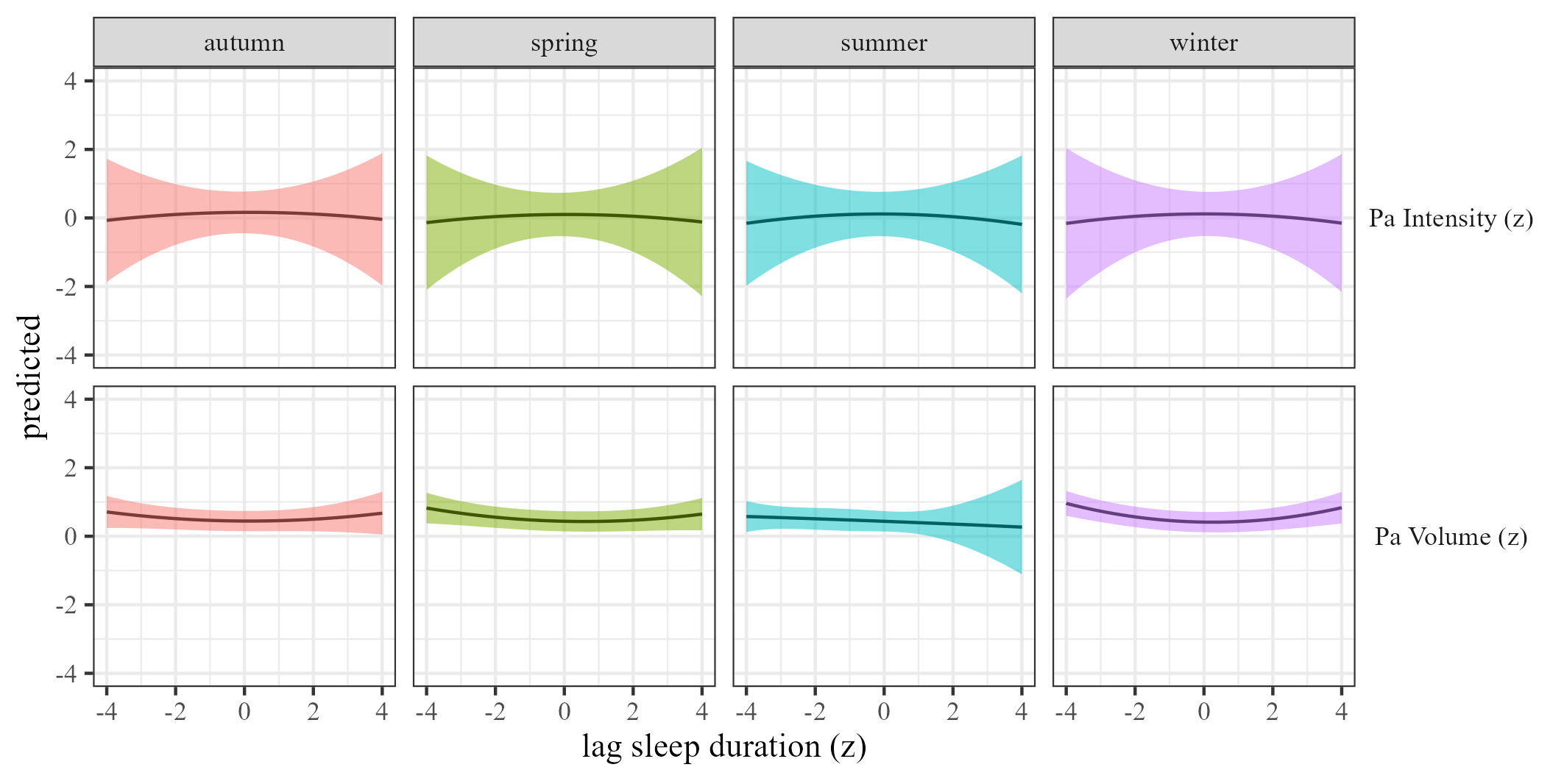

Figure 33: Physical activty by sleep duration moderated by season

### The effects of sleep efficiency on physical activity.

We estimated the effect of sleep efficiency on physical activity by season. Results, controlling for sex, SES, and BMI are presented in Table 12 and Figure 34.

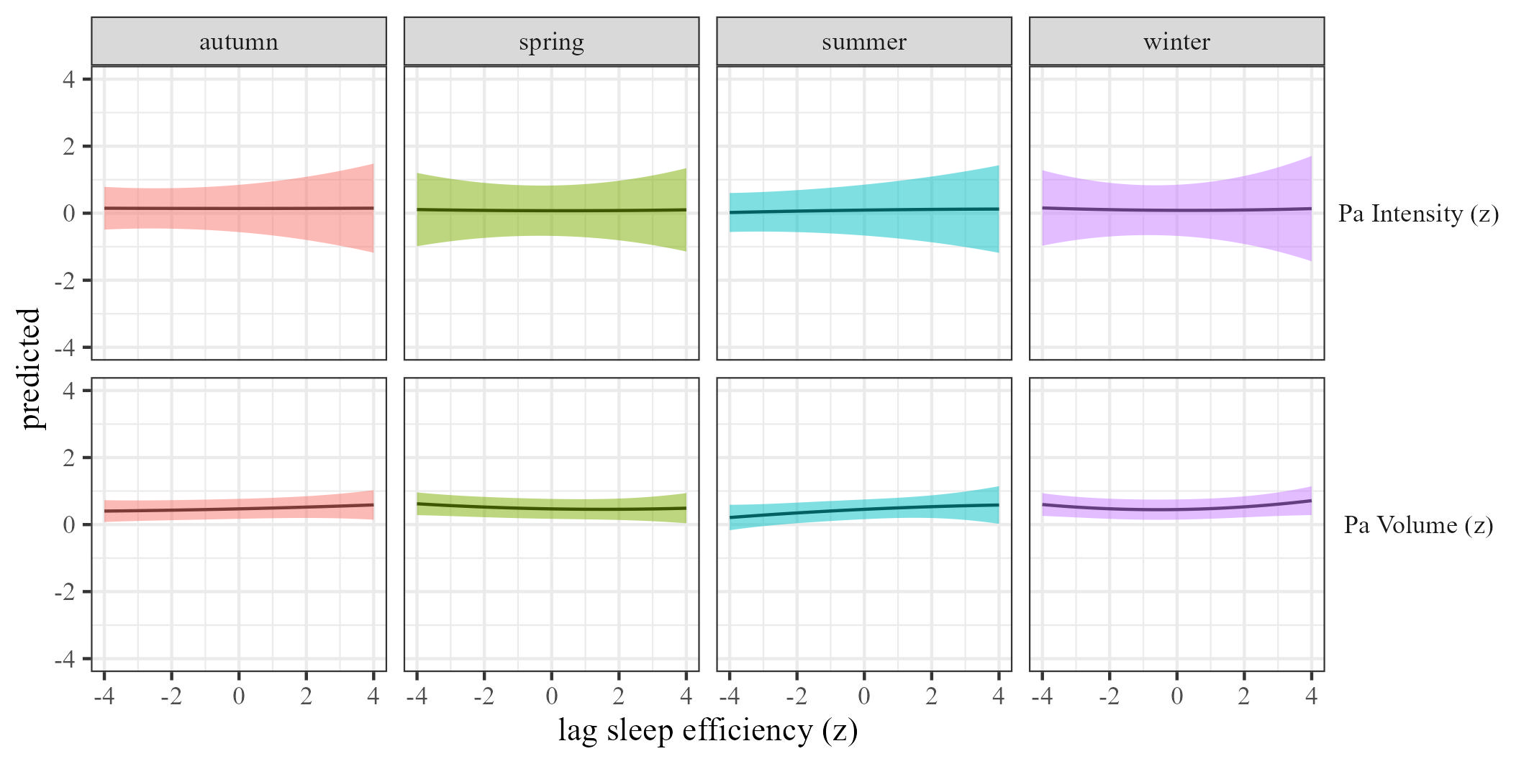

Figure 34: Physical activty by sleep efficiency moderated by season

### The effects of sleep onset on physical activity.

We estimated the effect of sleep onset on physical activity by season Results, controlling for sex, SES, and BMI are presented in Table 2 and Figure 35.

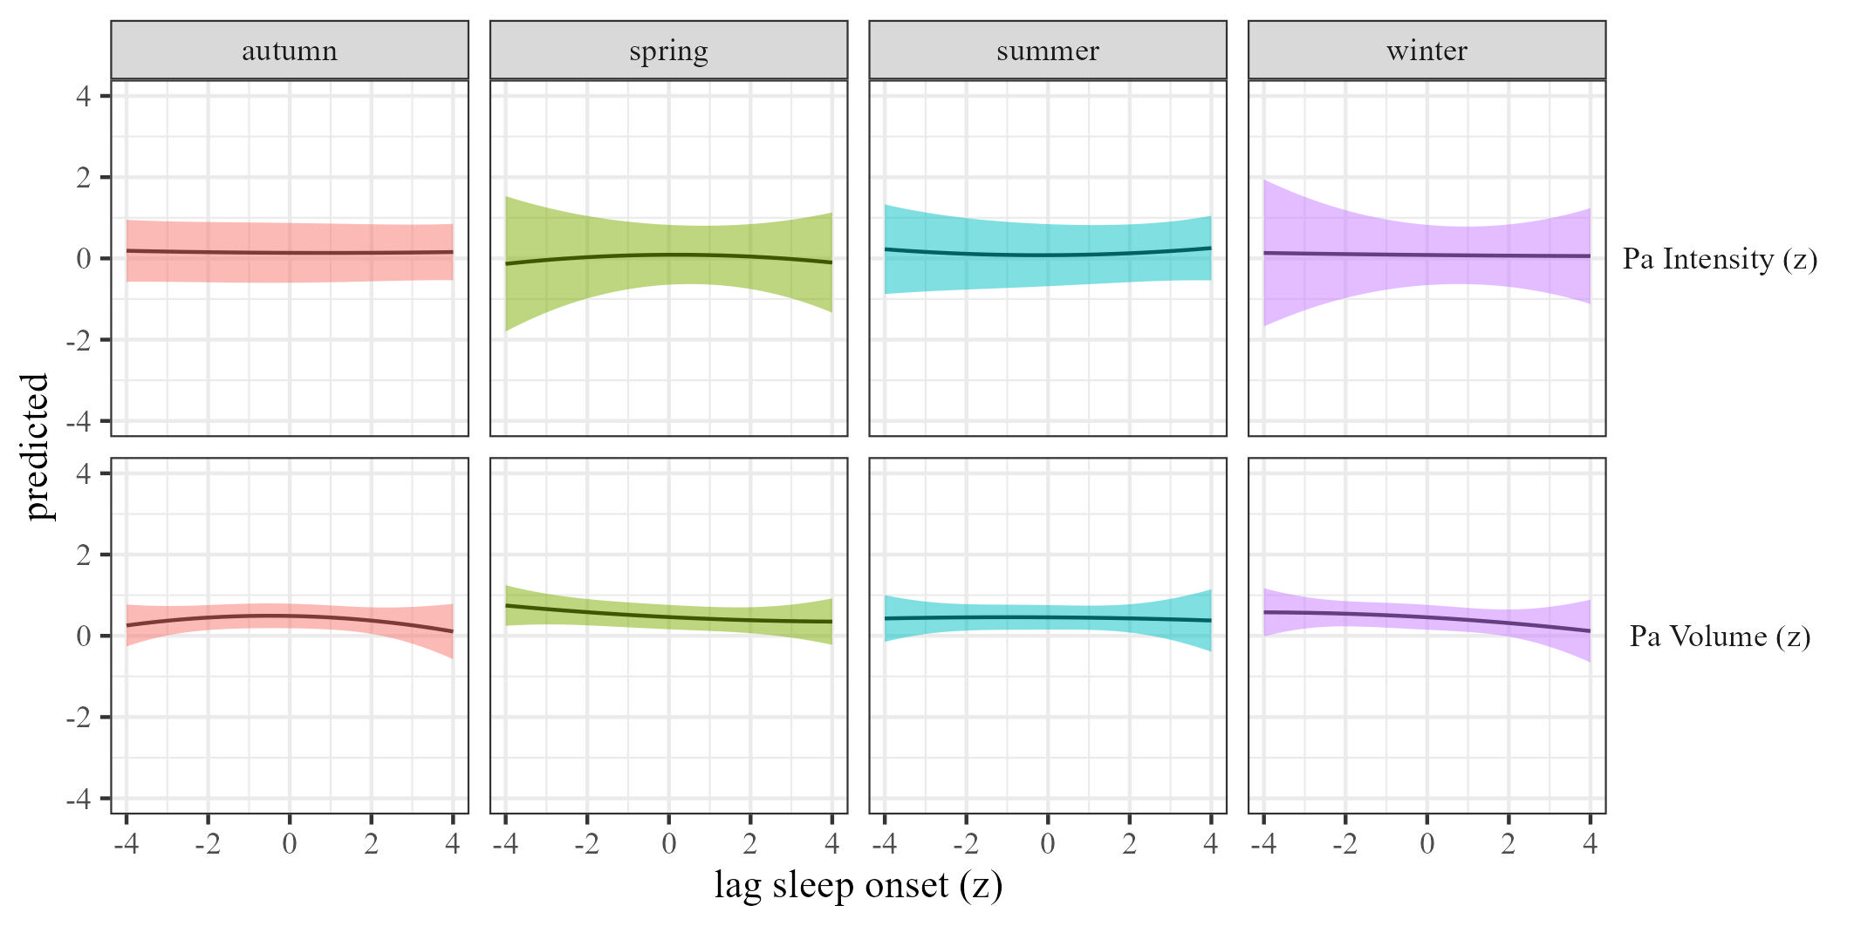

Figure 35: Physical activty by sleep onset moderated by season

### The effects of sleep regularity on physical activity.

We estimated the effect of sleep regularity on physical activity by season. Results are presented in Table 2 and Figure 36.

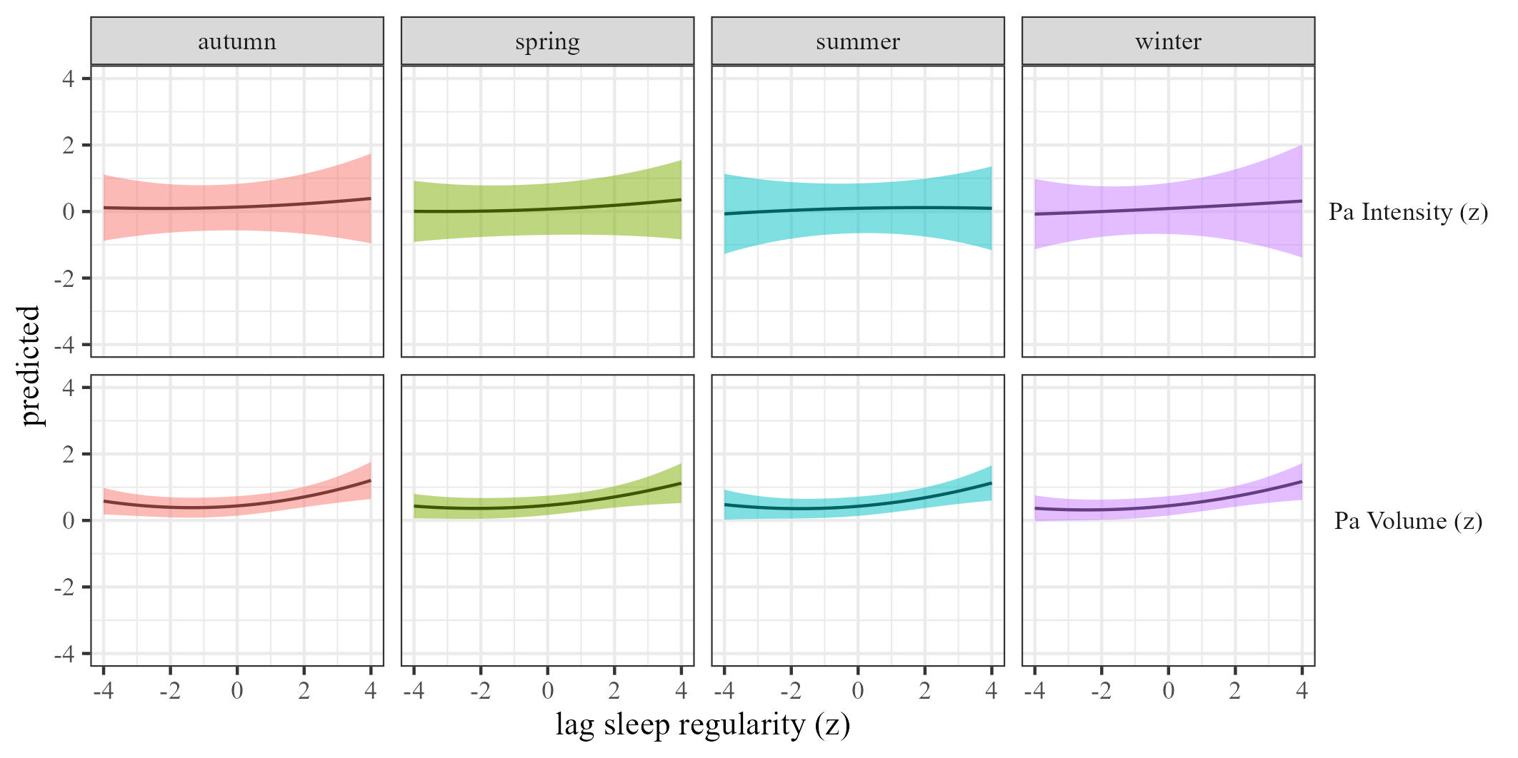 ## region

### The effects of physical activity volume on sleep.

We estimated the effects of physical activity on sleep (RQ1) using mixed-effects models We estimated the effect of physical activity volume on sleep by region, and the results are presented in Table 13 and Figure 37

Table 13:

*Physical activity on sleep controlling for SES, gender and BMI*

| Term | $β$ [95% CI] | SE | t | p | $β$ [95% CI] | SE | t | p |
| --- | --- | --- | --- | --- | --- | --- | --- | --- |
| Sleep duration |  |  |  |  |  |  |  |  |
| (Intercept) | 0.58 [0.35, 0.82] | 0.12 | 4.89 | < .001 | 0.59 [0.30, 0.88] | 0.15 | 3.96 | .003 |
| Physical activity | 0.11 [0.00, 0.22] | 0.06 | 1.88 | .124 | 0.07 [-0.36, 0.50] | 0.22 | 0.33 | .772 |
| Regioneurope | -0.15 [-0.32, 0.03] | 0.09 | -1.65 | .100 | -0.13 [-0.30, 0.05] | 0.09 | -1.42 | .155 |
| Regionafrica | -0.10 [-0.39, 0.19] | 0.15 | -0.66 | .532 | -0.16 [-0.46, 0.14] | 0.15 | -1.04 | .335 |
| Regionasia | -0.31 [-0.55, -0.07] | 0.12 | -2.55 | .016 | -0.54 [-0.77, -0.32] | 0.12 | -4.71 | < .001 |
| Regionnorth america | -0.04 [-0.27, 0.20] | 0.12 | -0.30 | .764 | -0.07 [-0.27, 0.14] | 0.10 | -0.64 | .520 |
| Regionsouth america | -0.35 [-0.54, -0.16] | 0.10 | -3.60 | .001 | -0.42 [-0.60, -0.24] | 0.09 | -4.47 | < .001 |
| Physical activity $​^{2}$ | -0.01 [-0.03, 0.01] | 0.01 | -1.28 | .228 | 0.01 [-0.09, 0.11] | 0.05 | 0.18 | .865 |
| Age | 0.00 [-0.01, 0.00] | 0.00 | -1.79 | .074 | 0.00 [-0.01, 0.00] | 0.00 | -1.30 | .259 |
| Physical activity $×$ regioneurope | 0.00 [-0.11, 0.11] | 0.06 | -0.05 | .963 | 0.00 [-0.26, 0.25] | 0.13 | -0.01 | .990 |
| Physical activity $×$ regionafrica | 0.15 [-0.06, 0.37] | 0.11 | 1.38 | .237 | 0.03 [-0.31, 0.36] | 0.17 | 0.16 | .885 |
| Physical activity $×$ regionasia | 0.27 [0.07, 0.48] | 0.11 | 2.58 | .047 | -0.02 [-0.37, 0.33] | 0.18 | -0.10 | .928 |
| Physical activity $×$ regionnorth america | 0.08 [-0.06, 0.21] | 0.07 | 1.12 | .261 | -0.08 [-0.27, 0.12] | 0.10 | -0.75 | .460 |
| Physical activity $×$ regionsouth america | 0.13 [0.02, 0.25] | 0.06 | 2.23 | .038 | -0.08 [-0.28, 0.12] | 0.10 | -0.79 | .470 |
| Regioneurope $×$ Physical activity $​^{2}$ | 0.01 [-0.01, 0.03] | 0.01 | 0.77 | .461 | 0.01 [-0.12, 0.13] | 0.06 | 0.10 | .926 |
| Regionafrica $×$ Physical activity $​^{2}$ | -0.04 [-0.12, 0.04] | 0.04 | -0.92 | .397 | 0.01 [-0.16, 0.18] | 0.09 | 0.11 | .917 |
| Regionasia $×$ Physical activity $​^{2}$ | -0.07 [-0.17, 0.04] | 0.05 | -1.29 | .262 | 0.15 [-0.22, 0.52] | 0.19 | 0.79 | .496 |
| Regionnorth america $×$ Physical activity $​^{2}$ | -0.02 [-0.06, 0.03] | 0.02 | -0.76 | .445 | 0.06 [-0.07, 0.18] | 0.06 | 0.93 | .369 |
| Regionsouth america $×$ Physical activity $​^{2}$ | 0.00 [-0.04, 0.04] | 0.02 | 0.09 | .929 | 0.09 [-0.08, 0.27] | 0.09 | 1.03 | .385 |
| Sleep efficency |  |  |  |  |  |  |  |  |
| (Intercept) | 0.24 [-0.07, 0.55] | 0.16 | 1.50 | .185 | 0.31 [-0.04, 0.66] | 0.18 | 1.75 | .143 |
| Physical activity | -0.04 [-0.24, 0.16] | 0.10 | -0.38 | .737 | -0.08 [-0.30, 0.15] | 0.11 | -0.66 | .561 |
| Regioneurope | -0.17 [-0.35, 0.00] | 0.09 | -1.97 | .052 | -0.17 [-0.36, 0.01] | 0.09 | -1.89 | .063 |
| Regionafrica | -0.08 [-0.27, 0.12] | 0.10 | -0.77 | .445 | -0.13 [-0.35, 0.09] | 0.11 | -1.17 | .247 |
| Regionasia | -0.22 [-0.43, -0.01] | 0.11 | -2.09 | .038 | -0.48 [-0.69, -0.27] | 0.11 | -4.53 | < .001 |
| Regionnorth america | -0.08 [-0.28, 0.11] | 0.10 | -0.83 | .407 | -0.15 [-0.35, 0.05] | 0.10 | -1.43 | .154 |
| Regionsouth america | -0.32 [-0.51, -0.12] | 0.10 | -3.19 | .003 | -0.47 [-0.68, -0.26] | 0.11 | -4.35 | < .001 |
| Physical activity $​^{2}$ | 0.00 [-0.03, 0.03] | 0.02 | 0.22 | .841 | 0.00 [-0.04, 0.05] | 0.03 | 0.19 | .853 |
| Age | 0.00 [0.00, 0.01] | 0.00 | 0.99 | .341 | 0.00 [0.00, 0.00] | 0.00 | 0.44 | .660 |
| Physical activity $×$ regioneurope | 0.08 [0.01, 0.15] | 0.03 | 2.23 | .026 | 0.04 [-0.12, 0.19] | 0.08 | 0.44 | .678 |
| Physical activity $×$ regionafrica | 0.18 [-0.09, 0.44] | 0.13 | 1.31 | .283 | 0.05 [-0.36, 0.47] | 0.21 | 0.25 | .822 |
| Physical activity $×$ regionasia | 0.40 [0.15, 0.65] | 0.13 | 3.10 | .047 | 0.10 [-0.42, 0.62] | 0.27 | 0.38 | .732 |
| Physical activity $×$ regionnorth america | 0.15 [-0.22, 0.53] | 0.19 | 0.80 | .492 | 0.02 [-0.28, 0.31] | 0.15 | 0.11 | .916 |
| Physical activity $×$ regionsouth america | 0.33 [0.18, 0.48] | 0.08 | 4.37 | .008 | -0.01 [-0.37, 0.35] | 0.18 | -0.05 | .963 |
| Regioneurope $×$ Physical activity $​^{2}$ | -0.01 [-0.03, 0.01] | 0.01 | -1.17 | .245 | -0.02 [-0.09, 0.05] | 0.04 | -0.49 | .645 |
| Regionafrica $×$ Physical activity $​^{2}$ | -0.03 [-0.10, 0.05] | 0.04 | -0.73 | .496 | -0.02 [-0.20, 0.16] | 0.09 | -0.18 | .865 |
| Regionasia $×$ Physical activity $​^{2}$ | -0.08 [-0.15, -0.02] | 0.03 | -2.41 | .028 | 0.03 [-0.16, 0.21] | 0.09 | 0.31 | .770 |
| Regionnorth america $×$ Physical activity $​^{2}$ | -0.02 [-0.06, 0.02] | 0.02 | -1.02 | .312 | 0.02 [-0.14, 0.18] | 0.08 | 0.22 | .836 |
| Regionsouth america $×$ Physical activity $​^{2}$ | -0.05 [-0.10, -0.01] | 0.02 | -2.21 | .069 | 0.03 [-0.14, 0.19] | 0.08 | 0.33 | .766 |
| Sleep onset |  |  |  |  |  |  |  |  |
| (Intercept) | 0.05 [-0.55, 0.64] | 0.30 | 0.15 | .889 | 0.08 [-0.65, 0.81] | 0.37 | 0.21 | .845 |
| Physical activity | 0.07 [-0.25, 0.40] | 0.16 | 0.45 | .692 | 0.15 [-0.15, 0.45] | 0.15 | 0.97 | .424 |
| Regioneurope | 0.10 [-0.06, 0.25] | 0.08 | 1.24 | .218 | 0.08 [-0.08, 0.24] | 0.08 | 0.99 | .322 |
| Regionafrica | -0.01 [-0.22, 0.20] | 0.11 | -0.11 | .911 | -0.16 [-0.60, 0.27] | 0.22 | -0.74 | .514 |
| Regionasia | 0.22 [0.02, 0.41] | 0.10 | 2.21 | .031 | -0.04 [-0.45, 0.38] | 0.21 | -0.18 | .869 |
| Regionnorth america | 0.04 [-0.14, 0.22] | 0.09 | 0.45 | .656 | -0.21 [-0.61, 0.20] | 0.21 | -0.99 | .394 |
| Regionsouth america | -0.06 [-0.34, 0.21] | 0.14 | -0.45 | .678 | -0.21 [-0.73, 0.31] | 0.27 | -0.79 | .501 |
| Physical activity $​^{2}$ | -0.02 [-0.06, 0.03] | 0.02 | -0.69 | .553 | -0.06 [-0.17, 0.06] | 0.06 | -0.99 | .406 |
| Age | 0.00 [0.00, 0.01] | 0.00 | 0.57 | .591 | 0.00 [0.00, 0.00] | 0.00 | 0.69 | .491 |
| Physical activity $×$ regioneurope | -0.04 [-0.13, 0.05] | 0.05 | -0.95 | .377 | -0.12 [-0.38, 0.13] | 0.13 | -0.95 | .425 |
| Physical activity $×$ regionafrica | 0.30 [-0.14, 0.74] | 0.22 | 1.35 | .299 | 0.04 [-0.30, 0.37] | 0.17 | 0.21 | .845 |
| Physical activity $×$ regionasia | 0.25 [-0.15, 0.65] | 0.21 | 1.23 | .329 | 0.05 [-0.32, 0.42] | 0.19 | 0.27 | .806 |
| Physical activity $×$ regionnorth america | 0.35 [-0.17, 0.87] | 0.26 | 1.32 | .310 | 0.01 [-0.20, 0.23] | 0.11 | 0.13 | .901 |
| Physical activity $×$ regionsouth america | 0.20 [-0.05, 0.44] | 0.13 | 1.57 | .233 | -0.08 [-0.28, 0.12] | 0.10 | -0.77 | .489 |
| Regioneurope $×$ Physical activity $​^{2}$ | 0.01 [-0.01, 0.04] | 0.01 | 1.00 | .370 | 0.08 [-0.06, 0.23] | 0.08 | 1.10 | .372 |
| Regionafrica $×$ Physical activity $​^{2}$ | 0.01 [-0.05, 0.07] | 0.03 | 0.33 | .747 | 0.13 [-0.13, 0.39] | 0.13 | 0.98 | .413 |
| Regionasia $×$ Physical activity $​^{2}$ | -0.02 [-0.08, 0.04] | 0.03 | -0.66 | .513 | 0.21 [-0.29, 0.72] | 0.26 | 0.82 | .491 |
| Regionnorth america $×$ Physical activity $​^{2}$ | -0.02 [-0.08, 0.03] | 0.03 | -0.81 | .457 | 0.17 [-0.10, 0.44] | 0.14 | 1.21 | .327 |
| Regionsouth america $×$ Physical activity $​^{2}$ | 0.03 [-0.05, 0.10] | 0.04 | 0.69 | .548 | 0.16 [-0.19, 0.52] | 0.18 | 0.90 | .457 |
| Sleep regularity |  |  |  |  |  |  |  |  |
| (Intercept) | -0.24 [-0.69, 0.21] | 0.23 | -1.04 | .362 | -0.15 [-0.66, 0.36] | 0.26 | -0.58 | .601 |
| Physical activity | 0.08 [-0.01, 0.17] | 0.05 | 1.77 | .121 | 0.09 [-0.01, 0.20] | 0.05 | 1.70 | .131 |
| Regioneurope | 0.21 [0.03, 0.39] | 0.09 | 2.35 | .021 | 0.16 [-0.03, 0.35] | 0.10 | 1.64 | .107 |
| Regionafrica | 0.35 [0.15, 0.54] | 0.10 | 3.50 | .001 | 0.38 [0.17, 0.60] | 0.11 | 3.49 | .001 |
| Regionasia | 0.29 [0.09, 0.50] | 0.10 | 2.84 | .005 | 0.27 [-0.03, 0.57] | 0.15 | 1.79 | .119 |
| Regionnorth america | 0.01 [-0.25, 0.28] | 0.13 | 0.10 | .926 | 0.01 [-0.33, 0.35] | 0.17 | 0.06 | .957 |
| Regionsouth america | 0.06 [-0.17, 0.28] | 0.11 | 0.49 | .635 | -0.05 [-0.42, 0.32] | 0.19 | -0.26 | .808 |
| Physical activity $​^{2}$ | -0.01 [-0.02, 0.01] | 0.01 | -1.04 | .307 | -0.05 [-0.13, 0.04] | 0.04 | -1.08 | .355 |
| Age | 0.00 [-0.01, 0.00] | 0.00 | -0.81 | .424 | 0.00 [-0.01, 0.00] | 0.00 | -1.19 | .236 |
| Physical activity $×$ regioneurope | 0.06 [-0.02, 0.15] | 0.05 | 1.42 | .183 | -0.05 [-0.16, 0.06] | 0.05 | -0.88 | .402 |
| Physical activity $×$ regionafrica | -0.16 [-0.46, 0.13] | 0.15 | -1.09 | .363 | -0.03 [-0.17, 0.12] | 0.07 | -0.37 | .711 |
| Physical activity $×$ regionasia | -0.09 [-0.39, 0.21] | 0.15 | -0.59 | .598 | 0.01 [-0.23, 0.25] | 0.12 | 0.07 | .947 |
| Physical activity $×$ regionnorth america | -0.06 [-0.19, 0.06] | 0.06 | -0.99 | .327 | -0.02 [-0.18, 0.14] | 0.08 | -0.23 | .820 |
| Physical activity $×$ regionsouth america | 0.05 [-0.12, 0.21] | 0.08 | 0.58 | .597 | 0.06 [-0.10, 0.22] | 0.08 | 0.74 | .489 |
| Regioneurope $×$ Physical activity $​^{2}$ | -0.03 [-0.05, -0.01] | 0.01 | -3.64 | < .001 | 0.03 [-0.02, 0.08] | 0.02 | 1.24 | .232 |
| Regionafrica $×$ Physical activity $​^{2}$ | -0.03 [-0.09, 0.03] | 0.03 | -1.08 | .307 | -0.08 [-0.22, 0.06] | 0.07 | -1.17 | .308 |
| Regionasia $×$ Physical activity $​^{2}$ | -0.04 [-0.13, 0.05] | 0.05 | -0.95 | .389 | -0.06 [-0.45, 0.33] | 0.20 | -0.31 | .786 |
| Regionnorth america $×$ Physical activity $​^{2}$ | -0.02 [-0.06, 0.03] | 0.02 | -0.77 | .446 | -0.04 [-0.15, 0.07] | 0.06 | -0.72 | .485 |
| Regionsouth america $×$ Physical activity $​^{2}$ | -0.06 [-0.09, -0.02] | 0.02 | -3.04 | .009 | -0.04 [-0.23, 0.15] | 0.10 | -0.41 | .716 |

*Note.* Adjusted for SES, BMI, and sex.

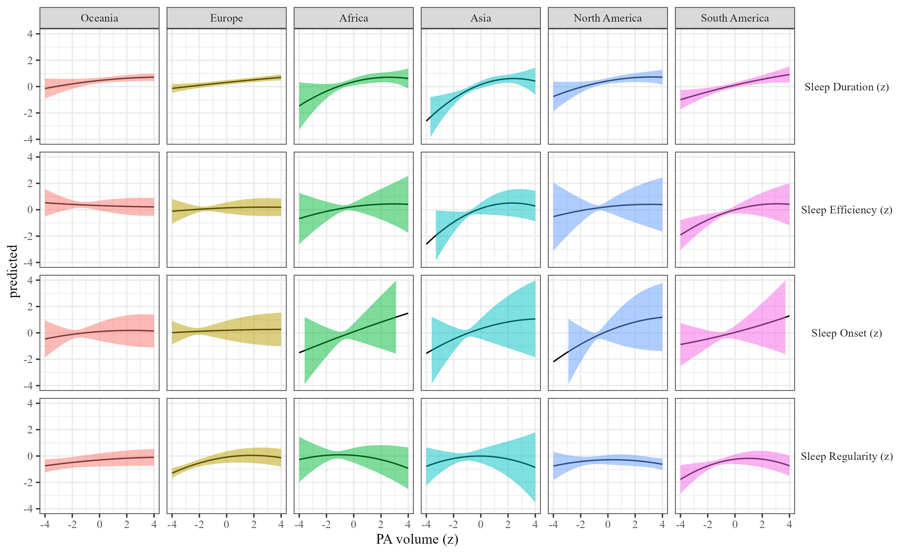

Figure 37: Sleep metrics on Physical activity volume by region

### The effects of physical activity intensity on sleep by region.

We estimated how physical activity intensity affects sleep across region We present the results in Table 13 and Figure 38.

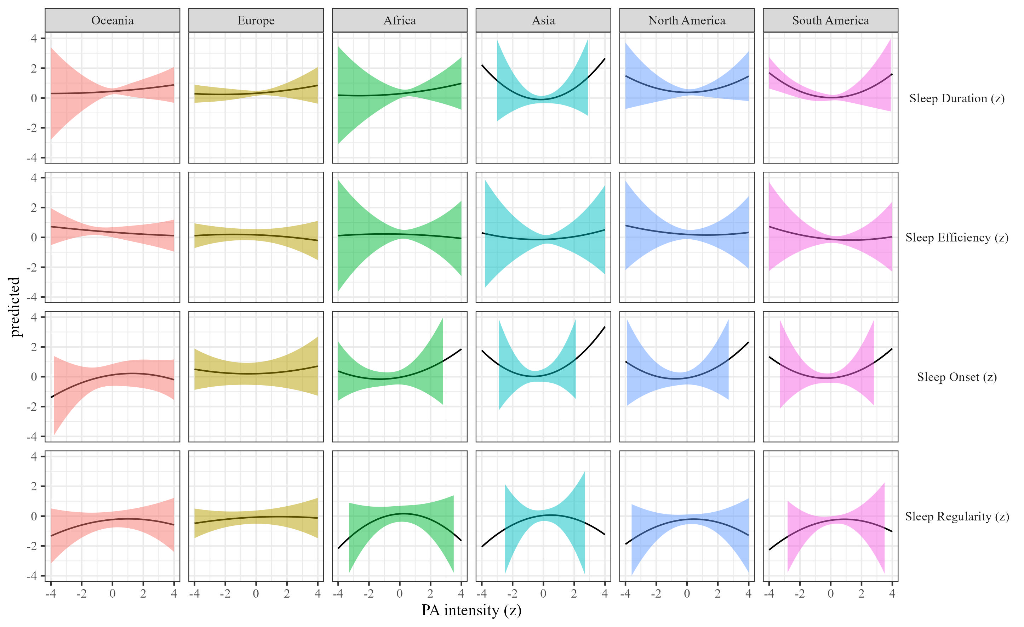

Figure 38: Sleep metrics on Physical activity intensity moderated by region

### The effects of sleep duration on physical activity.

We estimated the effect of sleep duration on physical activity by region Results, controlling for sex, SES, and BMI are presented in Table 2 and Figure 39.

Table 14:

*Sleep on physical activity controlling for SES, gender and BMI*

| Term | $β$ [95% CI] | SE | t | p | $β$ [95% CI] | SE | t | p |
| --- | --- | --- | --- | --- | --- | --- | --- | --- |
| Sleep duration |  |  |  |  |  |  |  |  |
| (Intercept) | 1.41 [1.10, 1.72] | 0.16 | 8.99 | < .001 | 0.94 [0.14, 1.73] | 0.40 | 2.31 | .132 |
| Sleep duration | 0.03 [-0.02, 0.08] | 0.03 | 1.23 | .230 | 0.03 [-0.06, 0.12] | 0.04 | 0.65 | .564 |
| Regioneurope | -0.23 [-0.42, -0.03] | 0.10 | -2.27 | .028 | -0.10 [-0.27, 0.07] | 0.09 | -1.14 | .268 |
| Regionafrica | -0.23 [-0.54, 0.07] | 0.16 | -1.48 | .191 | -0.03 [-0.35, 0.29] | 0.16 | -0.19 | .862 |
| Regionasia | -0.50 [-0.77, -0.24] | 0.14 | -3.68 | .004 | -0.32 [-0.60, -0.04] | 0.14 | -2.23 | .081 |
| Regionnorth america | -0.47 [-0.77, -0.17] | 0.15 | -3.10 | .018 | -0.16 [-0.62, 0.30] | 0.23 | -0.68 | .553 |
| Regionsouth america | -0.64 [-0.91, -0.37] | 0.14 | -4.67 | .003 | -0.27 [-0.86, 0.33] | 0.31 | -0.87 | .467 |
| Sleep duration $​^{2}$ | 0.00 [-0.06, 0.06] | 0.03 | -0.08 | .939 | -0.03 [-0.13, 0.08] | 0.05 | -0.51 | .658 |
| Age | -0.02 [-0.02, -0.01] | 0.00 | -10.45 | < .001 | -0.02 [-0.02, -0.02] | 0.00 | -12.81 | < .001 |
| Sleep duration $×$ regioneurope | -0.06 [-0.12, 0.00] | 0.03 | -1.81 | .108 | -0.02 [-0.10, 0.05] | 0.04 | -0.64 | .564 |
| Sleep duration $×$ regionafrica | -0.11 [-0.42, 0.20] | 0.16 | -0.71 | .544 | -0.07 [-0.28, 0.15] | 0.11 | -0.60 | .601 |
| Sleep duration $×$ regionasia | -0.11 [-0.48, 0.26] | 0.19 | -0.58 | .615 | -0.07 [-0.23, 0.09] | 0.08 | -0.84 | .465 |
| Sleep duration $×$ regionnorth america | 0.08 [-0.22, 0.38] | 0.15 | 0.52 | .649 | -0.05 [-0.27, 0.18] | 0.12 | -0.40 | .721 |
| Sleep duration $×$ regionsouth america | -0.04 [-0.25, 0.16] | 0.11 | -0.40 | .720 | -0.05 [-0.20, 0.10] | 0.08 | -0.65 | .571 |
| Regioneurope $×$ Sleep duration $​^{2}$ | 0.01 [-0.05, 0.07] | 0.03 | 0.27 | .808 | 0.01 [-0.04, 0.06] | 0.02 | 0.40 | .716 |
| Regionafrica $×$ Sleep duration $​^{2}$ | 0.06 [-0.10, 0.22] | 0.08 | 0.76 | .517 | -0.01 [-0.18, 0.15] | 0.08 | -0.18 | .873 |
| Regionasia $×$ Sleep duration $​^{2}$ | 0.06 [-0.12, 0.25] | 0.09 | 0.65 | .572 | -0.01 [-0.14, 0.13] | 0.07 | -0.09 | .932 |
| Regionnorth america $×$ Sleep duration $​^{2}$ | 0.04 [-0.05, 0.12] | 0.04 | 0.89 | .438 | 0.01 [-0.03, 0.05] | 0.02 | 0.44 | .664 |
| Regionsouth america $×$ Sleep duration $​^{2}$ | 0.04 [-0.03, 0.11] | 0.04 | 1.12 | .349 | 0.02 [0.00, 0.05] | 0.01 | 1.66 | .106 |
| Sleep efficency |  |  |  |  |  |  |  |  |
| (Intercept) | 1.43 [1.12, 1.74] | 0.16 | 9.05 | < .001 | 0.90 [-0.05, 1.85] | 0.49 | 1.86 | .194 |
| Sleep efficiency | -0.09 [-0.19, 0.01] | 0.05 | -1.73 | .131 | -0.05 [-0.26, 0.16] | 0.11 | -0.44 | .697 |
| Regioneurope | -0.24 [-0.42, -0.06] | 0.09 | -2.61 | .010 | -0.10 [-0.31, 0.11] | 0.11 | -0.90 | .403 |
| Regionafrica | -0.13 [-0.32, 0.06] | 0.10 | -1.32 | .188 | -0.05 [-0.22, 0.12] | 0.09 | -0.61 | .546 |
| Regionasia | -0.40 [-0.59, -0.20] | 0.10 | -3.97 | < .001 | -0.30 [-0.49, -0.12] | 0.10 | -3.21 | .004 |
| Regionnorth america | -0.43 [-0.62, -0.23] | 0.10 | -4.30 | < .001 | -0.18 [-0.60, 0.25] | 0.22 | -0.81 | .484 |
| Regionsouth america | -0.64 [-0.84, -0.44] | 0.10 | -6.28 | < .001 | -0.25 [-0.94, 0.44] | 0.35 | -0.71 | .545 |
| Sleep efficiency $​^{2}$ | -0.02 [-0.04, 0.00] | 0.01 | -1.61 | .135 | -0.01 [-0.07, 0.05] | 0.03 | -0.29 | .794 |
| Age | -0.02 [-0.02, -0.01] | 0.00 | -10.20 | < .001 | -0.02 [-0.02, -0.02] | 0.00 | -12.81 | < .001 |
| Sleep efficiency $×$ regioneurope | 0.11 [-0.01, 0.23] | 0.06 | 1.85 | .122 | 0.06 [-0.13, 0.24] | 0.09 | 0.61 | .594 |
| Sleep efficiency $×$ regionafrica | 0.29 [0.12, 0.45] | 0.08 | 3.41 | .011 | -0.03 [-0.29, 0.22] | 0.13 | -0.26 | .816 |
| Sleep efficiency $×$ regionasia | 0.30 [0.14, 0.46] | 0.08 | 3.62 | .005 | 0.09 [-0.06, 0.24] | 0.08 | 1.14 | .294 |
| Sleep efficiency $×$ regionnorth america | 0.00 [-0.22, 0.22] | 0.11 | -0.03 | .975 | 0.05 [-0.38, 0.48] | 0.22 | 0.23 | .840 |
| Sleep efficiency $×$ regionsouth america | 0.03 [-0.09, 0.14] | 0.06 | 0.42 | .681 | 0.05 [-0.22, 0.32] | 0.14 | 0.38 | .737 |
| Regioneurope $×$ Sleep efficiency $​^{2}$ | 0.03 [0.00, 0.06] | 0.02 | 2.28 | .055 | 0.01 [-0.02, 0.04] | 0.02 | 0.65 | .545 |
| Regionafrica $×$ Sleep efficiency $​^{2}$ | 0.04 [0.01, 0.07] | 0.02 | 2.87 | .005 | -0.01 [-0.04, 0.02] | 0.01 | -0.61 | .551 |
| Regionasia $×$ Sleep efficiency $​^{2}$ | 0.06 [0.02, 0.11] | 0.02 | 2.73 | .011 | 0.01 [-0.02, 0.04] | 0.02 | 0.55 | .585 |
| Regionnorth america $×$ Sleep efficiency $​^{2}$ | 0.01 [-0.04, 0.07] | 0.03 | 0.55 | .611 | 0.02 [-0.05, 0.09] | 0.03 | 0.59 | .600 |
| Regionsouth america $×$ Sleep efficiency $​^{2}$ | 0.01 [-0.02, 0.04] | 0.01 | 0.77 | .455 | 0.01 [-0.05, 0.07] | 0.03 | 0.38 | .733 |
| Sleep onset |  |  |  |  |  |  |  |  |
| (Intercept) | 1.33 [1.01, 1.65] | 0.16 | 8.11 | < .001 | 0.88 [0.03, 1.73] | 0.43 | 2.04 | .164 |
| Sleep onset | -0.09 [-0.21, 0.03] | 0.06 | -1.44 | .230 | -0.03 [-0.17, 0.11] | 0.07 | -0.42 | .704 |
| Regioneurope | -0.11 [-0.30, 0.08] | 0.10 | -1.15 | .252 | -0.08 [-0.24, 0.08] | 0.08 | -0.94 | .351 |
| Regionafrica | 0.12 [-0.34, 0.58] | 0.24 | 0.50 | .642 | -0.10 [-0.47, 0.27] | 0.19 | -0.53 | .623 |
| Regionasia | -0.34 [-0.59, -0.09] | 0.13 | -2.62 | .009 | -0.27 [-0.49, -0.06] | 0.11 | -2.47 | .015 |
| Regionnorth america | -0.43 [-0.80, -0.06] | 0.19 | -2.29 | .061 | -0.09 [-0.72, 0.55] | 0.32 | -0.26 | .812 |
| Regionsouth america | -0.53 [-0.77, -0.29] | 0.12 | -4.30 | < .001 | -0.22 [-0.85, 0.42] | 0.32 | -0.67 | .564 |
| Sleep onset $​^{2}$ | 0.03 [-0.02, 0.08] | 0.03 | 1.11 | .305 | -0.01 [-0.11, 0.09] | 0.05 | -0.20 | .855 |
| Age | -0.02 [-0.02, -0.01] | 0.00 | -10.28 | < .001 | -0.02 [-0.02, -0.02] | 0.00 | -12.78 | < .001 |
| Sleep onset $×$ regioneurope | 0.06 [-0.04, 0.16] | 0.05 | 1.15 | .296 | 0.03 [-0.09, 0.15] | 0.06 | 0.46 | .672 |
| Sleep onset $×$ regionafrica | 0.08 [-0.35, 0.50] | 0.22 | 0.36 | .731 | 0.03 [-0.29, 0.34] | 0.16 | 0.16 | .877 |
| Sleep onset $×$ regionasia | -0.31 [-1.22, 0.60] | 0.46 | -0.67 | .551 | -0.02 [-0.93, 0.90] | 0.47 | -0.03 | .976 |
| Sleep onset $×$ regionnorth america | 0.01 [-0.19, 0.22] | 0.10 | 0.14 | .893 | 0.07 [-0.13, 0.28] | 0.10 | 0.67 | .523 |
| Sleep onset $×$ regionsouth america | 0.03 [-0.12, 0.18] | 0.08 | 0.40 | .705 | 0.02 [-0.08, 0.13] | 0.05 | 0.41 | .692 |
| Regioneurope $×$ Sleep onset $​^{2}$ | -0.04 [-0.09, 0.01] | 0.02 | -1.66 | .121 | 0.01 [-0.08, 0.10] | 0.05 | 0.24 | .830 |
| Regionafrica $×$ Sleep onset $​^{2}$ | -0.18 [-0.59, 0.24] | 0.21 | -0.83 | .468 | 0.06 [-0.50, 0.61] | 0.28 | 0.20 | .857 |
| Regionasia $×$ Sleep onset $​^{2}$ | -0.38 [-1.15, 0.40] | 0.40 | -0.95 | .424 | -0.07 [-0.92, 0.79] | 0.44 | -0.15 | .893 |
| Regionnorth america $×$ Sleep onset $​^{2}$ | 0.05 [-0.22, 0.31] | 0.13 | 0.34 | .758 | 0.00 [-0.15, 0.15] | 0.08 | -0.03 | .980 |
| Regionsouth america $×$ Sleep onset $​^{2}$ | -0.04 [-0.11, 0.04] | 0.04 | -1.01 | .345 | 0.00 [-0.06, 0.06] | 0.03 | -0.07 | .948 |
| Sleep regularity |  |  |  |  |  |  |  |  |
| (Intercept) | 1.41 [1.11, 1.71] | 0.15 | 9.17 | < .001 | 0.90 [-0.02, 1.82] | 0.47 | 1.91 | .185 |
| Sleep regularity | 0.06 [0.00, 0.13] | 0.03 | 1.88 | .109 | 0.04 [0.00, 0.08] | 0.02 | 1.78 | .089 |
| Regioneurope | -0.25 [-0.46, -0.04] | 0.11 | -2.35 | .031 | -0.11 [-0.28, 0.07] | 0.09 | -1.19 | .253 |
| Regionafrica | -0.22 [-0.53, 0.10] | 0.16 | -1.35 | .237 | -0.10 [-0.33, 0.13] | 0.12 | -0.82 | .438 |
| Regionasia | -0.49 [-0.72, -0.25] | 0.12 | -4.10 | < .001 | -0.34 [-0.58, -0.11] | 0.12 | -2.88 | .022 |
| Regionnorth america | -0.44 [-0.71, -0.18] | 0.14 | -3.27 | .009 | -0.14 [-0.53, 0.25] | 0.20 | -0.70 | .537 |
| Regionsouth america | -0.64 [-0.84, -0.44] | 0.10 | -6.19 | < .001 | -0.25 [-0.89, 0.40] | 0.33 | -0.74 | .528 |
| Sleep regularity $​^{2}$ | 0.00 [-0.04, 0.04] | 0.02 | -0.09 | .930 | 0.00 [-0.05, 0.04] | 0.02 | -0.03 | .979 |
| Age | -0.02 [-0.02, -0.01] | 0.00 | -9.94 | < .001 | -0.02 [-0.02, -0.02] | 0.00 | -12.93 | < .001 |
| Sleep regularity $×$ regioneurope | 0.02 [-0.05, 0.08] | 0.03 | 0.50 | .630 | -0.01 [-0.07, 0.05] | 0.03 | -0.23 | .824 |
| Sleep regularity $×$ regionafrica | 0.02 [-0.32, 0.36] | 0.17 | 0.13 | .905 | 0.01 [-0.19, 0.20] | 0.10 | 0.06 | .960 |
| Sleep regularity $×$ regionasia | 0.01 [-0.30, 0.33] | 0.16 | 0.09 | .933 | 0.02 [-0.14, 0.18] | 0.08 | 0.25 | .815 |
| Sleep regularity $×$ regionnorth america | 0.22 [-0.07, 0.51] | 0.15 | 1.50 | .255 | -0.01 [-0.38, 0.37] | 0.19 | -0.03 | .979 |
| Sleep regularity $×$ regionsouth america | 0.03 [-0.14, 0.20] | 0.09 | 0.37 | .743 | 0.03 [-0.09, 0.15] | 0.06 | 0.48 | .663 |
| Regioneurope $×$ Sleep regularity $​^{2}$ | 0.02 [-0.03, 0.07] | 0.03 | 0.78 | .479 | 0.00 [-0.04, 0.05] | 0.02 | 0.15 | .884 |
| Regionafrica $×$ Sleep regularity $​^{2}$ | 0.04 [-0.12, 0.19] | 0.08 | 0.45 | .688 | 0.01 [-0.09, 0.11] | 0.05 | 0.14 | .895 |
| Regionasia $×$ Sleep regularity $​^{2}$ | 0.03 [-0.09, 0.15] | 0.06 | 0.45 | .683 | 0.01 [-0.03, 0.06] | 0.02 | 0.49 | .624 |
| Regionnorth america $×$ Sleep regularity $​^{2}$ | 0.07 [-0.05, 0.20] | 0.06 | 1.19 | .326 | -0.02 [-0.09, 0.05] | 0.04 | -0.56 | .602 |
| Regionsouth america $×$ Sleep regularity $​^{2}$ | 0.04 [-0.05, 0.14] | 0.05 | 0.83 | .474 | 0.01 [-0.02, 0.05] | 0.02 | 0.90 | .371 |

*Note.* Adjusted for SES, BMI, and sex.

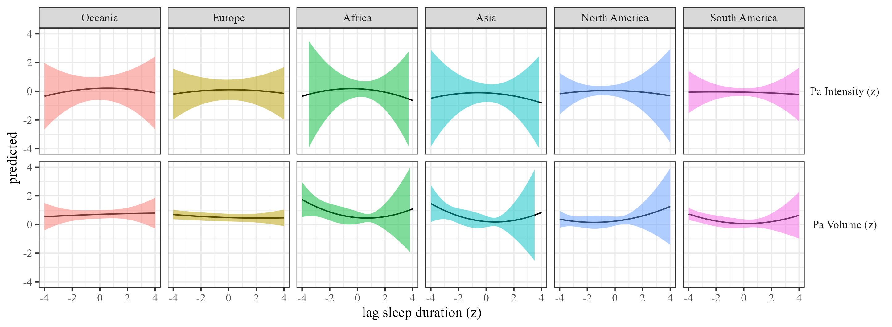

Figure 39: Physical activty by sleep duration moderated by region

### The effects of sleep efficiency on physical activity.

We estimated the effect of sleep efficiency on physical activity by region. Results, controlling for sex, SES, and BMI are presented in Table 14 and Figure 40.

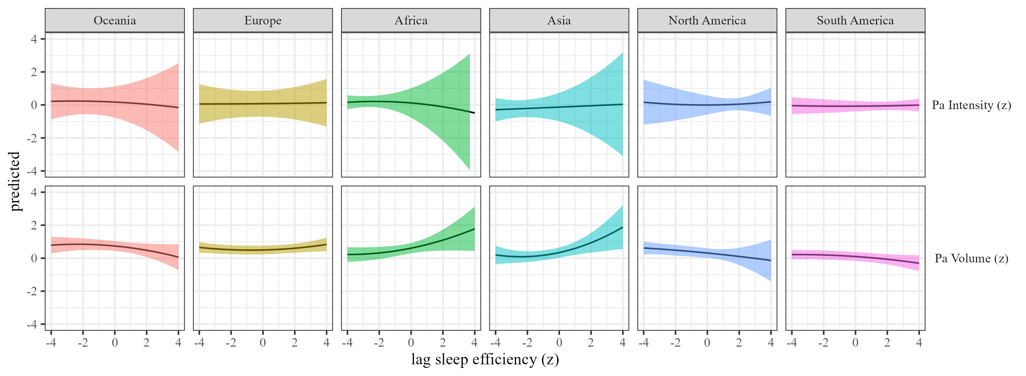

Figure 40: Physical activty by sleep efficiency moderated by region

### The effects of sleep onset on physical activity.

We estimated the effect of sleep onset on physical activity by region Results, controlling for sex, SES, and BMI are presented in Table 2 and Figure 41.

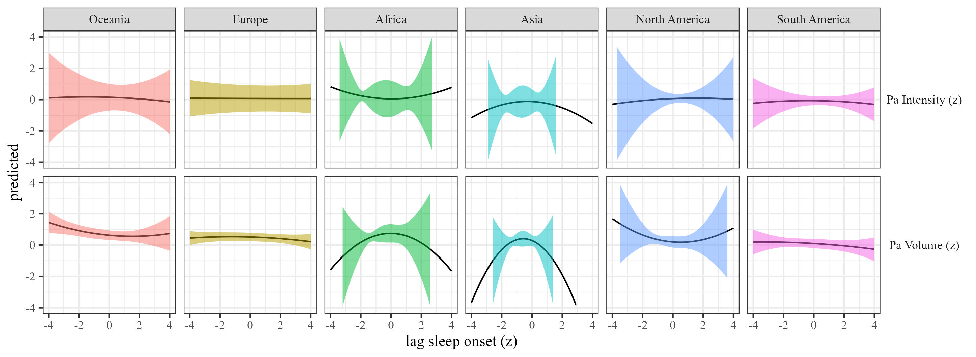

Figure 41: Physical activty by sleep onset moderated by region

### The effects of sleep regularity on physical activity.

We estimated the effect of sleep regularity on physical activity by region. Results are presented in Table 2 and Figure 42.

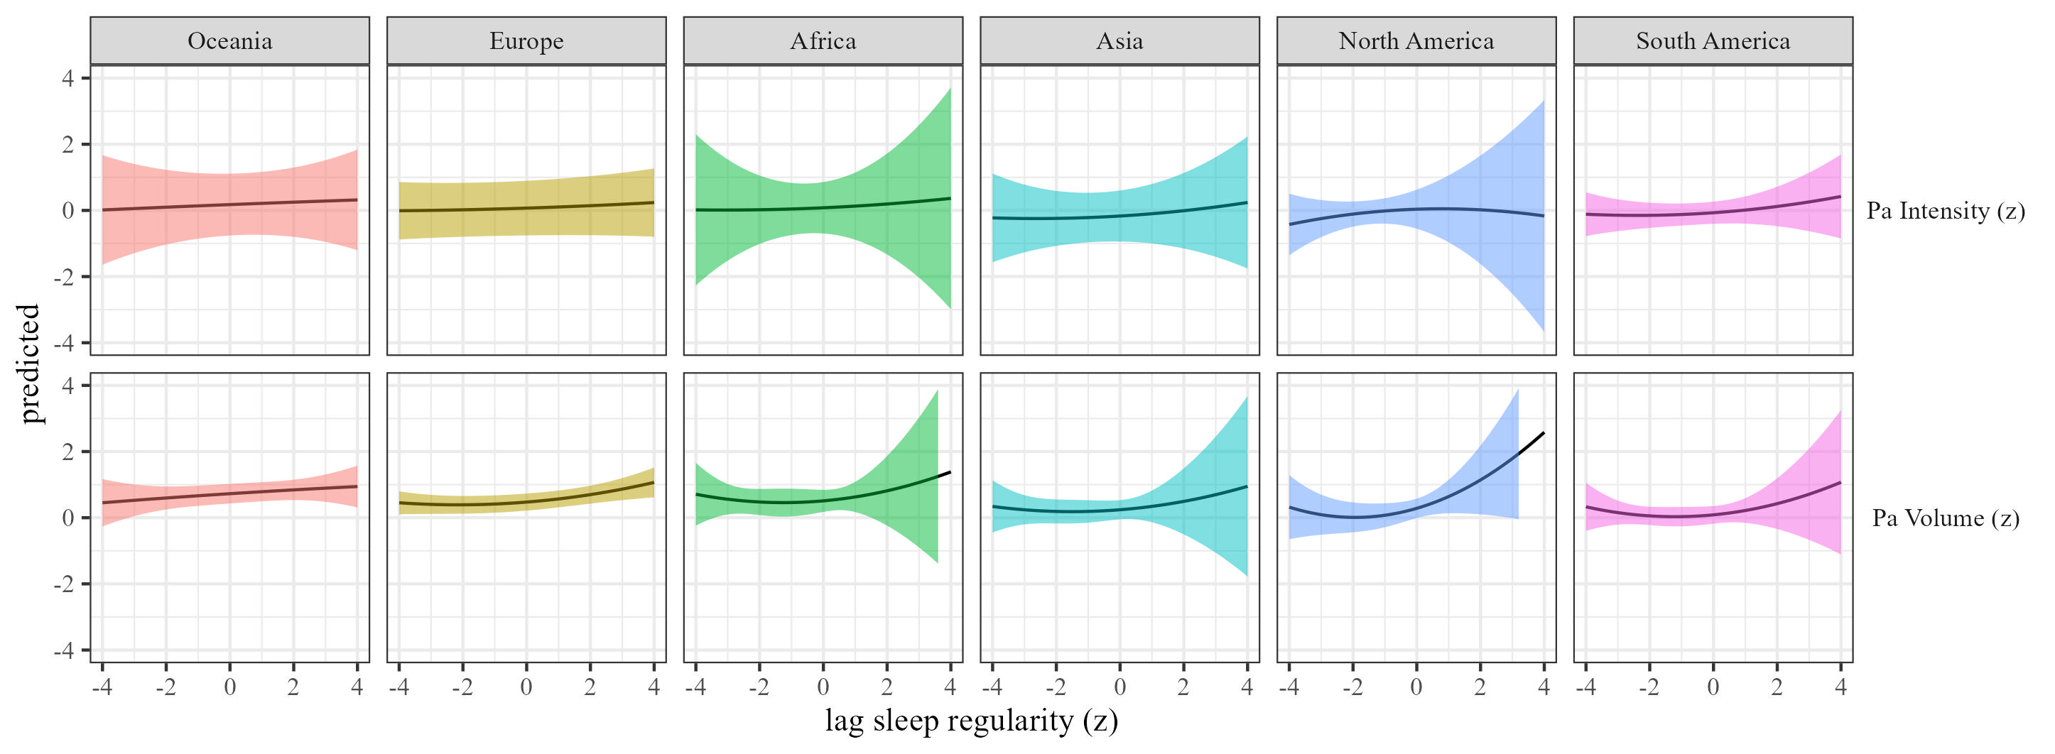 ## daylight hours

### The effects of physical activity volume on sleep.

We estimated the effects of physical activity on sleep (RQ1) using mixed-effects models We estimated the effect of physical activity volume on sleep by daylight hours, and the results are presented in Table 15 and Figure 43

Table 15:

*Physical activity on sleep controlling for SES, gender and BMI*

| Term | $β$ [95% CI] | SE | t | p | $β$ [95% CI] | SE | t | p |
| --- | --- | --- | --- | --- | --- | --- | --- | --- |
| Sleep duration |  |  |  |  |  |  |  |  |
| (Intercept) | 0.74 [0.44, 1.03] | 0.15 | 4.91 | < .001 | 0.80 [0.26, 1.34] | 0.28 | 2.89 | .063 |
| Physical activity | 0.18 [0.06, 0.30] | 0.06 | 2.95 | .003 | 0.05 [-0.13, 0.24] | 0.10 | 0.56 | .614 |
| Daylight hours | -0.03 [-0.04, -0.02] | 0.01 | -4.79 | < .001 | -0.03 [-0.04, -0.01] | 0.01 | -4.33 | < .001 |
| Physical activity $​^{2}$ | -0.05 [-0.09, 0.00] | 0.02 | -1.93 | .062 | 0.01 [-0.08, 0.09] | 0.04 | 0.14 | .894 |
| Age | 0.00 [-0.01, 0.00] | 0.00 | -0.96 | .340 | 0.00 [-0.01, 0.00] | 0.00 | -1.10 | .340 |
| Physical activity $×$ daylight hours | 0.00 [-0.01, 0.01] | 0.01 | -0.29 | .769 | 0.00 [-0.02, 0.02] | 0.01 | 0.10 | .927 |
| Daylight hours $×$ Physical activity $​^{2}$ | 0.00 [0.00, 0.01] | 0.00 | 1.30 | .203 | 0.00 [-0.01, 0.01] | 0.00 | 0.39 | .715 |
| Sleep efficency |  |  |  |  |  |  |  |  |
| (Intercept) | 0.09 [-0.25, 0.44] | 0.18 | 0.53 | .612 | 0.23 [-0.20, 0.67] | 0.22 | 1.05 | .353 |
| Physical activity | 0.11 [-0.38, 0.61] | 0.25 | 0.45 | .696 | -0.04 [-0.32, 0.23] | 0.14 | -0.31 | .785 |
| Daylight hours | 0.00 [-0.01, 0.01] | 0.01 | -0.16 | .873 | 0.00 [-0.01, 0.01] | 0.01 | -0.25 | .803 |
| Physical activity $​^{2}$ | -0.01 [-0.10, 0.07] | 0.05 | -0.32 | .769 | -0.01 [-0.12, 0.10] | 0.06 | -0.23 | .830 |
| Age | 0.00 [0.00, 0.01] | 0.00 | 1.51 | .178 | 0.00 [0.00, 0.01] | 0.00 | 0.65 | .530 |
| Physical activity $×$ daylight hours | 0.00 [-0.02, 0.02] | 0.01 | -0.14 | .900 | 0.00 [-0.01, 0.01] | 0.00 | -0.02 | .982 |
| Daylight hours $×$ Physical activity $​^{2}$ | 0.00 [-0.01, 0.00] | 0.00 | -0.09 | .935 | 0.00 [-0.01, 0.01] | 0.00 | 0.19 | .856 |
| Sleep onset |  |  |  |  |  |  |  |  |
| (Intercept) | -0.25 [-0.60, 0.10] | 0.18 | -1.42 | .178 | -0.25 [-0.72, 0.22] | 0.24 | -1.04 | .342 |
| Physical activity | 0.22 [-0.33, 0.77] | 0.28 | 0.79 | .510 | 0.07 [-0.21, 0.36] | 0.14 | 0.51 | .655 |
| Daylight hours | 0.01 [0.00, 0.02] | 0.01 | 1.62 | .127 | 0.01 [0.00, 0.02] | 0.01 | 2.34 | .019 |
| Physical activity $​^{2}$ | -0.03 [-0.11, 0.06] | 0.04 | -0.57 | .613 | 0.04 [-0.09, 0.18] | 0.07 | 0.62 | .583 |
| Age | 0.00 [0.00, 0.01] | 0.00 | 0.70 | .529 | 0.00 [0.00, 0.00] | 0.00 | 0.52 | .604 |
| Physical activity $×$ daylight hours | -0.01 [-0.02, 0.01] | 0.01 | -0.77 | .486 | 0.00 [-0.01, 0.01] | 0.01 | -0.09 | .934 |
| Daylight hours $×$ Physical activity $​^{2}$ | 0.00 [0.00, 0.01] | 0.00 | 0.19 | .856 | 0.00 [-0.01, 0.00] | 0.00 | -0.21 | .835 |
| Sleep regularity |  |  |  |  |  |  |  |  |
| (Intercept) | 0.25 [-0.36, 0.87] | 0.31 | 0.80 | .482 | 0.34 [-0.33, 1.02] | 0.35 | 0.99 | .400 |
| Physical activity | -0.04 [-0.33, 0.25] | 0.15 | -0.29 | .790 | 0.04 [-0.06, 0.15] | 0.06 | 0.81 | .440 |
| Daylight hours | 0.00 [-0.01, 0.01] | 0.01 | -0.03 | .979 | 0.00 [-0.02, 0.01] | 0.01 | -0.62 | .546 |
| Physical activity $​^{2}$ | 0.03 [-0.05, 0.10] | 0.04 | 0.64 | .563 | -0.06 [-0.11, 0.00] | 0.03 | -2.10 | .036 |
| Age | 0.00 [-0.01, 0.00] | 0.00 | -0.26 | .804 | 0.00 [0.00, 0.00] | 0.00 | -0.22 | .825 |
| Physical activity $×$ daylight hours | 0.01 [0.00, 0.03] | 0.01 | 1.45 | .207 | 0.00 [-0.01, 0.01] | 0.01 | 0.00 | > .999 |
| Daylight hours $×$ Physical activity $​^{2}$ | 0.00 [-0.01, 0.00] | 0.00 | -1.48 | .202 | 0.00 [-0.01, 0.01] | 0.00 | 0.68 | .533 |

*Note.* Adjusted for SES, BMI, and sex.

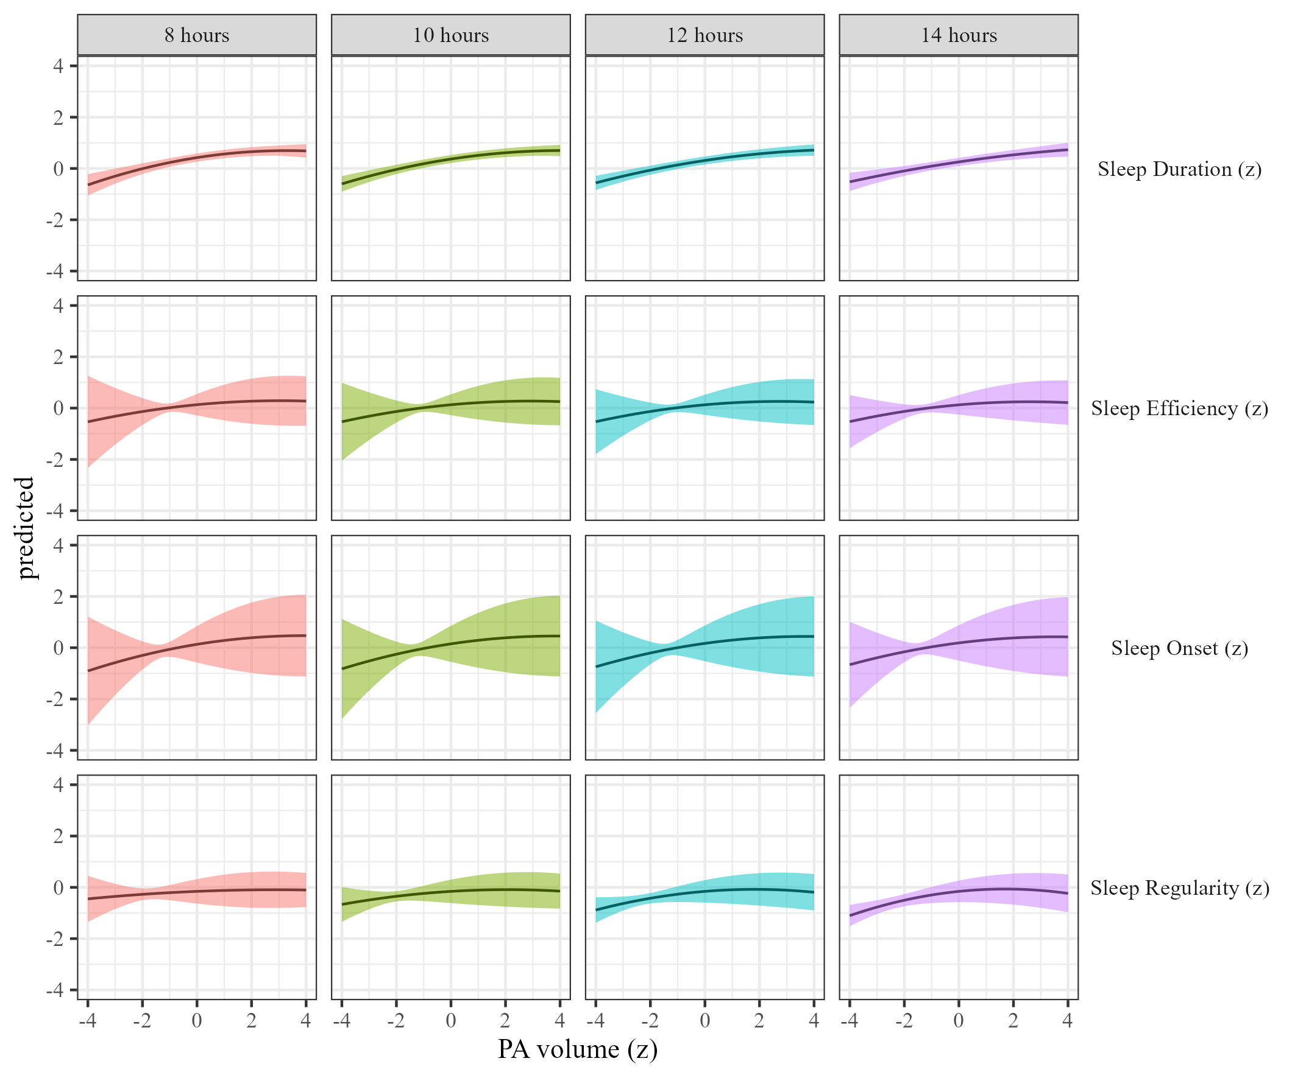

Figure 43: Sleep metrics on Physical activity volume by daylight hours

### The effects of physical activity intensity on sleep by daylight hours.

We estimated how physical activity intensity affects sleep across daylight hours We present the results in Table 15 and Figure 44.

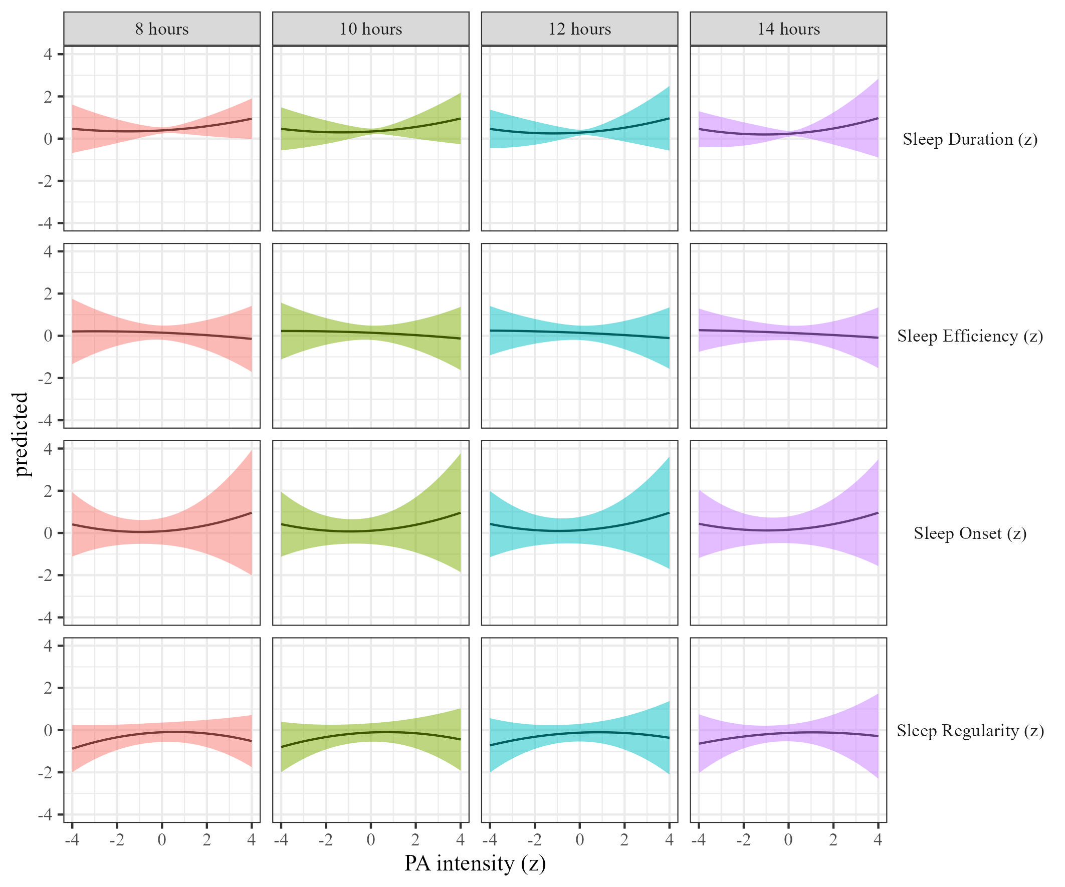

Figure 44: Sleep metrics on Physical activity intensity moderated by daylight hours

### The effects of sleep duration on physical activity.

We estimated the effect of sleep duration on physical activity by daylight hours Results, controlling for sex, SES, and BMI are presented in Table 2 and Figure 45.

Table 16:

*Sleep on physical activity controlling for SES, gender and BMI*

| Term | $β$ [95% CI] | SE | t | p | $β$ [95% CI] | SE | t | p |
| --- | --- | --- | --- | --- | --- | --- | --- | --- |
| Sleep duration |  |  |  |  |  |  |  |  |
| (Intercept) | 1.27 [0.79, 1.75] | 0.25 | 5.16 | .001 | 1.13 [0.60, 1.66] | 0.27 | 4.17 | .027 |
| Sleep duration | 0.00 [-0.18, 0.17] | 0.09 | -0.02 | .988 | 0.02 [-0.06, 0.09] | 0.04 | 0.46 | .651 |
| Daylight hours | 0.01 [0.00, 0.03] | 0.01 | 2.37 | .020 | 0.00 [-0.02, 0.01] | 0.01 | -0.51 | .628 |
| Sleep duration $​^{2}$ | 0.06 [-0.01, 0.13] | 0.03 | 1.74 | .131 | -0.01 [-0.10, 0.08] | 0.05 | -0.27 | .803 |
| Age | -0.02 [-0.02, -0.01] | 0.00 | -8.67 | < .001 | -0.02 [-0.02, -0.02] | 0.00 | -12.48 | < .001 |
| Sleep duration $×$ daylight hours | 0.00 [-0.02, 0.02] | 0.01 | -0.16 | .887 | 0.00 [-0.01, 0.01] | 0.00 | -0.35 | .737 |
| Daylight hours $×$ Sleep duration $​^{2}$ | 0.00 [-0.01, 0.00] | 0.00 | -1.15 | .299 | 0.00 [0.00, 0.00] | 0.00 | -0.18 | .860 |
| Sleep efficency |  |  |  |  |  |  |  |  |
| (Intercept) | 1.30 [0.75, 1.85] | 0.28 | 4.63 | .005 | 1.12 [0.56, 1.67] | 0.28 | 3.96 | .032 |
| Sleep efficiency | -0.02 [-0.14, 0.10] | 0.06 | -0.36 | .718 | -0.05 [-0.15, 0.06] | 0.05 | -0.86 | .396 |
| Daylight hours | 0.01 [0.00, 0.02] | 0.01 | 2.09 | .037 | 0.00 [-0.02, 0.01] | 0.01 | -0.59 | .579 |
| Sleep efficiency $​^{2}$ | 0.02 [-0.06, 0.10] | 0.04 | 0.48 | .662 | 0.00 [-0.05, 0.04] | 0.02 | -0.06 | .952 |
| Age | -0.02 [-0.02, -0.01] | 0.00 | -8.40 | < .001 | -0.02 [-0.02, -0.02] | 0.00 | -12.27 | < .001 |
| Sleep efficiency $×$ daylight hours | 0.00 [-0.01, 0.01] | 0.00 | 0.61 | .541 | 0.00 [0.00, 0.01] | 0.00 | 0.97 | .330 |
| Daylight hours $×$ Sleep efficiency $​^{2}$ | 0.00 [-0.01, 0.01] | 0.00 | -0.32 | .767 | 0.00 [0.00, 0.00] | 0.00 | 0.17 | .866 |
| Sleep onset |  |  |  |  |  |  |  |  |
| (Intercept) | 1.33 [0.81, 1.85] | 0.27 | 5.00 | .002 | 1.10 [0.58, 1.62] | 0.27 | 4.12 | .026 |
| Sleep onset | -0.04 [-0.14, 0.05] | 0.05 | -0.87 | .394 | -0.04 [-0.12, 0.03] | 0.04 | -1.17 | .248 |
| Daylight hours | 0.01 [0.00, 0.02] | 0.01 | 1.36 | .187 | 0.00 [-0.02, 0.01] | 0.01 | -0.37 | .722 |
| Sleep onset $​^{2}$ | -0.04 [-0.14, 0.06] | 0.05 | -0.81 | .459 | 0.01 [-0.05, 0.07] | 0.03 | 0.37 | .712 |
| Age | -0.02 [-0.02, -0.01] | 0.00 | -8.47 | < .001 | -0.02 [-0.02, -0.02] | 0.00 | -12.23 | < .001 |
| Sleep onset $×$ daylight hours | 0.00 [-0.01, 0.01] | 0.00 | 0.16 | .877 | 0.00 [0.00, 0.01] | 0.00 | 1.17 | .245 |
| Daylight hours $×$ Sleep onset $​^{2}$ | 0.00 [0.00, 0.01] | 0.00 | 0.76 | .474 | 0.00 [-0.01, 0.00] | 0.00 | -0.42 | .682 |
| Sleep regularity |  |  |  |  |  |  |  |  |
| (Intercept) | 1.21 [0.70, 1.73] | 0.26 | 4.60 | .004 | 1.09 [0.58, 1.60] | 0.26 | 4.18 | .024 |
| Sleep regularity | 0.09 [-0.04, 0.22] | 0.07 | 1.40 | .230 | 0.07 [-0.06, 0.19] | 0.07 | 0.99 | .387 |
| Daylight hours | 0.01 [0.00, 0.02] | 0.01 | 1.90 | .058 | 0.00 [-0.02, 0.01] | 0.01 | -0.70 | .506 |
| Sleep regularity $​^{2}$ | 0.02 [-0.03, 0.08] | 0.03 | 0.83 | .411 | -0.01 [-0.06, 0.05] | 0.03 | -0.21 | .833 |
| Age | -0.02 [-0.02, -0.01] | 0.00 | -8.21 | < .001 | -0.02 [-0.02, -0.01] | 0.00 | -12.13 | < .001 |
| Sleep regularity $×$ daylight hours | 0.00 [-0.01, 0.01] | 0.00 | -0.10 | .924 | 0.00 [-0.01, 0.01] | 0.00 | -0.55 | .600 |
| Daylight hours $×$ Sleep regularity $​^{2}$ | 0.00 [0.00, 0.00] | 0.00 | -0.06 | .954 | 0.00 [0.00, 0.00] | 0.00 | 0.39 | .697 |

*Note.* Adjusted for SES, BMI, and sex.

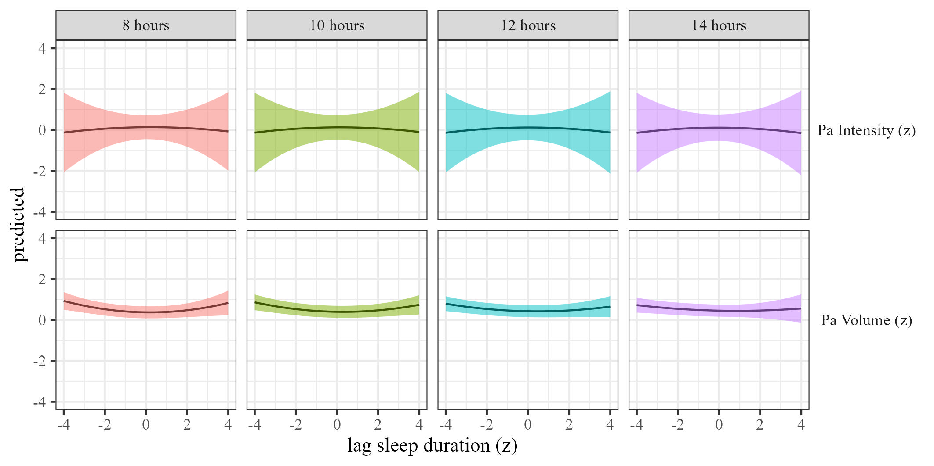

Figure 45: Physical activty by sleep duration moderated by daylight hours

### The effects of sleep efficiency on physical activity.

We estimated the effect of sleep efficiency on physical activity by daylight hours. Results, controlling for sex, SES, and BMI are presented in Table 16 and Figure 46.

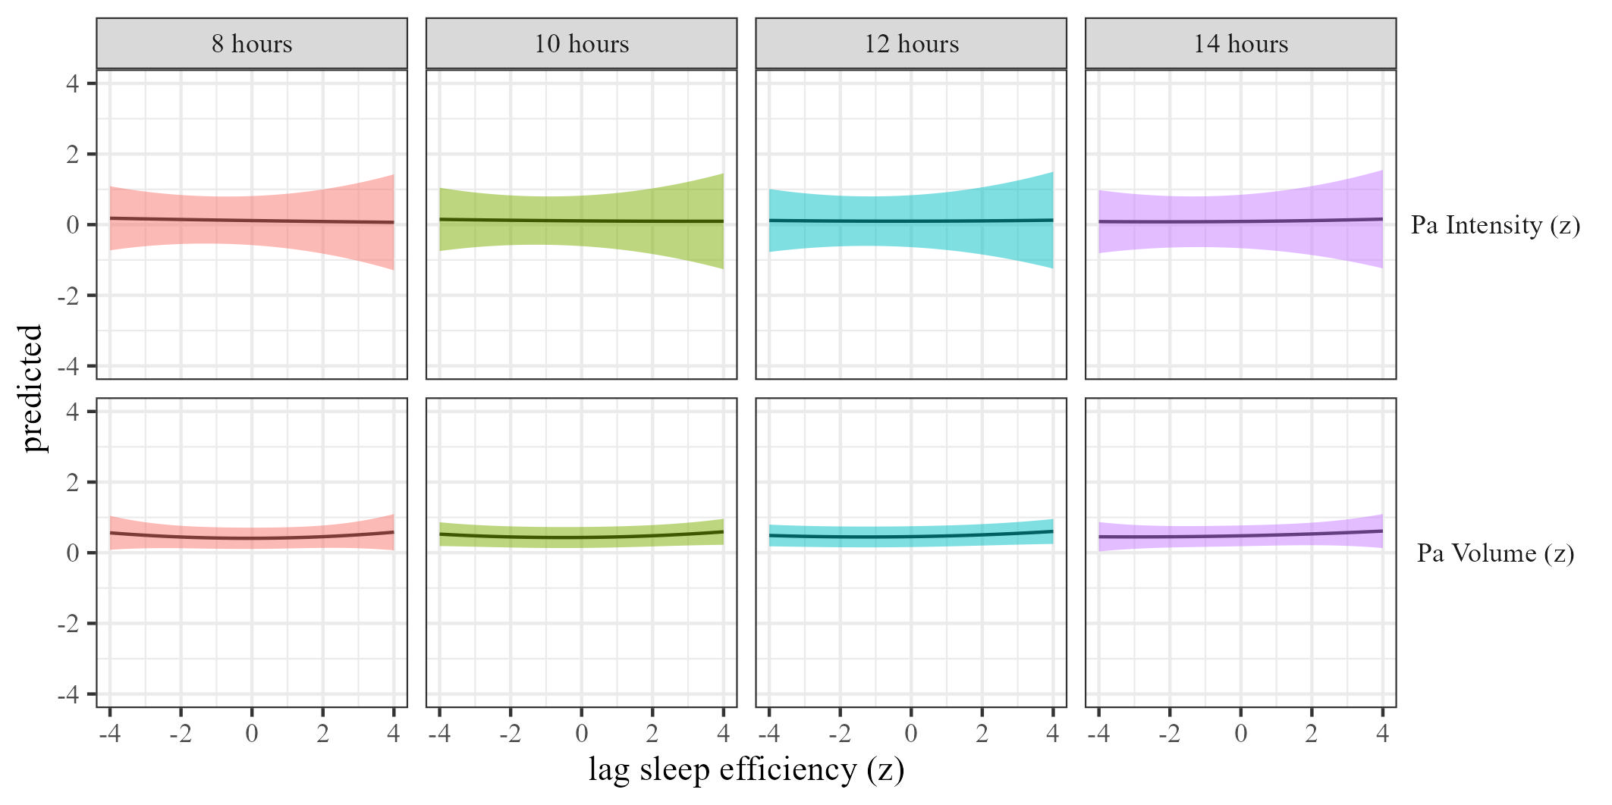

Figure 46: Physical activty by sleep efficiency moderated by daylight hours

### The effects of sleep onset on physical activity.

We estimated the effect of sleep onset on physical activity by daylight hours Results, controlling for sex, SES, and BMI are presented in Table 2 and Figure 47.

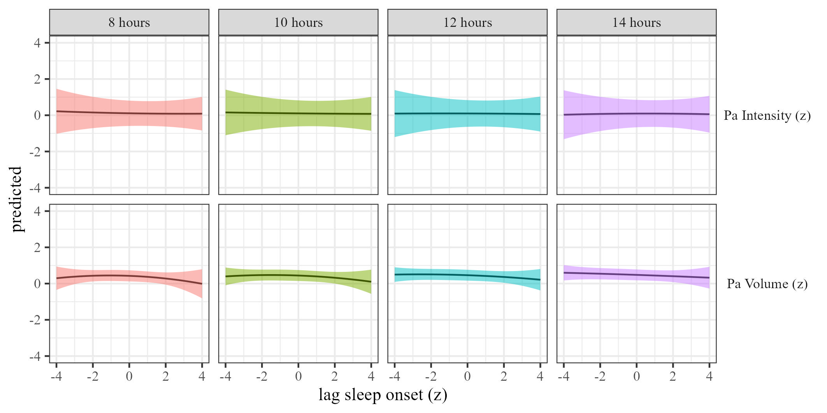

Figure 47: Physical activty by sleep onset moderated by daylight hours

### The effects of sleep regularity on physical activity.

We estimated the effect of sleep regularity on physical activity by daylight hours. Results are presented in Table 2 and Figure 48.

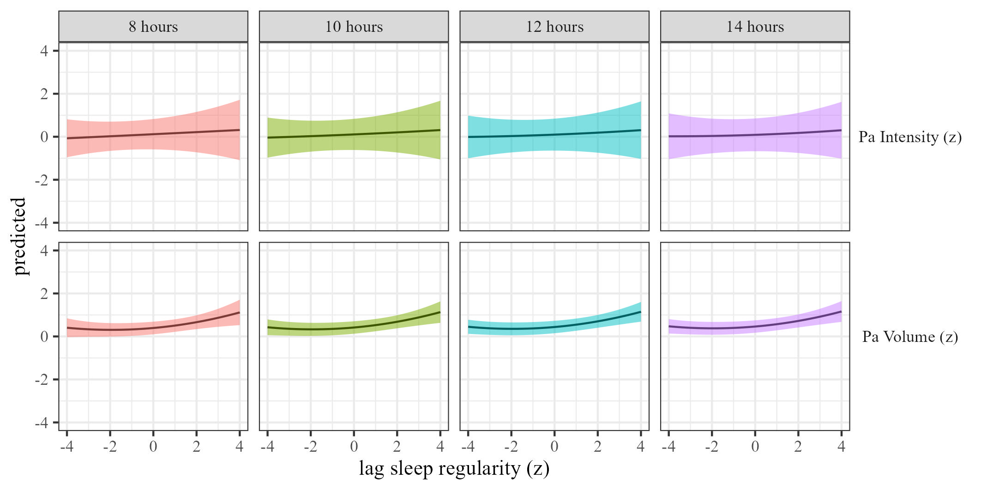 ## wear location

### The effects of physical activity volume on sleep.

We estimated the effects of physical activity on sleep (RQ1) using mixed-effects models We estimated the effect of physical activity volume on sleep by wear location, and the results are presented in Table @ref(tab:sleep-outcomes-by-wear_location) and Figure 49

(#tab:sleep-outcomes-by-wear_location)

*Physical activity on sleep controlling for SES, gender and BMI*

| Term | $β$ [95% CI] | SE | t | p | $β$ [95% CI] | SE | t | p |
| --- | --- | --- | --- | --- | --- | --- | --- | --- |
| Sleep duration |  |  |  |  |  |  |  |  |
| (Intercept) | 0.92 [0.60, 1.25] | 0.17 | 5.55 | .001 | 0.83 [0.37, 1.28] | 0.23 | 3.53 | .037 |
| Physical activity | 0.23 [0.18, 0.29] | 0.03 | 7.94 | < .001 | 0.05 [-0.28, 0.38] | 0.17 | 0.30 | .795 |
| Accelerometer wear locationwrist | -0.58 [-0.82, -0.34] | 0.12 | -4.69 | < .001 | -0.45 [-0.68, -0.21] | 0.12 | -3.78 | < .001 |
| Physical activity $​^{2}$ | -0.03 [-0.05, -0.01] | 0.01 | -2.59 | .013 | 0.05 [0.00, 0.10] | 0.03 | 2.13 | .096 |
| Age | 0.00 [-0.01, 0.00] | 0.00 | -1.80 | .073 | 0.00 [-0.01, 0.00] | 0.00 | -1.24 | .283 |
| Physical activity $×$ accelerometer wear locationwrist | -0.13 [-0.22, -0.04] | 0.04 | -2.94 | .033 | 0.02 [-0.08, 0.12] | 0.05 | 0.36 | .734 |
| Accelerometer wear locationwrist $×$ Physical activity $​^{2}$ | 0.02 [0.00, 0.04] | 0.01 | 1.84 | .071 | -0.04 [-0.08, 0.01] | 0.02 | -1.69 | .120 |
| Sleep efficency |  |  |  |  |  |  |  |  |
| (Intercept) | -0.35 [-0.88, 0.18] $​^{‡}$ | 0.27 | -1.30 | .311 | -0.41 [-0.84, 0.03] | 0.22 | -1.82 | .187 |
| Physical activity | 0.24 [-0.19, 0.67] $​^{‡}$ | 0.22 | 1.11 | .384 | -0.02 [-0.45, 0.41] | 0.22 | -0.09 | .935 |
| Accelerometer wear locationwrist | 0.68 [0.46, 0.91] $​^{‡}$ | 0.12 | 5.93 | .002 | 0.78 [0.58, 0.98] | 0.10 | 7.72 | < .001 |
| Physical activity $​^{2}$ | -0.04 [-0.07, -0.01] $​^{‡}$ | 0.02 | -2.50 | .063 | 0.01 [-0.14, 0.16] | 0.08 | 0.11 | .919 |
| Age | 0.00 [0.00, 0.00] $​^{‡}$ | 0.00 | 0.83 | .404 | 0.00 [0.00, 0.00] | 0.00 | 0.46 | .646 |
| Physical activity $×$ accelerometer wear locationwrist | -0.27 [-0.60, 0.07] $​^{‡}$ | 0.17 | -1.55 | .256 | -0.02 [-0.45, 0.40] | 0.22 | -0.10 | .926 |
| Accelerometer wear locationwrist $×$ Physical activity $​^{2}$ | 0.04 [0.01, 0.07] $​^{‡}$ | 0.01 | 2.83 | .028 | -0.03 [-0.15, 0.10] | 0.06 | -0.40 | .726 |
| Sleep onset |  |  |  |  |  |  |  |  |
| (Intercept) | -0.75 [-1.50, 0.00] | 0.38 | -1.96 | .133 | -0.94 [-1.48, -0.40] | 0.27 | -3.41 | .008 |
| Physical activity | 0.34 [-0.31, 0.99] | 0.33 | 1.04 | .412 | 0.16 [-0.20, 0.51] | 0.18 | 0.86 | .477 |
| Accelerometer wear locationwrist | 1.02 [0.57, 1.47] | 0.23 | 4.47 | < .001 | 1.11 [0.62, 1.59] | 0.25 | 4.45 | < .001 |
| Physical activity $​^{2}$ | 0.01 [-0.06, 0.07] | 0.03 | 0.23 | .839 | 0.09 [-0.11, 0.30] | 0.10 | 0.87 | .475 |
| Age | 0.00 [0.00, 0.00] | 0.00 | -0.50 | .627 | 0.00 [0.00, 0.00] | 0.00 | 0.07 | .948 |
| Physical activity $×$ accelerometer wear locationwrist | -0.41 [-0.91, 0.10] | 0.26 | -1.58 | .255 | -0.16 [-0.53, 0.22] | 0.19 | -0.82 | .495 |
| Accelerometer wear locationwrist $×$ Physical activity $​^{2}$ | 0.00 [-0.08, 0.08] | 0.04 | -0.02 | .988 | -0.09 [-0.26, 0.09] | 0.09 | -0.98 | .426 |
| Sleep regularity |  |  |  |  |  |  |  |  |
| (Intercept) | -0.07 [-0.70, 0.55] | 0.32 | -0.22 | .833 | -0.11 [-0.70, 0.48] | 0.30 | -0.36 | .735 |
| Physical activity | 0.07 [-0.17, 0.30] | 0.12 | 0.54 | .639 | 0.12 [0.02, 0.22] | 0.05 | 2.32 | .113 |
| Accelerometer wear locationwrist | 0.33 [-0.07, 0.72] | 0.20 | 1.61 | .108 | 0.50 [0.10, 0.90] | 0.21 | 2.44 | .015 |
| Physical activity $​^{2}$ | -0.08 [-0.12, -0.04] | 0.02 | -4.07 | .025 | -0.08 [-0.31, 0.14] | 0.12 | -0.73 | .543 |
| Age | 0.00 [0.00, 0.00] | 0.00 | -0.13 | .896 | 0.00 [-0.01, 0.00] | 0.00 | -0.65 | .527 |
| Physical activity $×$ accelerometer wear locationwrist | 0.08 [-0.12, 0.28] | 0.10 | 0.78 | .511 | -0.08 [-0.25, 0.09] | 0.08 | -0.94 | .433 |
| Accelerometer wear locationwrist $×$ Physical activity $​^{2}$ | 0.05 [0.01, 0.10] | 0.02 | 2.42 | .097 | 0.07 [-0.13, 0.27] | 0.10 | 0.69 | .562 |

*Note.* Adjusted for SES, BMI, and sex.

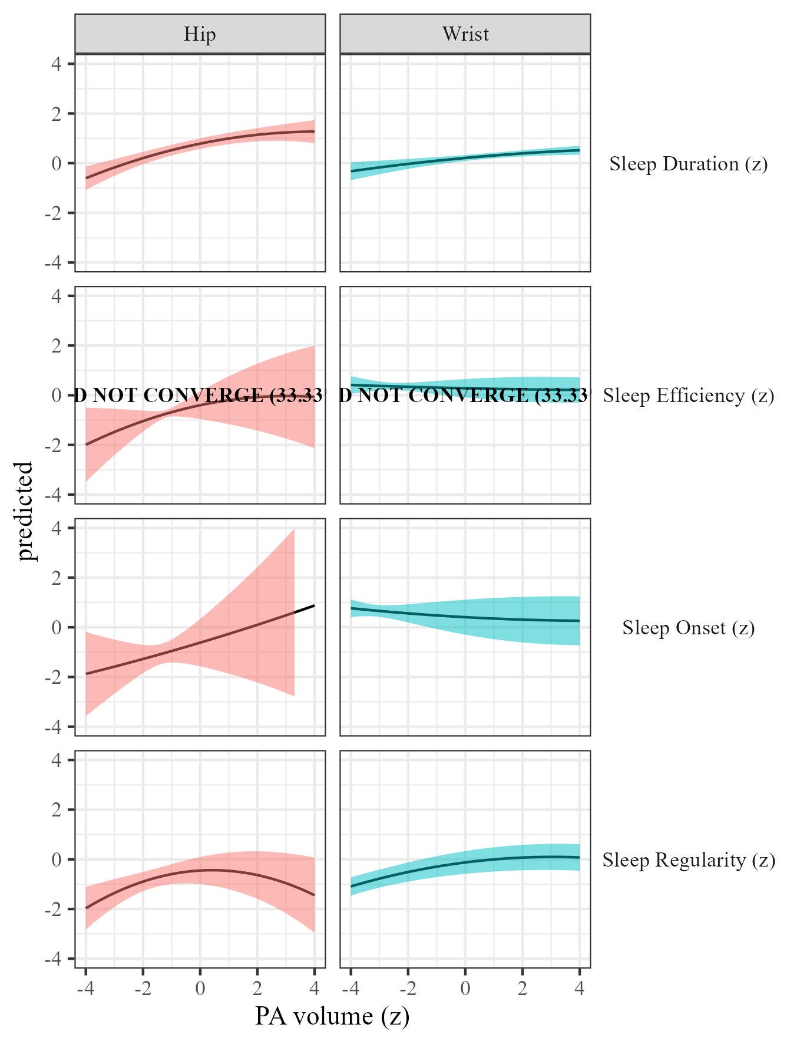

Figure 49: Sleep metrics on Physical activity volume by wear location

### The effects of physical activity intensity on sleep by wear location.

We estimated how physical activity intensity affects sleep across wear location We present the results in Table @ref(tab:sleep-outcomes-by-wear_location) and Figure 50.

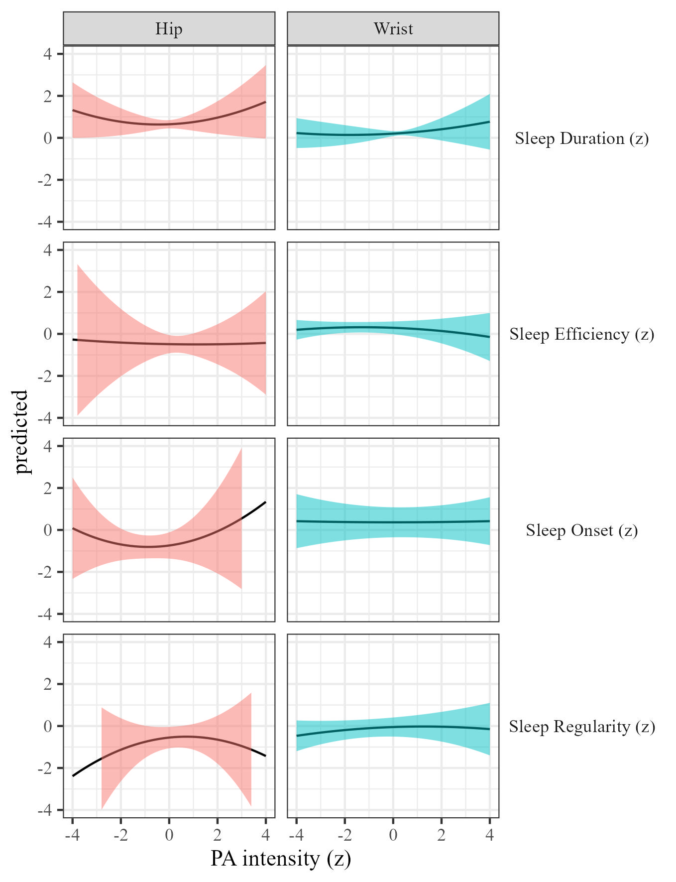

Figure 50: Sleep metrics on Physical activity intensity moderated by wear location

### The effects of sleep duration on physical activity.

We estimated the effect of sleep duration on physical activity by wear location Results, controlling for sex, SES, and BMI are presented in Table 2 and Figure 51.

(#tab:pa-outcomes-by-wear_location)

*Sleep on physical activity controlling for SES, gender and BMI*

| Term | $β$ [95% CI] | SE | t | p | $β$ [95% CI] | SE | t | p |
| --- | --- | --- | --- | --- | --- | --- | --- | --- |
| Sleep duration |  |  |  |  |  |  |  |  |
| (Intercept) | 0.41 [-0.16, 0.98] | 0.29 | 1.41 | .179 | 0.87 [0.32, 1.41] | 0.28 | 3.12 | .021 |
| Sleep duration | -0.02 [-0.06, 0.02] | 0.02 | -0.97 | .382 | -0.01 [-0.04, 0.01] | 0.01 | -0.93 | .364 |
| Accelerometer wear locationwrist | 1.28 [0.76, 1.80] | 0.27 | 4.83 | < .001 | 0.28 [-0.15, 0.71] | 0.22 | 1.26 | .212 |
| Sleep duration $​^{2}$ | 0.06 [0.03, 0.08] | 0.01 | 4.65 | .012 | -0.01 [-0.13, 0.12] | 0.06 | -0.11 | .923 |
| Age | -0.02 [-0.02, -0.01] | 0.00 | -8.89 | < .001 | -0.02 [-0.02, -0.02] | 0.00 | -12.42 | < .001 |
| Sleep duration $×$ accelerometer wear locationwrist | 0.02 [-0.04, 0.08] | 0.03 | 0.57 | .603 | 0.03 [-0.03, 0.08] | 0.03 | 0.96 | .405 |
| Accelerometer wear locationwrist $×$ Sleep duration $​^{2}$ | -0.08 [-0.10, -0.05] | 0.01 | -5.96 | .001 | -0.02 [-0.10, 0.07] | 0.04 | -0.40 | .726 |
| Sleep efficency |  |  |  |  |  |  |  |  |
| (Intercept) | 0.52 [-0.03, 1.07] | 0.28 | 1.86 | .078 | 0.86 [0.18, 1.55] | 0.35 | 2.48 | .070 |
| Sleep efficiency | 0.05 [0.01, 0.10] | 0.02 | 2.50 | .021 | 0.01 [-0.10, 0.12] | 0.06 | 0.24 | .830 |
| Accelerometer wear locationwrist | 1.15 [0.64, 1.67] | 0.26 | 4.37 | < .001 | 0.27 [-0.17, 0.71] | 0.23 | 1.19 | .238 |
| Sleep efficiency $​^{2}$ | 0.01 [0.01, 0.02] | 0.00 | 3.25 | .002 | 0.00 [-0.03, 0.04] | 0.02 | 0.26 | .815 |
| Age | -0.02 [-0.02, -0.01] | 0.00 | -8.80 | < .001 | -0.02 [-0.02, -0.02] | 0.00 | -12.27 | < .001 |
| Sleep efficiency $×$ accelerometer wear locationwrist | -0.06 [-0.11, -0.01] | 0.03 | -2.33 | .028 | -0.02 [-0.10, 0.06] | 0.04 | -0.45 | .680 |
| Accelerometer wear locationwrist $×$ Sleep efficiency $​^{2}$ | -0.02 [-0.05, 0.00] | 0.01 | -2.01 | .094 | -0.01 [-0.02, 0.01] | 0.01 | -1.09 | .296 |
| Sleep onset |  |  |  |  |  |  |  |  |
| (Intercept) | 0.50 [-0.06, 1.05] | 0.28 | 1.75 | .099 | 0.84 [0.16, 1.52] | 0.35 | 2.44 | .072 |
| Sleep onset | -0.06 [-0.20, 0.08] | 0.07 | -0.84 | .424 | -0.10 [-0.34, 0.14] | 0.12 | -0.82 | .479 |
| Accelerometer wear locationwrist | 1.17 [0.66, 1.68] | 0.26 | 4.48 | < .001 | 0.29 [-0.20, 0.77] | 0.25 | 1.16 | .259 |
| Sleep onset $​^{2}$ | -0.03 [-0.16, 0.10] | 0.07 | -0.45 | .679 | -0.07 [-0.22, 0.08] | 0.08 | -0.89 | .448 |
| Age | -0.02 [-0.02, -0.01] | 0.00 | -8.85 | < .001 | -0.02 [-0.02, -0.02] | 0.00 | -12.19 | < .001 |
| Sleep onset $×$ accelerometer wear locationwrist | 0.02 [-0.10, 0.14] | 0.06 | 0.33 | .742 | 0.10 [-0.15, 0.34] | 0.13 | 0.78 | .501 |
| Accelerometer wear locationwrist $×$ Sleep onset $​^{2}$ | 0.03 [-0.10, 0.15] | 0.06 | 0.39 | .717 | 0.07 [-0.07, 0.21] | 0.07 | 0.95 | .417 |
| Sleep regularity |  |  |  |  |  |  |  |  |
| (Intercept) | 0.46 [-0.08, 0.99] | 0.27 | 1.68 | .103 | 0.86 [0.24, 1.48] | 0.32 | 2.72 | .045 |
| Sleep regularity | 0.13 [0.06, 0.20] | 0.03 | 3.71 | .038 | 0.06 [-0.07, 0.18] | 0.06 | 0.92 | .449 |
| Accelerometer wear locationwrist | 1.13 [0.60, 1.65] | 0.27 | 4.22 | < .001 | 0.23 [-0.21, 0.67] | 0.23 | 1.01 | .315 |
| Sleep regularity $​^{2}$ | 0.04 [0.00, 0.08] | 0.02 | 1.97 | .148 | 0.00 [-0.07, 0.06] | 0.03 | -0.08 | .943 |
| Age | -0.02 [-0.02, -0.01] | 0.00 | -8.82 | < .001 | -0.02 [-0.02, -0.02] | 0.00 | -12.35 | < .001 |
| Sleep regularity $×$ accelerometer wear locationwrist | -0.07 [-0.12, -0.02] | 0.03 | -2.59 | .038 | -0.04 [-0.16, 0.09] | 0.06 | -0.56 | .625 |
| Accelerometer wear locationwrist $×$ Sleep regularity $​^{2}$ | -0.03 [-0.07, 0.02] | 0.02 | -1.16 | .329 | 0.01 [-0.05, 0.07] | 0.03 | 0.29 | .796 |

*Note.* Adjusted for SES, BMI, and sex.

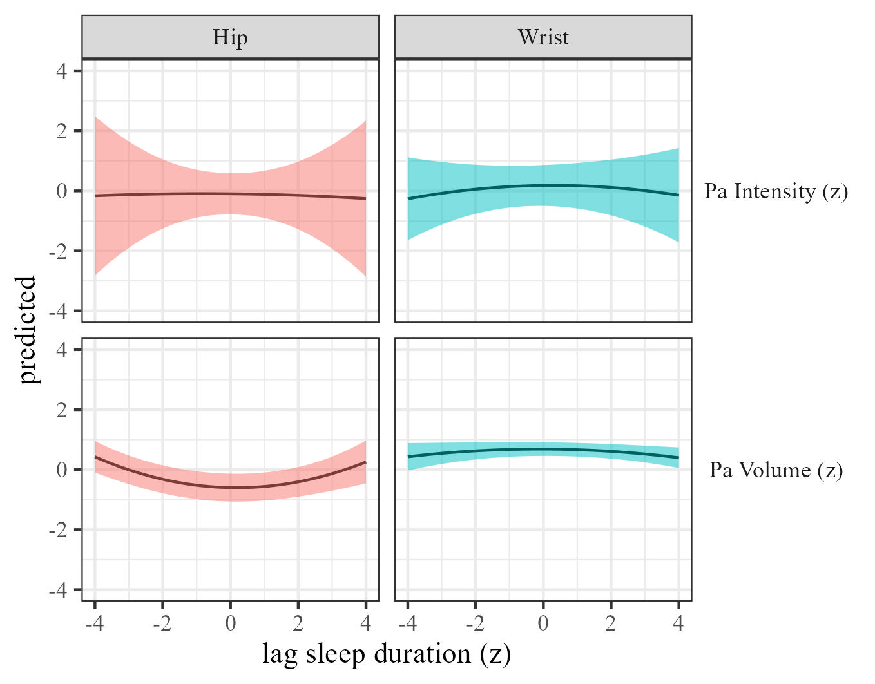

Figure 51: Physical activty by sleep duration moderated by wear location

### The effects of sleep efficiency on physical activity.

We estimated the effect of sleep efficiency on physical activity by wear location. Results, controlling for sex, SES, and BMI are presented in Table @ref(tab:pa-outcomes-by-wear_location) and Figure 52.

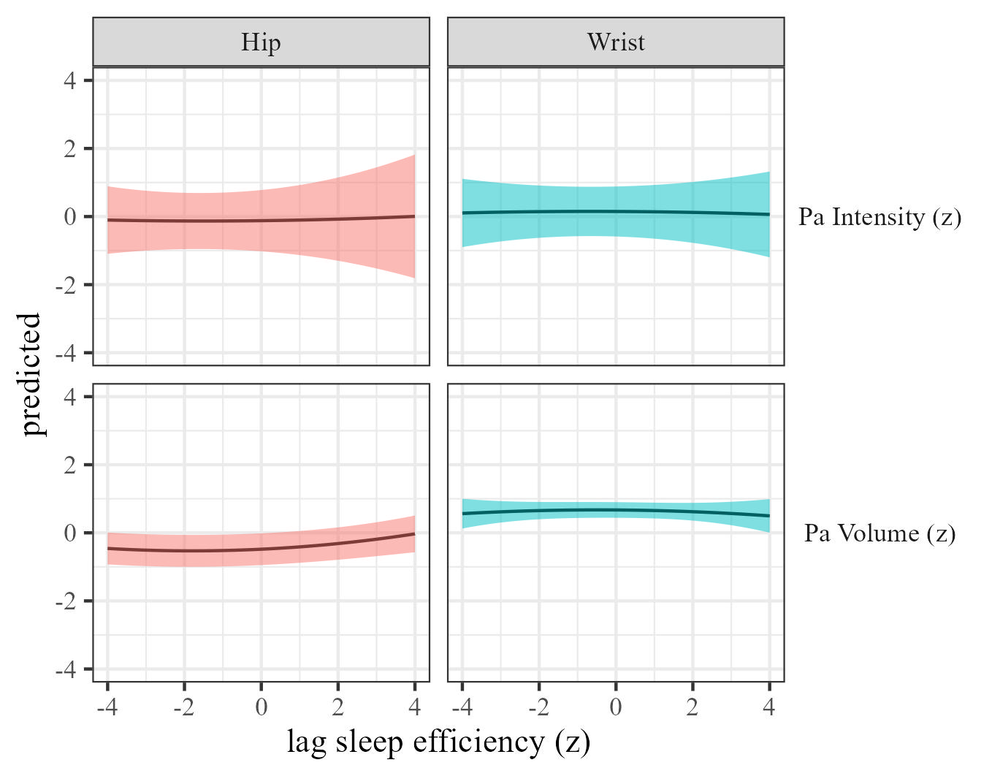

Figure 52: Physical activty by sleep efficiency moderated by wear location

### The effects of sleep onset on physical activity.

We estimated the effect of sleep onset on physical activity by wear location Results, controlling for sex, SES, and BMI are presented in Table 2 and Figure 53.

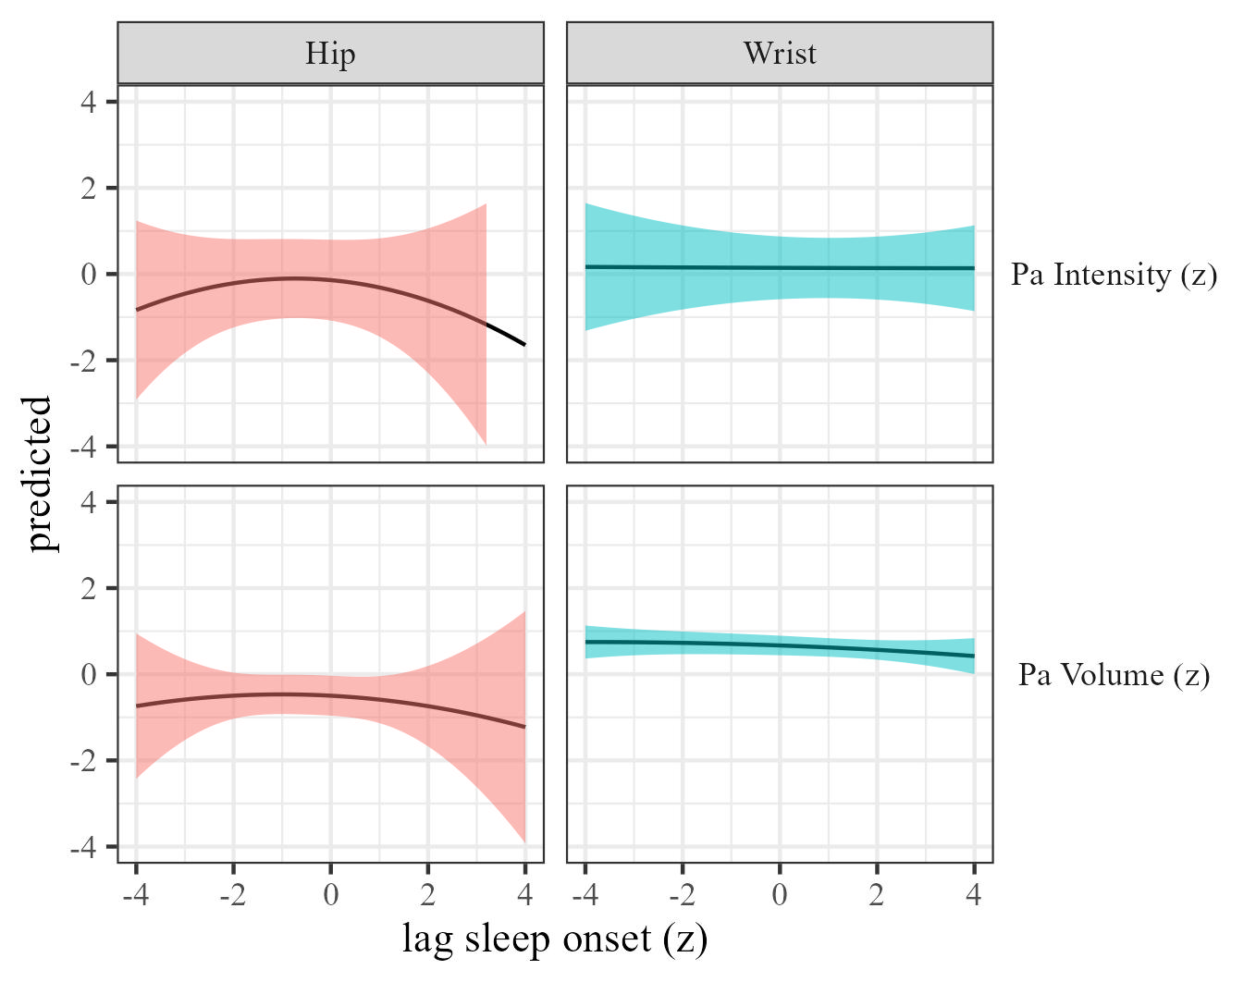

Figure 53: Physical activty by sleep onset moderated by wear location

### The effects of sleep regularity on physical activity.

We estimated the effect of sleep regularity on physical activity by wear location. Results are presented in Table 2 and Figure 54.

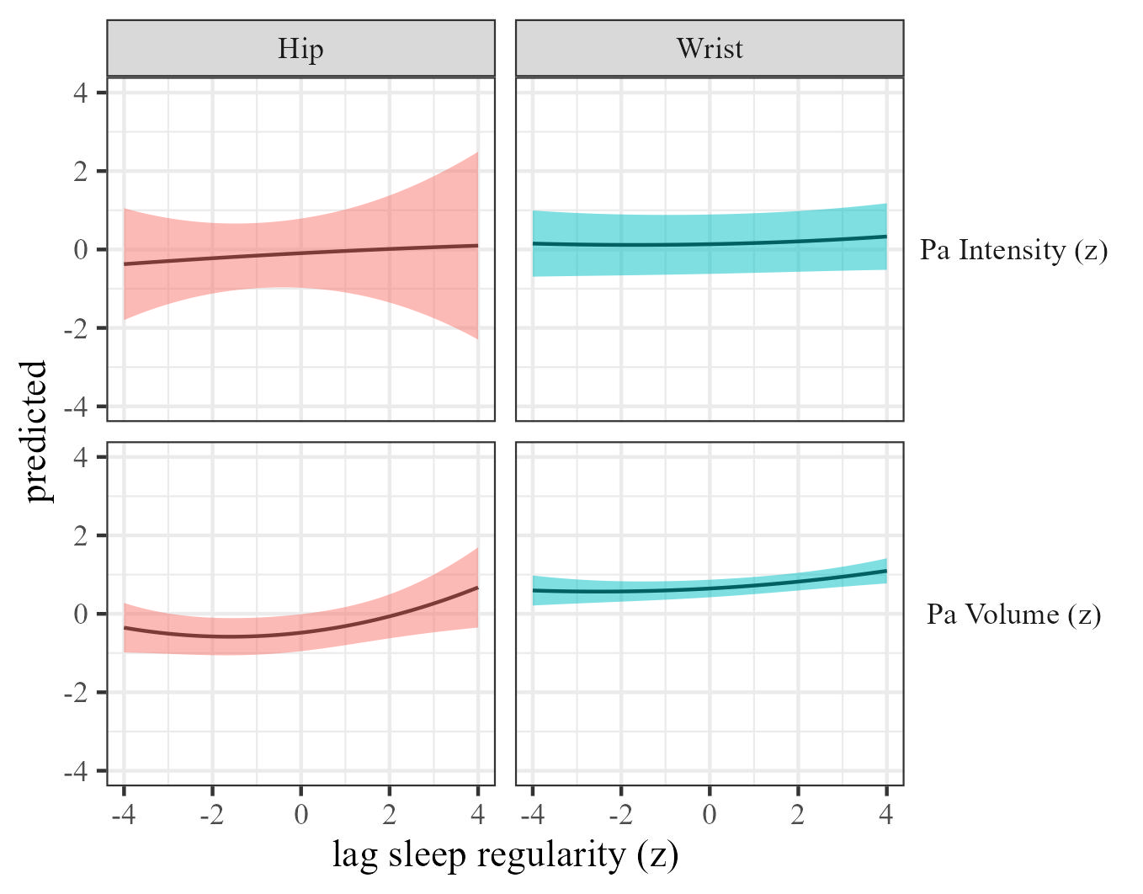

Figure 54: Physical activty by sleep regularity moderated by wear location